13-2/13-3 Angles, Reference Angles & Radians Notes
Remember: When sketching an angle, always start at the positive x-axis.
The positive x-axis represents ________º or _______º.
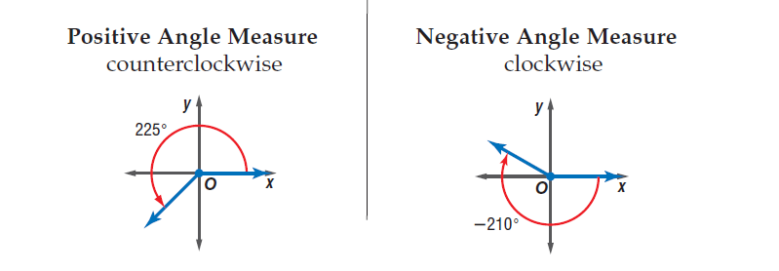

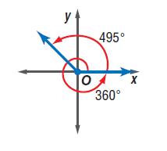

A reference angle is the acute angle formed by the terminal side and the x-axis. (denoted by $θ')$

Examples: Sketch each angle. Then find its reference angle.

1. 290° 2. 135° 3. -40°

$$θ'$$

$θ'$=70º

Radians
The definition of a radian is based on the unit circle,
a circle of radius 1 which centers at the origin.
One radian is the measure of angle in standard
position whose rays intercept and arc of length 1 unit.

Circle Review: The circumference of any circle
is _________________, where r is the radius.
The circumference of the unit circle would
be ______________, so 360° = _________ Radians 180° = __________Radians.
Conversions
Converting degrees to radians: Converting radians to degrees:
R=D($\frac{π }{180°}$) D=R$(\frac{180}{π})$

Examples:
Rewrite the degree measures in radians and the radian measure in degrees.

1. 60° 2. 45°
$R=60°∙\frac{π}{180°}=\frac{60π}{180}$ = $\frac{π}{3}$

3. $-\frac{7π}{4}$ 4. $\frac{5π}{3}$

$$D=-\frac{7π}{4}∙\frac{180}{π}=-\frac{1260}{4}=-315°$$

Coterminal Angles: The graph shows a 405° angle and a 45° angle. They both share the same terminal side. When two angles in standard position have the same terminal sides, they are called co terminal angles.
405°- 360°=45° In degrees, you add/subtract 360
In radians, you would add/subtract 2

Examples: Find one angle with positive measure and one angle with negative measure coterminal with each angle.
1. 240° 2. $\frac{9π}{4}$

3. 15° 4. $-\frac{π}{4}$

Name: __________________________________ Date: ___________
13-2/13-3 Angles, Reference Angles & Radians Hwk:
1. On the circle below, draw and label all of the following degrees:
0, 30, 45, 60, 90, 120, 135, 150, 180, 210, 225, 240, 270, 300, 315, 330, and 360.
Then find and label all radians of each degree.
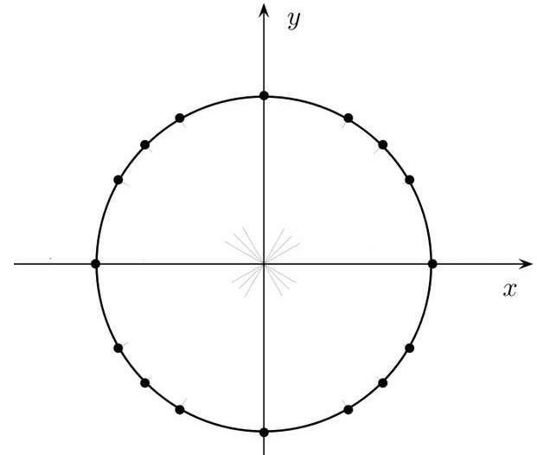
(1,0)

2. Without looking on the front, sketch each angle and find its reference angle.
a). 315º b). $\frac{7π}{4}$ c). -240º
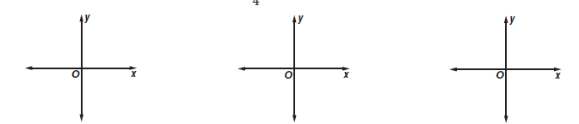

d). $-\frac{2π}{3}$ e). 750º f). $\frac{5π}{6}$

