13.3/13.6 Exact Values using the UNIT CIRCLE
ACC Geometry Notes

The circle below is called the _______________ ____________ because the value of the radius is ____________.

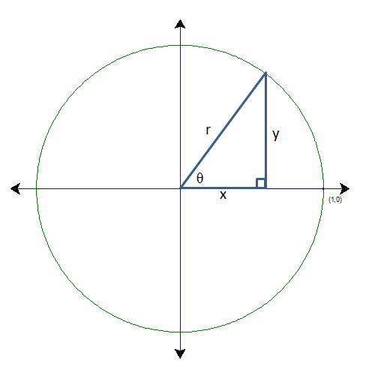

With radius= 1, find:

cos= __________

sin= __________

tan= ________

Unit Circle
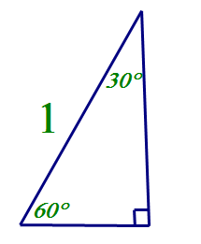

Find all points on the unit circle using special right triangles.
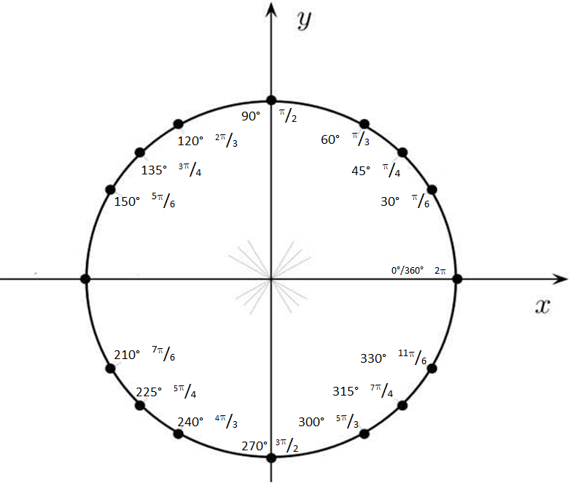

Find the exact value of each function by using the unit circle. Place the question # by the coordinates that correspond to the answer of the question.
1. cos (-240°) 2. tan ⁵/₄ 3. sin5

4. csc(¹¹/₄) 5. sec(⁻³/₄) 6. cot ⁷/₆

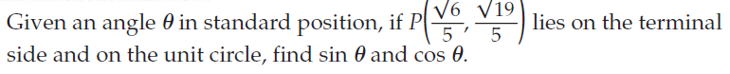
7.

8. Find the exact value of the function. 2(sin45⁰)-6(cos135⁰).

Name: ______________________________________ Date: ________ Hour_____
Unit Circle Homework
Find the exact value of each function by using the unit circle. Place the question # by the coordinates that correspond to the answer of the question.
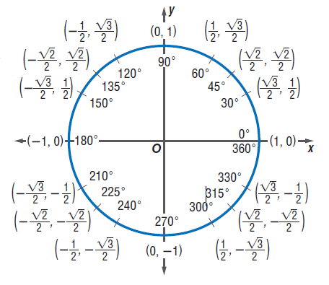

1. 2. 3. sec 5

4. tan 5. cot 6. Csc (-225°)

Directions: Find the exact value of each function… and I mean EXACT.
No decimals!!!!!!!

7. $\frac{cos60°+sin30°}{4}$ 8. $3(sin60°)(cos30°)$

9. $\sin{30°-\sin{60°}}$ 10. $\frac{4\cos{330}°+2\sin{60}°}{3}$

11. $12(\sin{150°)(\cos{150°)}}$ 12. ${(\sin{30°)}}^{2}+{(\cos{30°)}}^{2}$

13. A Regular hexagon is inscribed in a unit circle centered at the origin. If one vertex of the hexagon is at (1,0), find the exact coordinates of the remaining vertices. Use the picture to help!

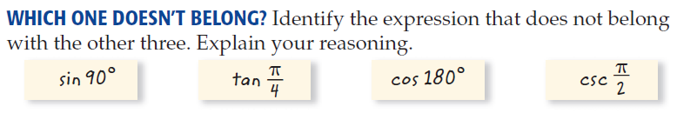
14.

