**Trig Transformations Day 2 Hwk Name_____________________**

**Supp Alg 2 14.2 Radians & Equation Writing**

**Sketch a graph of the following. State the amplitude, period, vertical shift and phase shift.**

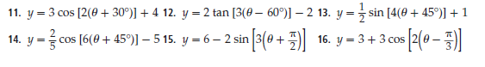











**Write an equation for each graph.**

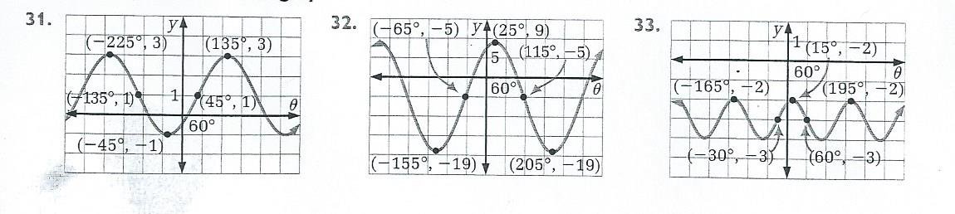

**34. 35.**



