14.3/ 14.4 Simplifying and Verifying Trig Identities Notes
Day Two
Simplify.
1. Simplify: cos csc .

2. Simplify: cos tan .

Verifying:
1. Verify that tan²-sin²=tan²sin²

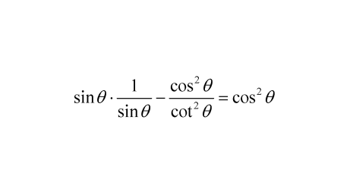
2. Verify that

3. Verify that sec²-tan²=tancot

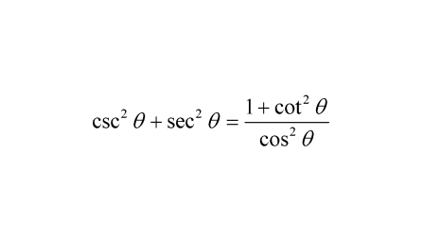

4. Verify that

