Name: _________________________________________________ DUE: ___________________ HOUR: ____________

2014/2015

ACC Geometry Final Exam Review

**Show all work and circle all answers.**

1. In a large cube, the edges are 4 times as long as the edges of the small cube. The volume of the large cube is how many times the volume of the small cube?
2. Two containers in the shape of right circular cylinders are equal in height. The radius of the larger container is 3 times the radius of the smaller container. The volume of the larger container is how many times the volume of the smaller container?
3. In order to winterize her pool, Leah must remove one fourth of the water before putting the winter cover on. Her pool measures 5 feet deep, 10 feet wide and 25 feet long. If the pool is completely filled at the end of the summer (prior to winterizing), how much water, in cubic feet, would she need to remove?
4. In order to winterize her pool, Leah must remove half of the water before putting the winter cover on. Her pool measures 5 feet deep, 10 feet wide and 25 feet long. If the pool is completely filled at the end of the summer (prior to winterizing), how much water, in cubic feet, would she need to remove?
5. 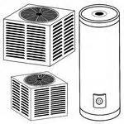If a hot water tank, shown with the diameter of 5 feet and length of 13 feet, is filled with water, then the weight in pounds at room temperature, of the water inside the take would be: (note: one cubic foot of water weighs approximately 62 lbs.)
6. 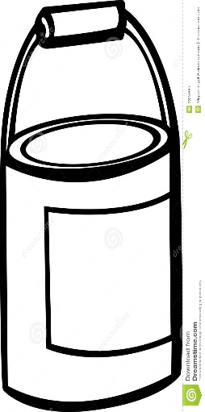If a paint bucket, shown below with the diameter of 26 inches and length of 39 inches, is filled with paint, then the weight in pounds at room temperature, of the paint inside the take would be: (note: one cubic inch of paint weighs approximately 0.12 lbs.)
7. Find the volume of the composite solid. Round your answer to the nearest tenth.

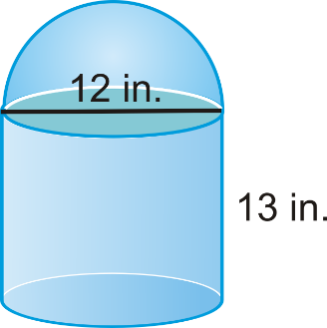

1. A box in the shape of a right rectangular prism has a volume of 60 cubic meters. The height of the box is 3 inches and the width is 4 inches. What is the length, in inches, of the box?
2. College engineering students designed an enlarged external fuel tank of a space shuttle as part of an assignment. The professor liked the design so much, that she decided to have the fuel tank constructed and used. How many cubic meters can the fuel tank hold?

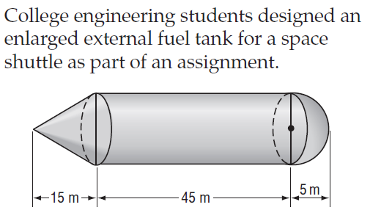

1. The pyramid below has a rectangular base with side lengths of 24 inches and 18 inches it also has the volume of 1728 in3. Find the height of the pyramid.

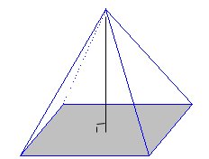

.

1. 12 ice cubes with 2 inch edges are stacked on a pan which is in the shape of a rectangular prism. It is 2 inches wide, 7 inches long and 1 inch deep. When the ice melts, will the ice’s water overflow the pan?
2. If a sphere filled with liquid has a radius of 8 inches, will the volume exceed the volume of a cone with the same radius but with a height 20 inches? Show the math you used to solve this question.
3. If a right circular cylinder has a radius of 4 inches and a surface area of $112π$ square inches, what is the height of the cylinder in inches?
4. Find the area of the image, in square units, if the pre-image (given below) is dilated by a scale factor of 5.

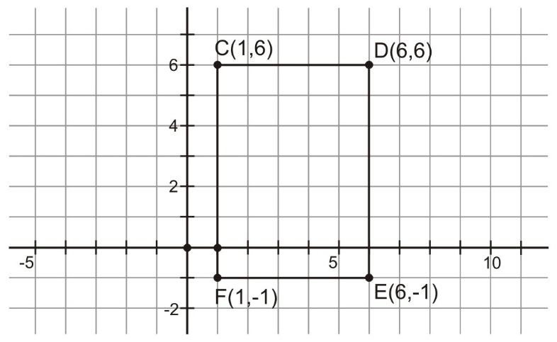

1. Find the magnitude and direction for the vector < -2, -6>.

1. Write the component form of vector XY with X(2,-9) and Y(-1, -3).
2. What figure(s) have four lines of symmetry?
3. Explain what would happen if you consecutively reflected a pre-image over two parallel lines.
4. Explain what would happen if you consecutively reflected a pre-image over two perpendicular lines.
5. Rotate X(-1,-9) 90 degrees counterclockwise about the origin.
6. Rotate X(-1,-9) 90 degrees clockwise about the origin.
7. Rotate X(-1,-9) 180 degrees about the origin.
8. If the image of point X’(-1,-9) and the pre-image is X(6,-3) name the translation rule in point notation.

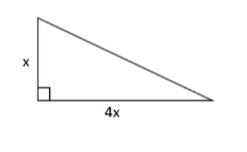

1. Find the length of the hypotenuse of this right triangle.
2. The altitude of the base of a cloud formation is called the ceiling. To find the height of the ceiling one night, a meteorologist directed a spotlight vertically at the clouds. Using a theodolite placed 8 meters from the spotlight and 1.5 meters above the ground, he knew the angle of elevation was 62.7 degrees. How high is the ceiling?
3. A digital camera with a panoramic lens is described as having a view with an angle of elevation of 38 degrees. If the camera is on a 3 foot tripod aimed directly at a monument 158.7 feet away, how tall is the monument?
4. Find the variable.

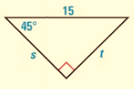

1. 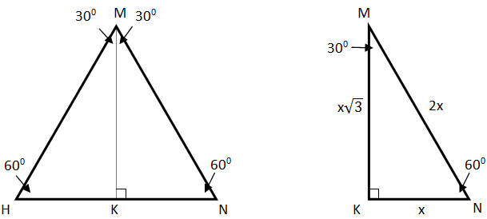If the sides of the equilateral triangle are 22 cm, find the height KM, of the triangle.

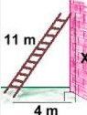29. A. A ladder 11m long is leaning against a building. The base of the ladder is 4m from the base of the building. How high up the wall does the ladder reach?

B. A 50ft ladder reaches up to a 3rd story window in order to rescue a little girl from a burning building. The base of the ladder is 35ft from the base of the building. How high is the window?

30. State whether the following sets of measures represent the sides of a right triangle.

a) 20, 48, 52

b) 9, 40, 41

c) 21, 21, 31

d) 12, 34, 37

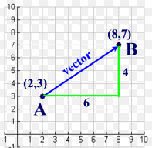31. Write the component form of the vector and find the magnitude and direction of the vector.

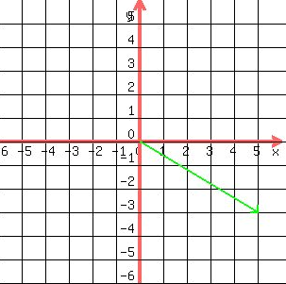32. Write the component form of the vector and find the magnitude and direction of the vector.

33. Find the component form of vector MN with M(1, 2) and N(4, 6).

34. Find the surface area of the right cylinder.

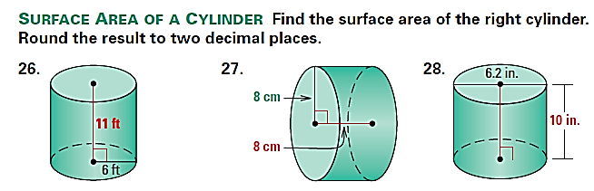Keep your answers in terms of pi.

 a) b)

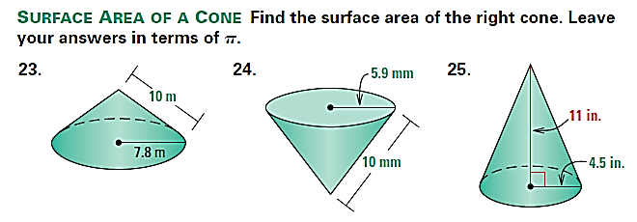35. Find the surface area of the cones below. Round to the nearest tenth.

a) b)

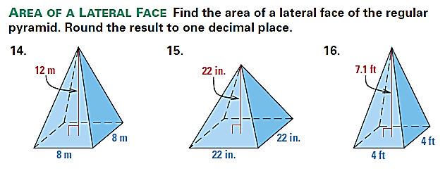36. Find the surface area of the square pyramid. Round your answer to the nearest tenth.

a) b)

37. Find the surface area of the figures below. The bases are regular polygons. Round to the nearest whole number.

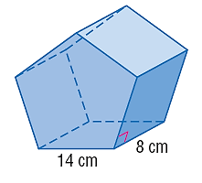 a)

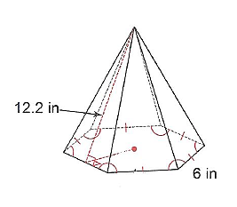

b)

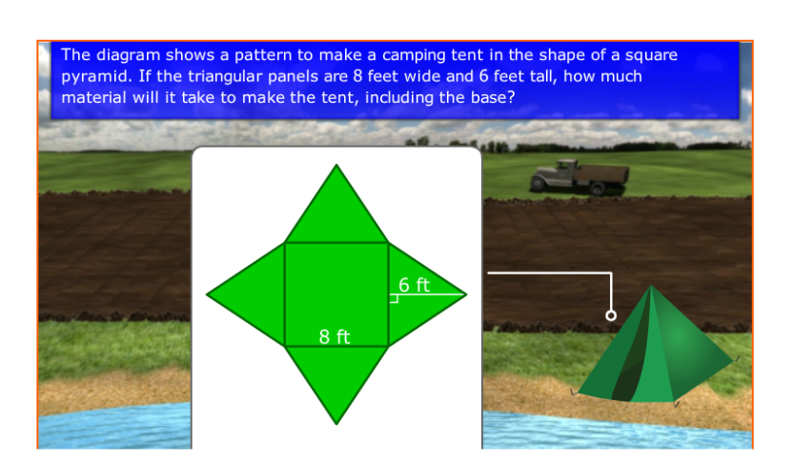38. A camping tent made of nylon is seen below in the shape of a square pyramid. If the triangular panels are 10 feet wide and 7 feet tall, how much material will it take to make the tent, including the base?

39. Jill wants to have her ottoman, shown below, reupholstered. Find the surface area that will be reupholstered.

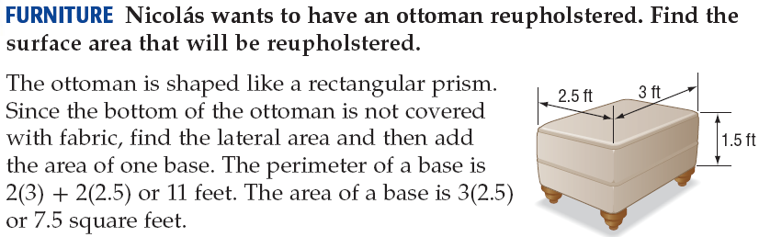

40. A library has an aquarium in the shape of a rectangular prism. The base is 6 feet by 2.5 feet, and the height is 4 feet. How many square feet of glass was used to build the aquarium?

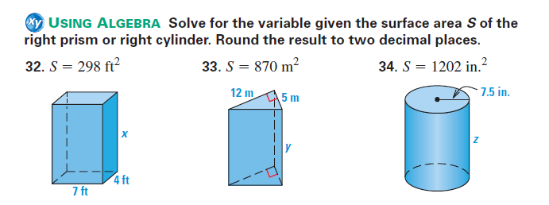41. Solve for the variable given the surface area *S* of the right prism. Round to the nearest tenth.

 a) b)

42. Timmy is flying a kite. The length of the string is 37 feet. The kite gets caught on the top of a tree that is perpendicular to the ground. Timmy is 10 feet from the tree’s base. How tall is the tree?

43. Give an example of three measures that could represent the sides of a right triangle. Prove or explain why these measures work.

44. Consider the triangle ABC, shown below. Use the Pythagorean Theorem to find the missing side. Then find all trig ratios below and simplify all answers.

x

20

B

A

X= _______________

21

C

sin ∠ A = __________ cos ∠ A = __________ tan ∠ A = __________

csc∠ B = __________ sec ∠ B = __________ cot ∠ B = __________

45. Find the measure of the missing angle.

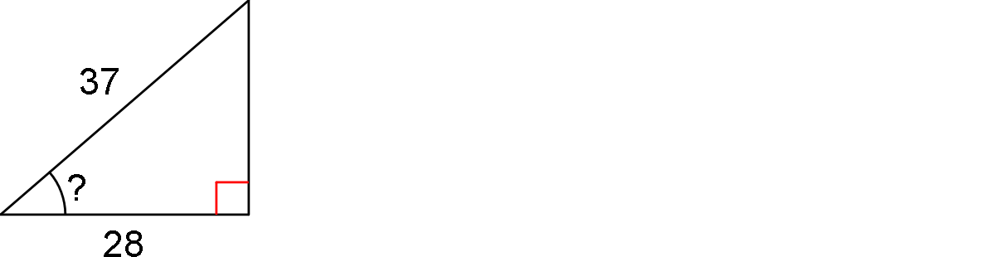

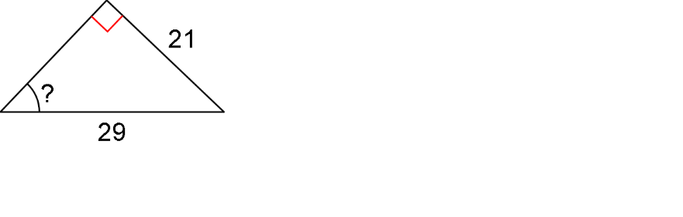46. Find the measure of the missing angle.

47. Solve to find each missing side. Round to the nearest tenth.

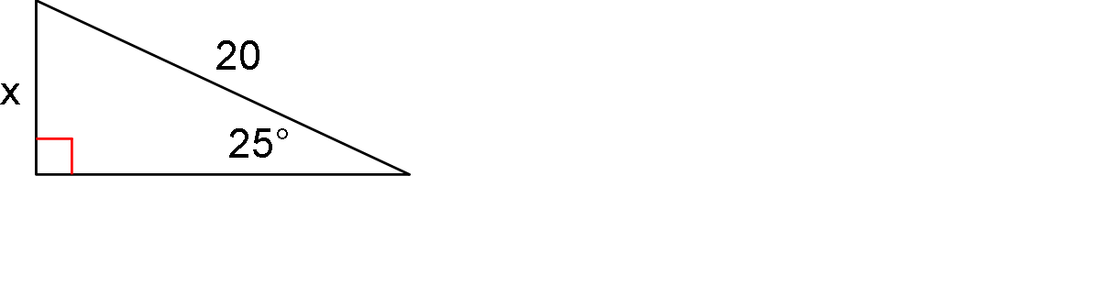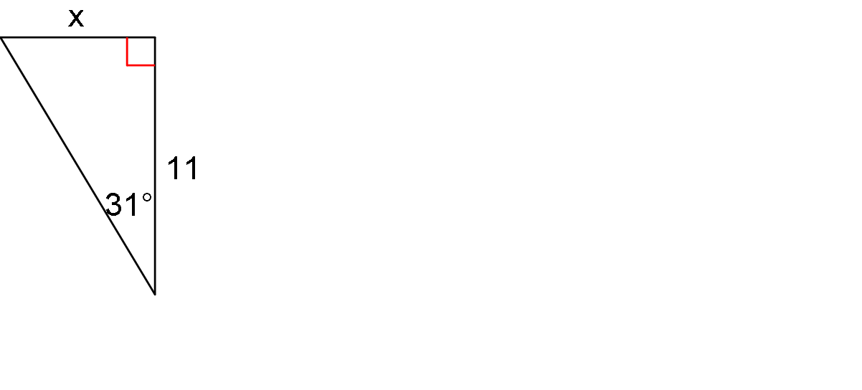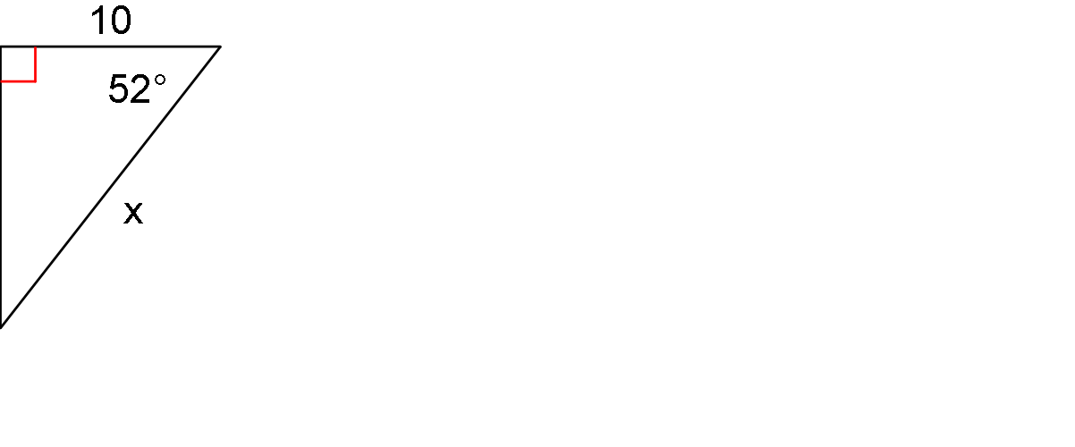

a. b. c.

48. Hannah is looking up at the top of a building at a 75o with the ground. She is standing 36 feet from the building. How tall is the building? Round answer to the nearest tenth.

49. Find *x* to the nearest degree.

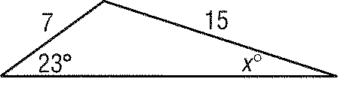

50. A tree grew at a 3° slant from the vertical. At a point 50 feet from the tree, the angle of elevation to the top of the tree is 17°. Find the length of the tree to the nearest tenth of a foot.

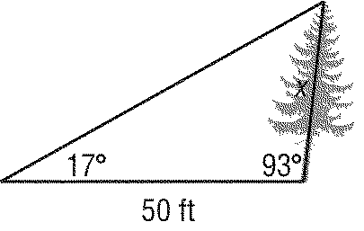

51. Find *x* to the nearest degree.

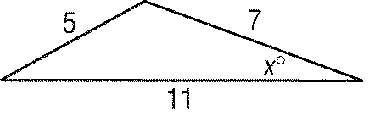

52. To approximate the length of a pond, a surveyor walks 400 meters from point *L* to point *K*, then turns and walks 220 meters from point *K* to point *E*. If *m*<*LKE*  110, find the length *LE* of the pond to the nearest tenth of a meter.

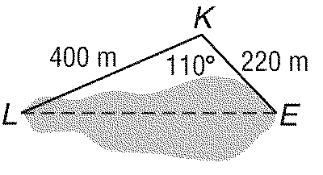

53. Solve *PQR* for *r*  22, *p*  51, and *m*<*Q*  96. Round angle measures to the nearest degree and side measures to the nearest tenth.

54. Solve Triangle PQR, given that: .

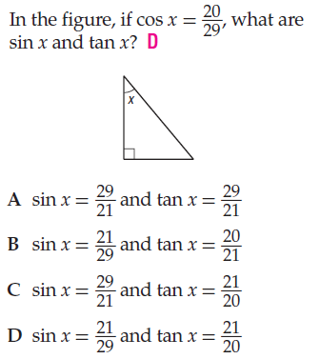

55.

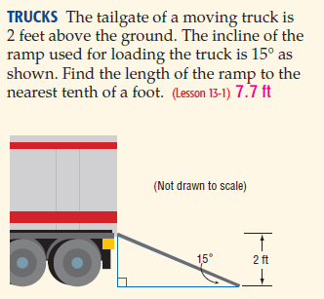

56.



Kelly and Jackie are debating the correct length of the ramp that the movers need in order to move their stuff to their new place. Who is reasoning correctly? Explain who is showing the correct work in complete sentences, support your answer with mathematical vocabulary.

|  |  |
| --- | --- |
| **Jackie’s Work** | **Kelly’s Work** |
|  |  |

57. A gardener installs $3$ sprinklers in a rectangular plot. Each sprinkler waters a circular region with a radius of $5$ cm, as shown below. No portion of the plot is watered by more than $1$ sprinkler. What is the approximate area of the portion of the plot that is NOT watered by a sprinkler? Round to the nearest tenth.

58. The figure below shows two tangent circles where the $4$-inch diameter of the smaller circle is equal to the radius of the larger circle. What percent of the larger circle is shaded?



59. Given the coordinates of the vertices below, find the area of the parallelogram.

A(2,-3), B(7,-3), C(9,2), D(4,2)

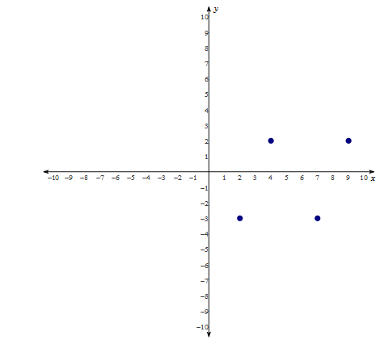

60. Find the area of the trapezoid.

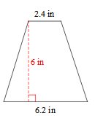

61. The trapezoid below is divided into $2$ triangles and $1$ rectangle. Lengths are given in inches. What is the shaded area?



62. What is the area of the circle?

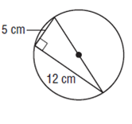

63. Find the area of a circle is the circumference is 20

64. Roy is fencing his tomato garden to protect it from rabbits and deer. If the diagram provided below is his tomato garden, what is the area of the garden to be fenced, in square meters?

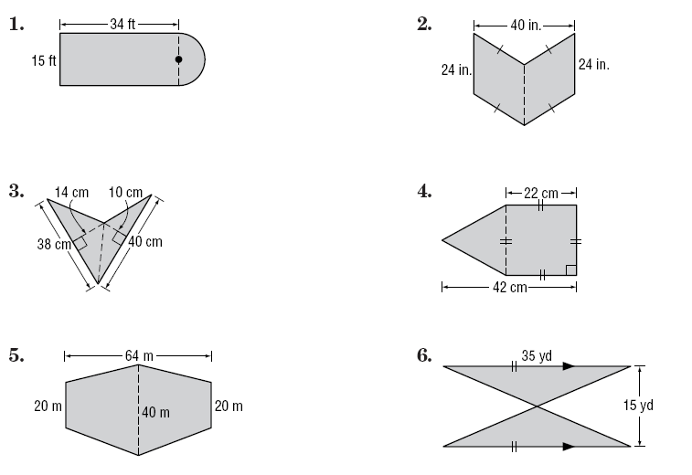

65. Find the area of the following figure.

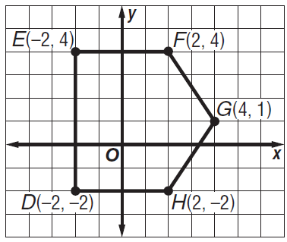

66. Find the area of the circle and the area of the shaded region.

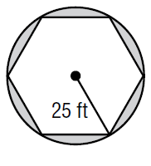

area of the circle: ___________

area of the shaded region:____________

67. The length of arc $XY$ of the following circle is equal to $\frac{1}{8}$ of the circumference of Circle P. The arc length is $3π$ meters. Find the radius, the central angle, and the area of the shaded sector. Round to the nearest tenth.

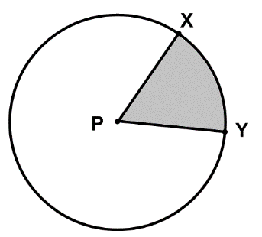

Radius = _________

Central Angle = _________

Sector Area =_________

68. The circle below is graphed from the equation

.

* 1. Graph and write an equation of another circle which is tangent to the one given.
  2. Graph and write an equation of a third circle which is NOT tangent to the circle given, nor the circle from part a, and has a center at the origin.

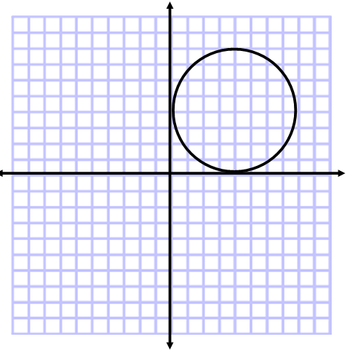

Find the length of each arc. Round your answer to the nearest tenth.

69. Radius = 13 mi and the central angle is 45⁰

70. If the ratio of the circumference of two circles is 4:7, what is the ratio of their radii?

71. Find the length of the segment indicated. Round your answer to the nearest tenth if necessary.

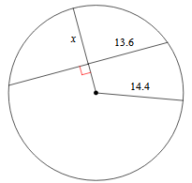

72. Find the perimeter of the polygon. Assume lines which appear to be tangent are tangent.

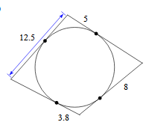

73. Use the information below to answer the questions which follow.

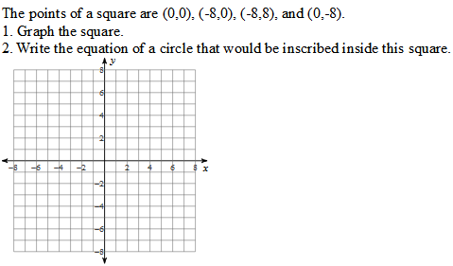

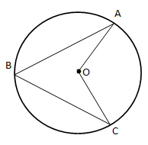

74. If AB = BC, and <ABC = 60⁰:

* 1. What is the measure of <AOC?
  2. If arc $\hat{AC}$ = 126⁰, what is the measure of $\hat{AB}$?

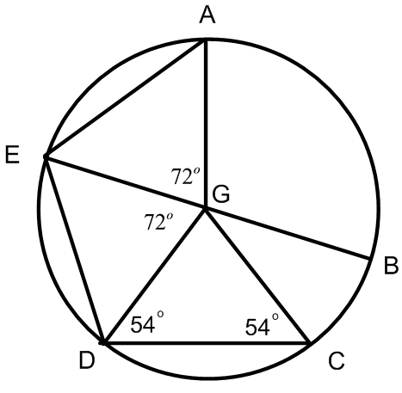75. Given: EB is a diameter of circle G.

True or False? If false, correct the statement to make it true.

* 1. <BGC = 72⁰
  2. AE // CD
  3. <GED = < GDC
  4. <DGC = 54⁰

76. Which function does ***not*** represent this graph?

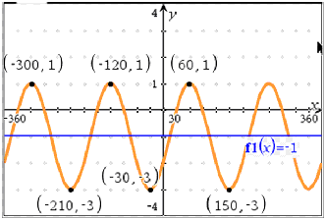

a.  c. 

b.  d. 

77. Which equation is graphed?

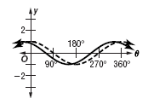

a. *y* = sin ( + 30°) c. *y* = cos ( + 30°)

b. *y* = sin ( – 30°) d. *y* = cos ( – 30°)

78. Graph the function *y* = 5 cos 2+3.

Amp: _________ Period: ________________ VS: __________________PS: ________

79. Graph the function **

Amp: _________ Period: ________________ VS: __________________PS: ________

80. Graph the function **

Amp: _________ Period: ________________ VS: __________________PS: ________

81. Graph the function **

Amp: _________ Period: ________________ VS: __________________PS: ________

82.**Convert each degree measure in radians and each radian measure in degrees. Show work!**

**a.**  **b.** 315°

83. **For questions a and b, find the exact value of each trigonometric function without using the unit circle.**

**A.) Sketch the triangle**

**B.) Show the reference angle**

**C.) Right angle**

**D.) Side lengths**

a.) cos (–300°) b.) tan 

**For #92-98 Show your work or explain how you arrived at your answer by use of the Unit Circle.**

84.  Answer:_____________

85. csc  Answer:_____________

86.  Answer:_____________

87. . Answer:_____________

88. sin (). Answer:_____________

89. sin  Answer:_____________

90.  Answer:_____________

91. 3(sin 120°)(cos 120°) Answer:_____________

92. If cos *A* =, in quadrant I, find 

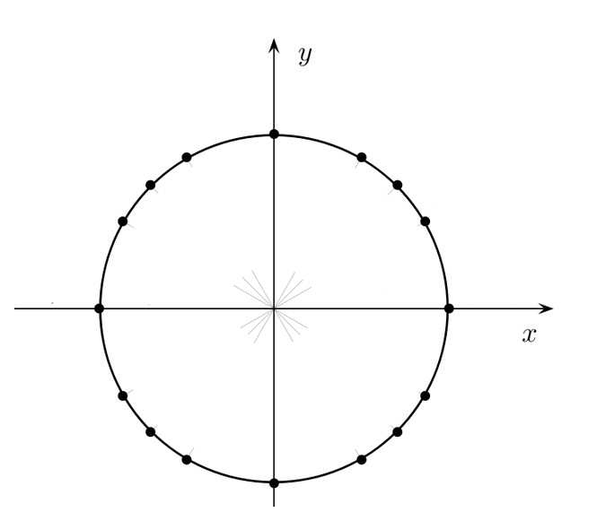93. Complete the unit circle.