Name: ______________________________________________________________________
3-2 Notes
Flipped Classroom

When a transversal intersects 2 parallel lines, ____________angles are formed.
These angles are given special names and have special relationships.

Please note the following properties.

Alternate interior angles are congruent.
Alternate exterior angles are congruent.
Corresponding angles are congruent.
Consecutive interior angles are supplementary.

Practice Example:
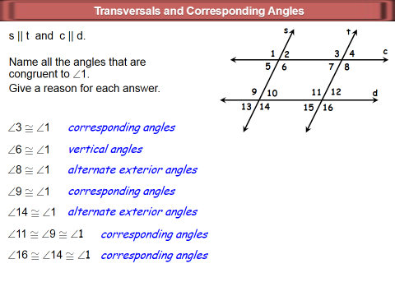

Now Complete: 3.2 Study Guide and Intervention pg. 13

