HW: 3-6 Perpendiculars and Distance

Construct the distance that represents the given information.
1. 2.

Find the distance between the line and the given point.

3. 4.

Find the distance between each parallel lines.
5.

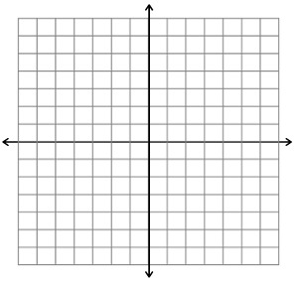
6.

7.

8.

9.

10.

