**Acc Geometry Name___________________________**

**4.1 & 4.2 Practice Date_______________**

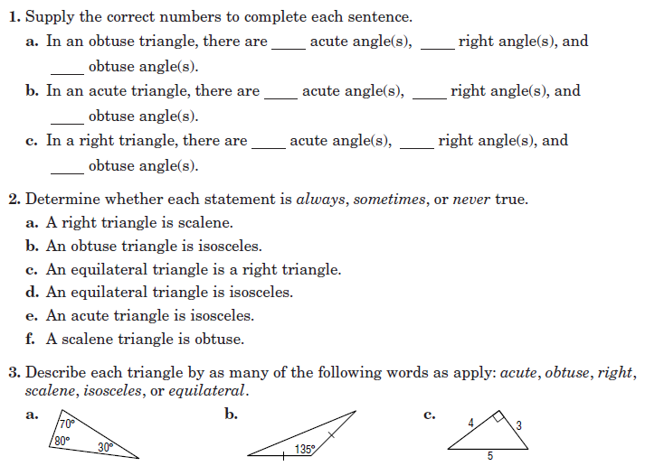

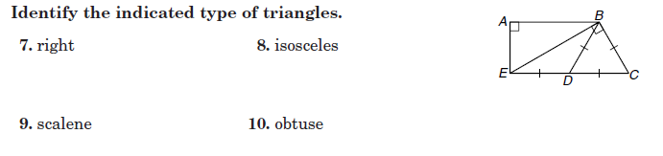

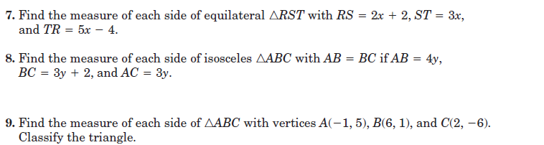



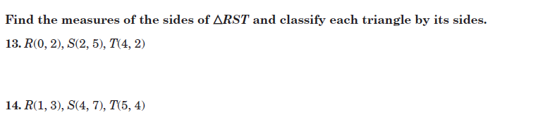

RS =____________ ST =______________ RT= _____________________ Classification:_____________________



RS =____________ ST =______________ RT= _____________________ Classification:_____________________

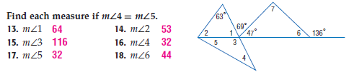



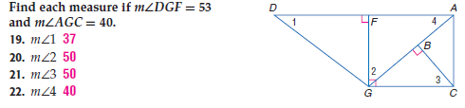

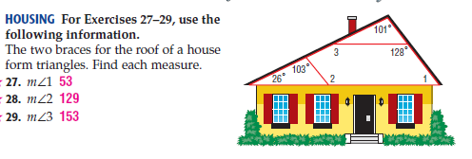

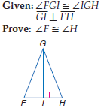

127°