Acc Geometry Name_____________________
Practice Ext Angle Thm & Side-Angle Inq (4.2 & 5.2) Date_________

Determine the relationship between the measures of the given angles.

1. $∠MJY__________∠JYM$

2. $∠AKJ__________∠JAK$

3. $∠JSY__________∠JYS$

Determine the relationship between the length of the given sides.
4. $\overline{SR}___________\overline{ZS}$

5. $\overline{ZY}___________\overline{RZ}$

6. $\overline{TY}___________\overline{ZT}$

List the sides of Triangle PQR in order from shortest to longest for the given angle measures.

7.

Arrange the unknown measures in order from greatest to least.
8.

9. Hector and Grace each labeled $∆QRS$. Who is correct? Explain.
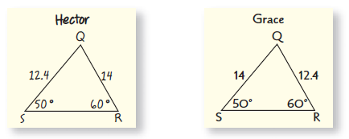

Solve for x or find the indicate angle measure.
17)
16)
15)
14)

18. Explain why $∆PQS$ is isosceles.

