Acc Geometry Name___________________________
4.6 Isosceles & Equilateral Proof Notes Date_______________

Isosceles Triangle Theorems
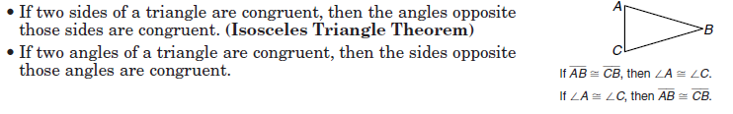
Prove the Isosceles Triangle Theorem:
Given: $PQ≅RQ$ and $SQ⊥RP$
Prove: $∠P≅∠R$

Prove:
The Converse of the Isosceles Triangle Theorem states:
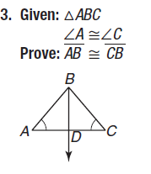

Equilateral Triangle Theorems
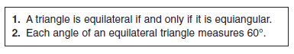
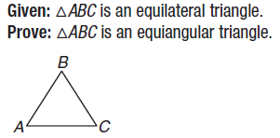
1.

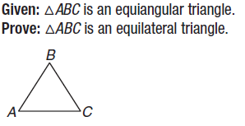
2.

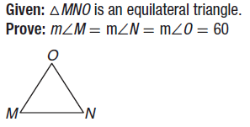
3.

4.6 Examples

1. m<CFD 2. m<AFB 3. m<ABF 4. m<A

5. Find x. 6.
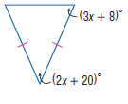

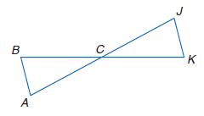
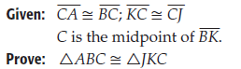
7.

