Acc Geometry Name___________________________
4.6 Isosceles & Equilateral Proof Practice Date_______________

Isosceles Triangle Theorems
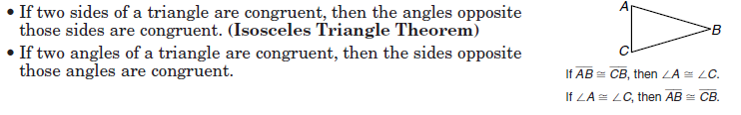
Equilateral Triangle Theorems
