5.1 Notes: Coordinate Geometry

The vertices of ∆ STU are S(0,1), T(4,7), and U(8,-3)



**Example 1. Find the ORTHOCENTER.**

The ORTHOCENTER is the point of concurrency where the altitudes of a triangle meet.

Step 1: Find two equations of the altitudes to two sides of the triangle. (Altitudes must be

perpendicular to the side of the triangle and through the opposite vertex)

Find slope perpendicular to the side of the triangle

Write the equation through the point opposite the side

Step 2: Find their point of intersection. (i.e. solve the system).

The vertices of ∆ STU are S(0,1), T(4,7), and U(8,-3)



**Example 2. Find the Centroid**

The CENTROID is the point of concurrency where the medians of a triangle meet.

Step 1: Find two equations of two medians. (Recall medians connect the vertex to the opposite sides midpoint)

Find the midpoint of the side of the triangle.

Find the equation of the line through the two points (vertex and midpoint)

Step 2: Find their point of intersection. (i.e. solve the system).

The vertices of ∆ STU are S(0,1), T(4,7), and U(8,-3)



**Example 3. Find the Circumcenter**

The circumcenter is the point of concurrency where the perpendicular bisectors of a triangle meet.

Step 1: Find two equations of two circumcenters. (Recall perpendicular bisectors go through the midpoint of a side and are perpendicular to that side.)

Find the midpoint of the side of the triangle

Find the equation of the line perpendicular to the side THROUGH the midpoint.

Step 2: Find their point of intersection. (i.e. solve the system).

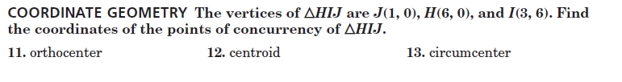5.1 HW: Coordinate Geometry

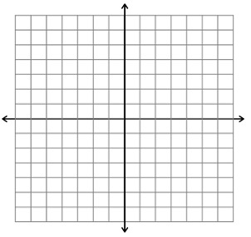

1. Centroid

2. Circumcenter

Pg. 274 #3



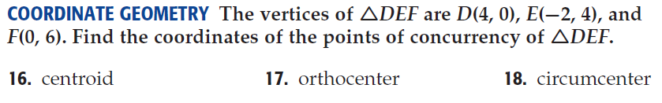Pg. 275 #16-22



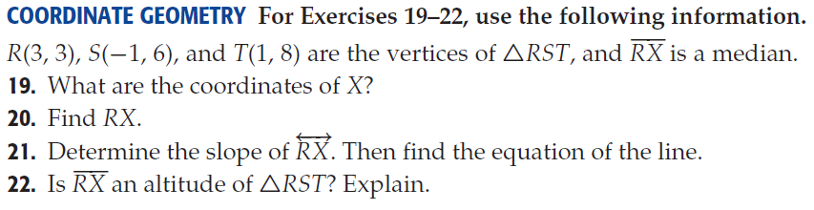



**Solutions:**

1. (10/3, 2) 2. (7/2, 5/2) 3. (-17/38, -7/38) 16. (2/3, 10/3)

17. (-4/5, 24/5) 18. (7/5, 13/5) 19. (0,7) 20. 5 units

21. m = -4/3; y=-4/3x+7 22. No, slopes are not perpendicular.