Name: ____________________________________________________________________________________
7.1 and 7.2 Homework
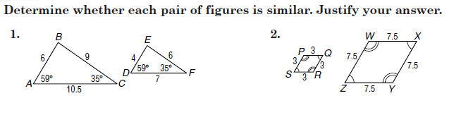

A. Write the similarity statement.
B. Find the scale factor.
C. Find x.
D. Find the measure of the indicated side

3. A. Quad ABCD_____________

B. ______________

C. _____________

D. GH=___________

4.

A. ∆XYW ~______________

B. ______________

C. ______________

D. ST=____SU= ____

5.
A. Quad PQRS~______________

B. ______________

C. ______________

D. WT=__________

6.
A. ∆LMN ~______________

B. ______________

C. ______________

D. TS=_____SP= ____

