Name: \_\_\_\_\_\_\_\_\_\_\_\_\_\_\_\_\_\_\_\_\_\_\_\_\_\_\_\_\_\_\_\_\_\_\_\_\_\_\_\_\_\_\_\_\_\_\_\_\_\_\_\_\_\_\_ Date: \_\_\_\_\_\_ HR: \_\_\_\_

8.1-8.7 (After Break Intervention)

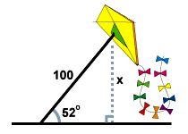**Draw a picture if one is not provided. Find all values to the nearest tenth. Show all work to receive full credit!*x* = 10 sec(20) latex_img1510.64 . The second boat must travel about 10.6 miles to get as far west as the first boat.**

[**Close**](http://www.sparknotes.com/math/trigonometry/solvingrighttriangles/problems_1.html#explanation1#explanation1)

1. A man flies a kite with a 100 foot string. The angle of elevation of the

string is 52 o . How high off the ground is the kite?

*x* = 100 sin(52) latex_img1578.8 . The kite is about 79 feet above the ground.

[Close](http://www.sparknotes.com/math/trigonometry/solvingrighttriangles/problems_1.html#explanation2#explanation2)

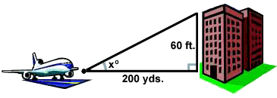2. An airplane takes off 200 yards in front of a 60 foot building. At what angle of elevation must the plane take off in order to avoid crashing into the building? Assume that the airplane flies in a straight line and the angle of elevation remains constant until the airplane flies over the building. (3 feet = 1 yard)

*x* = arctan(latex_img28) latex_img155.72 o . The plane must take off at an angle of elevation of about 5.72 o in order to avoid hitting the building.

[Close](http://www.sparknotes.com/math/trigonometry/solvingrighttriangles/problems_1.html#explanation3#explanation3)

3. A person stands at the window of a building so that his eyes are 12.6 m above the level ground. An object is on the ground 58.5 m away from the building on a line directly beneath the person. Compute the angle of depression of the person’s line of sight to the object on the ground.

*x* = arcsin(latex_img31) latex_img1568.3 o . The ladder must be situated with about a 68.2 o angle of elevation in order to reach the top of the wall.

[Close](http://www.sparknotes.com/math/trigonometry/solvingrighttriangles/problems_1.html#explanation4#explanation4)

4. From a plane flying due east at 265 m above sea level, the angles of depression of two ships sailing due east measure 35° and 25 °. How far apart are the ships?

5. Tom and Sam are on the opposite sides of a tower of 160 meters height. They measure the angle of elevation of the top of the tower as 40° and 55° respectively. Find the distance between Tom and Sam.

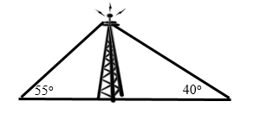

6. A man on the deck of a ship is 13 ft above water level. He observes that the angle of elevation of the top of a cliff is 40° and the angle of depression of the base is20°. Find the distance of the cliff from the ship and the height of the cliff if the base of the cliff is at sea level. (Find, x, y, and z)

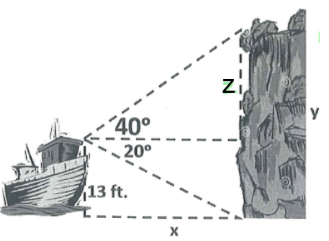

7. Bert is building a kite using side lengths of 2 feet and 3 feet. The long vertical dowel to construct the kite is 4.12 ft. find the measure of the angle that the 2 foot edge makes with the 3 foot edge.

[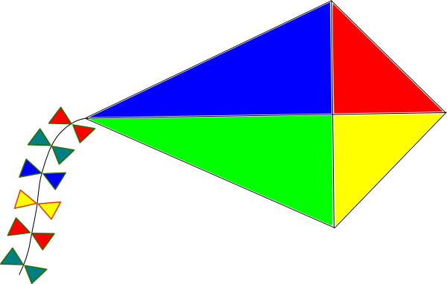](http://www.google.com/url?sa=i&rct=j&q=&esrc=s&source=images&cd=&cad=rja&uact=8&ved=0ahUKEwjDoMyUy5DLAhXCkoMKHWaSBTEQjRwIBw&url=http://clipartion.com/free-clipart-8534/&psig=AFQjCNFFnGhOXtEDXss8MS17VsRGbtGwiw&ust=1456409696714575)

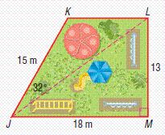

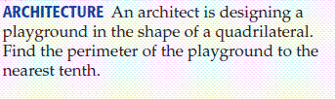

8.

9. In a scalene triangle, one side is 12 feet and another side is 20 feet. The angle opposite 20 feet is 83 degrees. Find the measure of the angle opposite the side that is 12 feet.

10. A tree grew at a 3° slant from the vertical. At a point 50 feet from the tree, the angle of elevation to the top of the tree is 17°. Find the length of the tree to the nearest tenth of a foot.

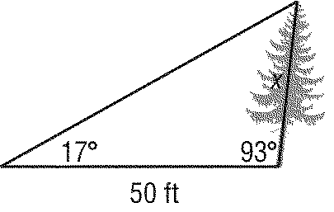

11. The angle of elevation from a point on the street to the top of a building is 29°. The angle of elevation from another point on the street, 50 feet farther away from the building, to the top of the building is 25°. To the nearest foot, how tall is the building?

b°

a°= \_\_\_\_\_\_\_\_\_\_\_\_\_\_\_\_\_\_

y

x

b°= \_\_\_\_\_\_\_\_\_\_\_\_\_\_\_\_\_\_

a°

25°

29°

x = \_\_\_\_\_\_\_\_\_\_\_\_\_\_\_\_\_\_

50 ft

height of building y: \_\_\_\_\_\_\_\_\_\_\_\_

12. Which set of measures could represent the sides of a right triangle?

a. 9, 40, 41 b. 8, 30, 31 c. 7, 8, 15 d.

Directions: For the following questions, find the variables as exact values.

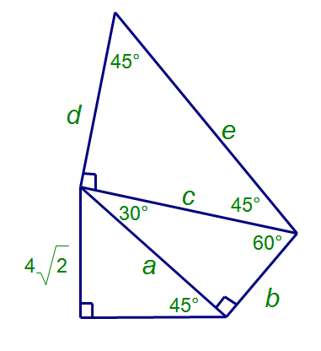

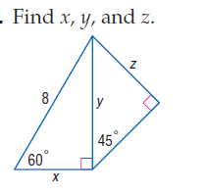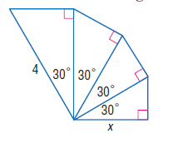13. 14. 15.

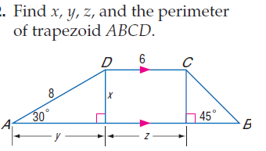

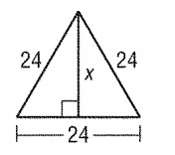16. 17. 18. Find the perimeter

of the trapezoid.

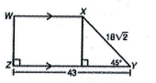

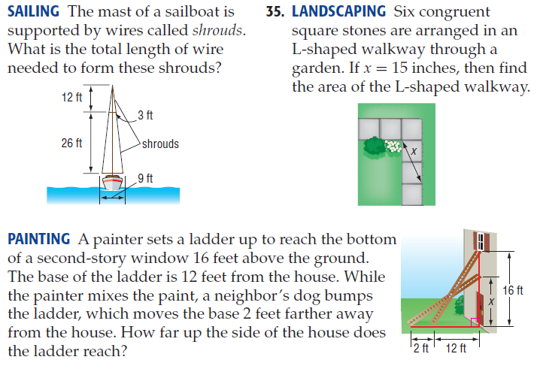18.



19.

Directions: For the following questions round to the nearest tenth.

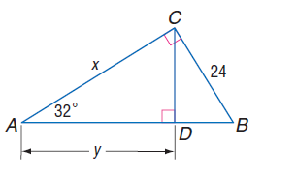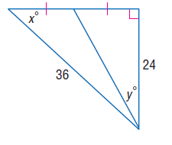

20. 21.

22. If the length of one leg of a right triangle is 4 times the length of the other and the hypotenuse is 30in, find the exact length of the shorter leg. This is not a special right triangle.

23. If x = 16, y = 30, and z = 34 in the right triangles, find the 6 trigonometric ratios.

24. If tan = find sin $θ$ and cos $θ.$