**8.7 Law of Cosines Notes**

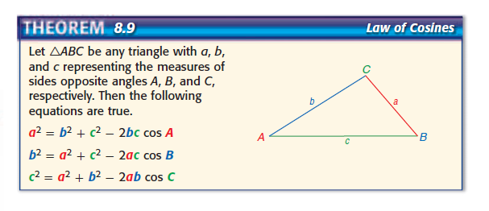

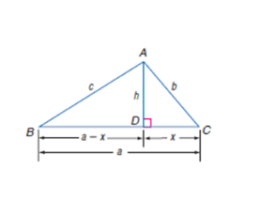**Proof of Law of Cosines**

**Given: nonright ∆ABC**

**Prove: $c^{2}=a^{2}+b^{2}-2ab\cos{C}$**

**When do I use the Law of Cosines to solve?**

**Ex1**

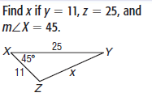

**Ex2**

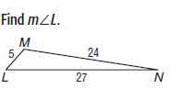

**Ex 3 Application**

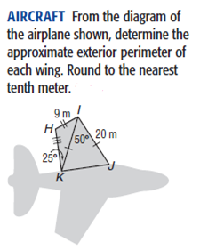

110o

**Ex4 **

