9.1-9.3 Reflections/Rotations/Translations- Review

ROTATIONS ON A PLANE
1 Rotate the triangle 60º counterclockwise about point G

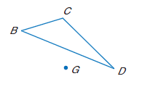

2. Reflect Triangle HJK over line m.

3. Reflect triangle KMN over the x-axis. K(2, -4), M(-4,2), N(-3,-4).

4.Lines of symmetry:

How many lines of symmetry does a square have?

Does it have a point of symmetry?

5: Translate triangle PQR down 2 units and right 2 units. P(-2,-4), Q(-1,2), R(2,1).

6: Rotate triangle ABC 50° cw (clockwise) around point F.

7: Rotate triangle DEF 120° ccw (counter clock wise)a round point G.

8Ex: Rotate triangle FGH 90° ccw around the origin. F(2,2), G(4,1), H(5,4).

