Name: _________________________________________ HOUR: _____________Due Date: __________________

*2014 ACC Geometry Midterm Review*

Directions: This review consists of problems that could be on your midterm. Make sure you complete each problem and **show your work.**

1. For equilateral ∆RST, find the variable and the side lengths. All units are in inches.

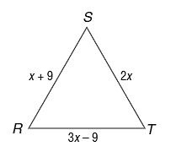

1. For isosceles ∆RST, find the variable and the side lengths. All units are in centimeters.

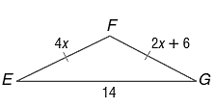

1. Find the missing angle measures, *m*<1 and *m*<2.

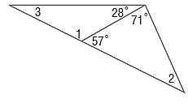

1. Find the missing angle measures.

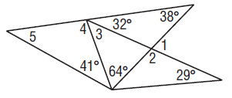

1. Find the missing angle measures.

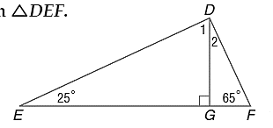

1. Do any of the following sets of numbers create a triangle?
   1. 7, 20, 10
   2. 7, 9, 12
   3. 16, 10, 9
   4. $\sqrt{13}$, 6, 6
$7, 18, 11$

2. What are the missing coordinates of the triangle?

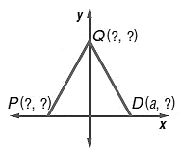

1. What are the missing coordinates of this isosceles right triangle?

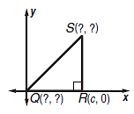

1. What is the shortest distance from P to line n?

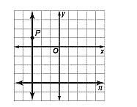

1. What is the shortest distance from point B to segment AC?

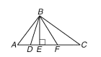

1. If FH is a median of ∆EFG, find the perimeter of ∆EFG.

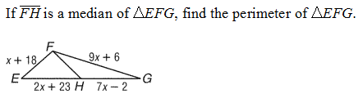

1. Find x.

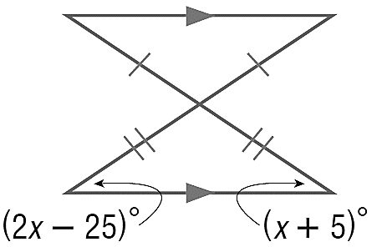

1. In the figure below, B is on , E is on ,  is parallel to , and  is congruent to .. Name the legs of the isosceles triangle, name the base angles and vertex angle of the isosceles triangle, and provide an example of an exterior angle. What is the measure of <DEB and <EBF?

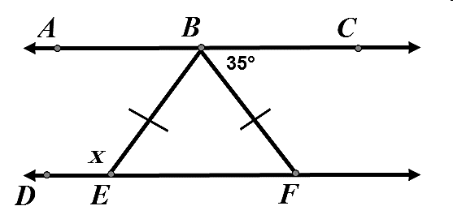

1. Identify the triangle ∆CAB is congruent to, then name all corresponding parts. There should be 6 pairs.

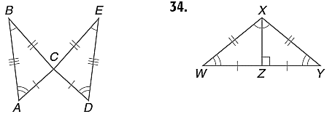

1. Identify the triangle ∆XZW is congruent to, then name all corresponding parts. There should be 6 pairs.



1. Write a two-column proof.

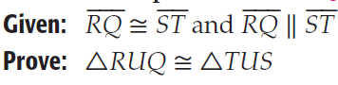

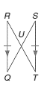

1. Write a two-column proof.

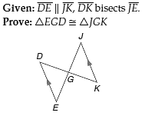

1. Write a two-column proof.

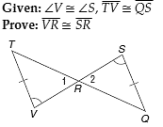

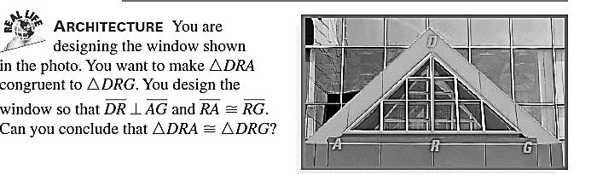

1. Write a two column proof using the stingray below.

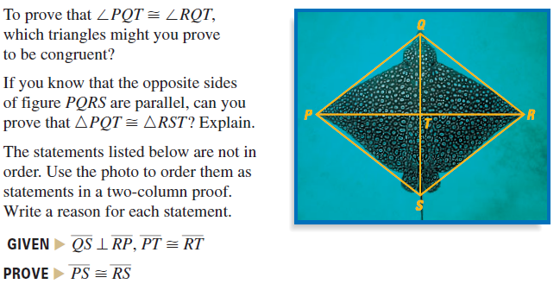

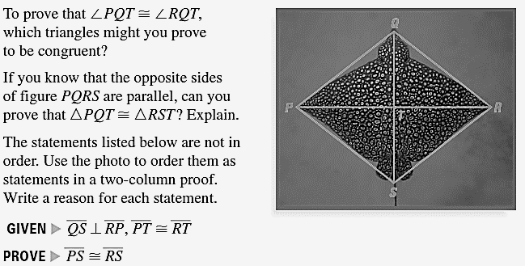

1. 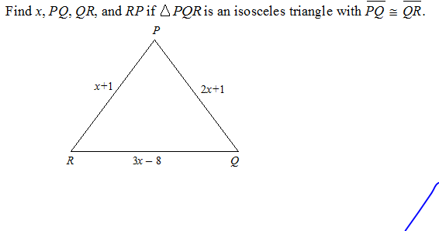
2. **BASEBALL** Alan, Brendon, and Carl were standing in a triangular formation shown. They were throwing the baseball to warm up for the game. Find the value of x, the measure of each angle and then conclude what two people must throw the farthest distance.

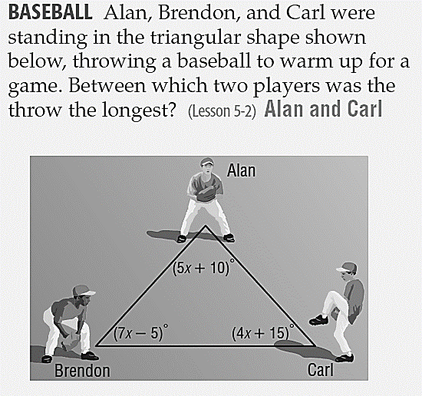

1. 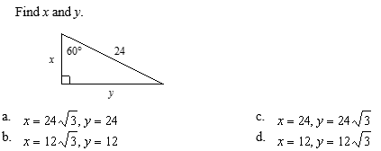
2. 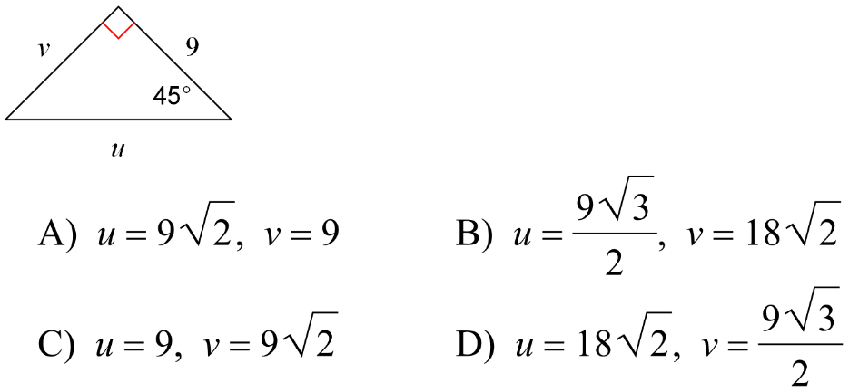
3. Find x.

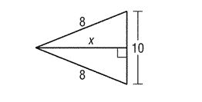

1. 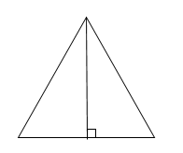 Find the altitude of an equilateral triangle whose sides are 20 cm long.

20 cm

1.  Find the altitude of an equilateral triangle whose sides are 12 in long.

12 in

1. Find the hypotenuse of a right triangle where one leg is twice the other leg.

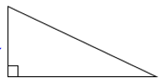

x

2x

1. Find the hypotenuse of a right triangle where one leg is 4 times the other leg.

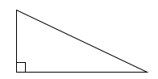

x

4x

1. Find x, the interior sum, exterior sum, and <M.

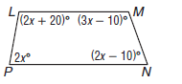Interior Angle Sum = _________

Exterior Angle Sum = ________

x = ________

<M = ________

1. Find x, the interior sum, exterior sum, and <G.

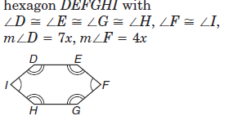Interior Angle Sum = _________

Exterior Angle Sum = ________

x = ________

<G = _______

1. Write a coordinate proof.

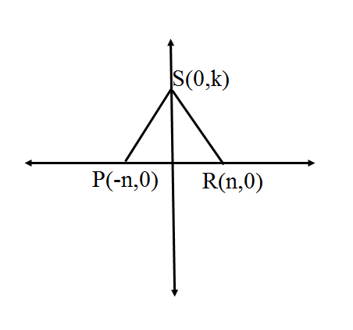**Given:** Coordinates of vertices of ΔSPQ and ΔSRQ.

**Prove:** ΔSPQ $≅$ ΔSRQ

1. Write a coordinate proof.

**Given:** Coordinates of vertices of ΔACD and ΔCAB.

**Prove:** ΔACD $≅$ ΔCAB

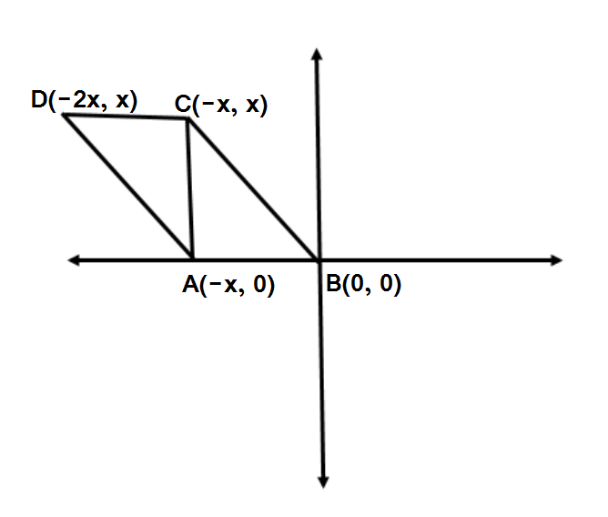

1. Find the distance between points S and T.

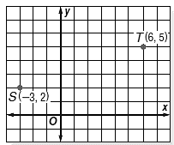

1. 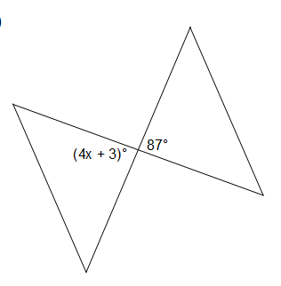Find the value of x.

1. What is the degree measure of the larger of the two angles?

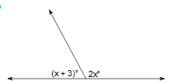

1. 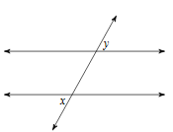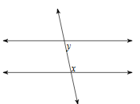Name the relationships.
2. Find x so that lines l and k are parallel, given $<2=27x+2$ and $<5=18x-2$.

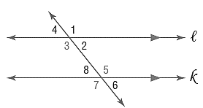

1. Find x so that lines l and k are parallel, given $<4=17x$ and $<6=-5+18x$.



1. Name all the relationships that allow us to say l is parallel to k.

$<1≅<7$ proves $l||k$ because

$<2≅<8$ ________________________

proves $l||k$ because

$<3≅<7$ ________________________

proves $l||k$ because

$<3+<8=180$ ________________________

proves $l||k$ because ________________________

1. 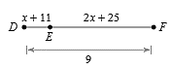Find x, then the length of EF. Show your work, geometry and justify your set up!
2. Point M is the segment bisector of lines AC and BD. Find x, y, and BM. Show your work, geometry and justify your set up!

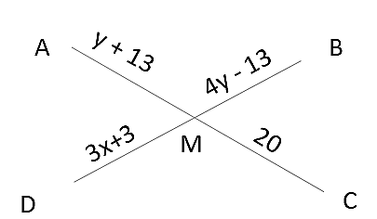

1. 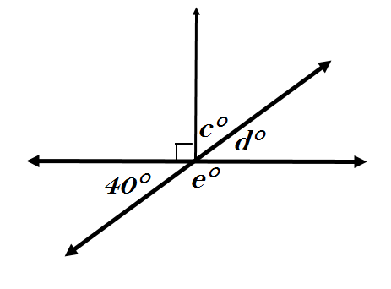Find all the missing angle measures. Then find the value of 2d – 3(e – c).
2. 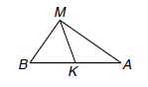 Given the following triangle with angle bisector MK state if the following statements are true or false.

a. $m<MKA = 90ᵒ$

b. $BK ≅ AK$

c. $m<BMK = m<AMK$

d. ∆BMA is isosceles with vertex angle M.

1. 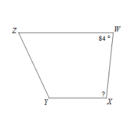Find the missing angle in the following trapezoids.

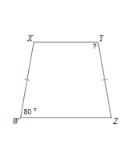 a. b.

1. Given that the following are parallelograms, find x.

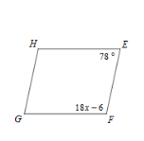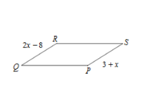a. b.

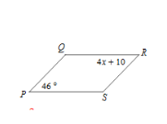

c.

1. Find x for the following quadrilaterals:

a. Suppose VWXY is a rectangle and b. Suppose ABCD is a square and

XV= 4x - 9 and WY = x + 3 AC = 9y – 8 and BD = 7y +8

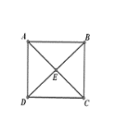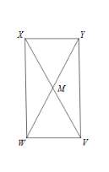

1. a. $ABCD$ is a rectangle with $B\left(5, -3\right), C\left(5, -6\right),$ and $D(9, -3)$. Find the coordinates of $A.$

b. $ABCD$ is a rectangle with $B\left(10, 7\right), C\left(10, 4\right),$ and $D(8, 4)$. Find the coordinates of A.

1. Given the set of vertices, choose all that apply: Quadrilateral, Parallelogram, Rectangle, Rhombus, and/or Square.

a.

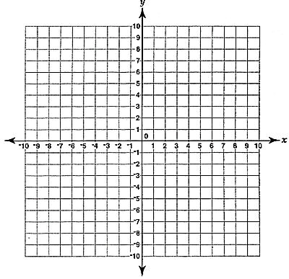

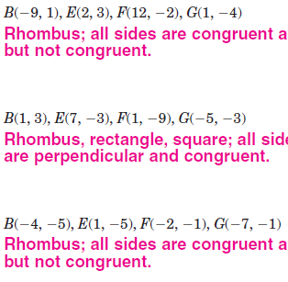

b.

c.

1. a. In a heptagon, one interior angle measures $35$ degrees. What is the total measure of the other $6$ interior angles?

b. In a nonagon, one interior angle measures $120$ degrees. What is the total measure of the other $8$ interior angles?

1. a. Given an isosceles trapezoid with height 3m and bases 18m and 26m. Find the perimeter, in meters.

b. Given an isosceles trapezoid with height 8 m and bases 13 m and 25 m. Find the perimeter, in meters.

1. 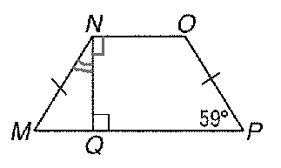For isosceles trapezoid *MNOP*, find m<M, m<MNO and *m*<*MNQ*.

m<M= ___________ m<MNO= ________ m<MNQ= ______________

1. Find m< 1 if m<K=118.

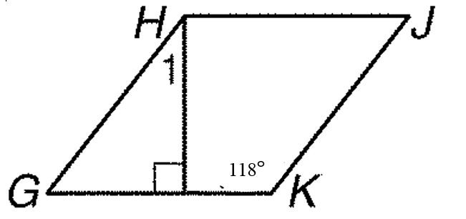

1. If  and triangle ABC is reflected over line m first, then line n, what transformation would occur from $∆$ ABC to $∆$ A”B”C”?



a. reflection

b. dilation

c. rotation

d. translation

1. If LMNO is reflected over line k first, then line m, what transformation would occur from LMNO to L”M”N”O”?

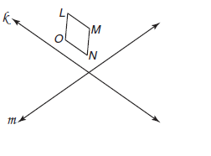

a. reflection

b. dilation

c. rotation

d. translation

1. Given point A(6, -1), find its image if it is reflected across the y-axis.
   1. (-6, -1) b. (6, -1)
2. (-6, 1) d. (-1, 6)
3. Given the point (x, y), write the image point if it is reflected across the x-axis.

1. What is the image of Y(-7, 4) under the translation (x,y) $→$ (x + 5, y)?
2. What is the pre-image of X’(2, 5) under the translation (x,y) $→$ (x - 1, y + 2)?
3. Find the reflection of the point A(6, -1) across the line y = x.
4. Symmetry: How many lines of symmetry does a(n) ….
   1. Square have? ________
   2. Rectangle have? ________
   3. Isosceles Trapezoid have? ________
   4. Isosceles Triangle have? ________
   5. Equilateral Triangle have? ________
   6. Pentagon have? ________
5. Graph the image of the figure with 63. Graph the image of the figure with a   
   a reflection across y = 2 reflection across y = x

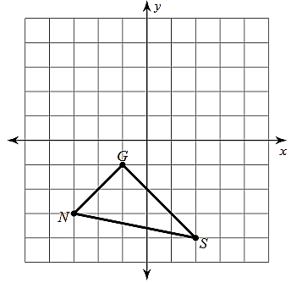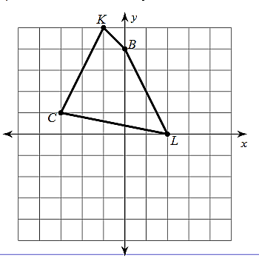

1. Graph the image of the figure 65. Graph the image of the figure with a   
   with a rotation $90°$ counterclockwise rotation $90°$ clockwise about the origin.

about the origin.

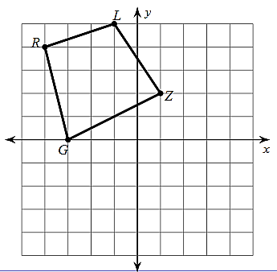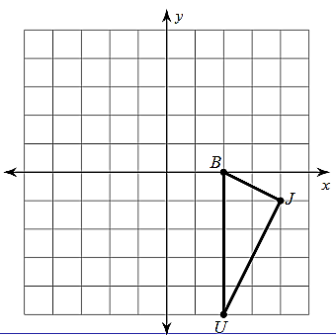

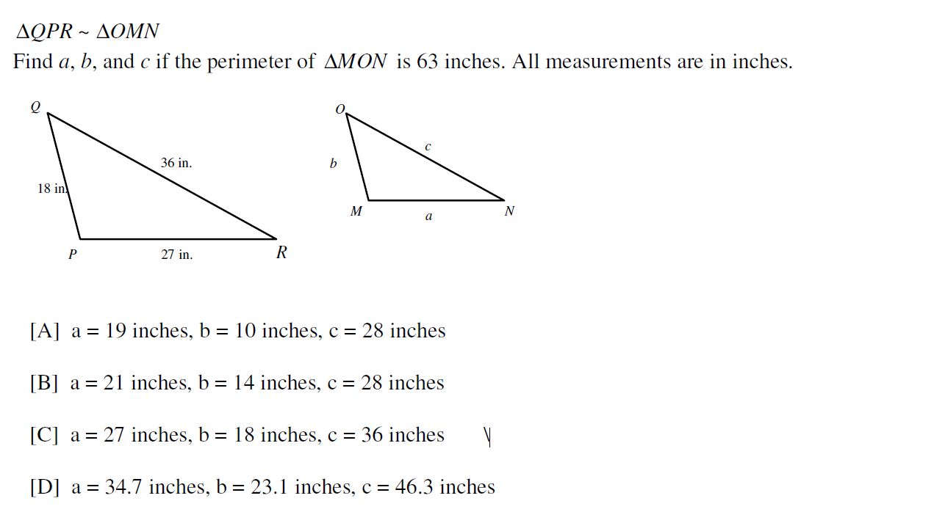

66.

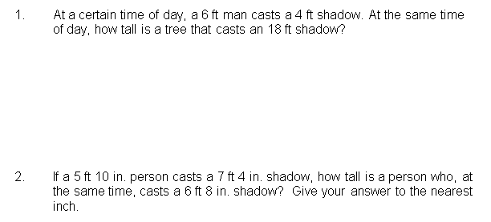

67. .



68.

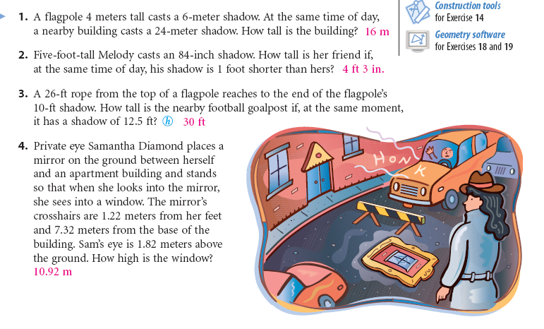

69.

**Directions:** Solve each problem and show a diagram with each question which accurately labeled measurements.

70. At a specific time of day, a flag pole has a shadow 8ft 4in long, at the same time of day Jose who is only 4ft 6in tall has a shadow of 3ft 4in long. Find the height of the flagpole. Please leave final answer as an exact value, no rounding!

The flagpole is: _____ft _____in

71. Nicole wants to find out the height of her favorite pine tree so that she can fit it in her house for Christmas. She stands within the tree’s shadow and walks until her shadow meets the trees shadow. Nicole is 152.4cm tall. Her feet are 91.44cm from the base of the tree. She also knows that the tree has a shadow of 274.32cm long at this time of day. Help Nicole find the height of her favorite tree. If she can fit a 250cm tree in her living room, will this tree fit for the holidays? Explain. Please leave final answer in cm and round to the nearest hundredth.



Height of tree: _____________

Can she use the tree for Christmas? _______________

**Explain…..**

72. Forget Twitter stalking, Noah is going old school! Noah knows his next-door neighbor, Alexis is having a “girls night” and wants get a rope to climb up to the window and scare the girls. He doesn’t want it took look obvious that he is looking in her window but he took Accelerated Geometry at DHS and knows exactly what to do. Noah eyes are 5.5ft above the ground. He places a mirror on the ground and walks away 6ft until he can see in her window. He knows the mirror is 15ft away from the base of her house. Find out how high the window is so he can get a rope to climb up to the window and scare the girls. Simplify your final answer and fill in the given blanks.

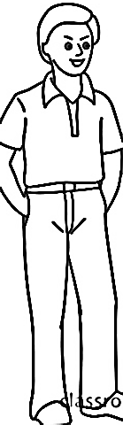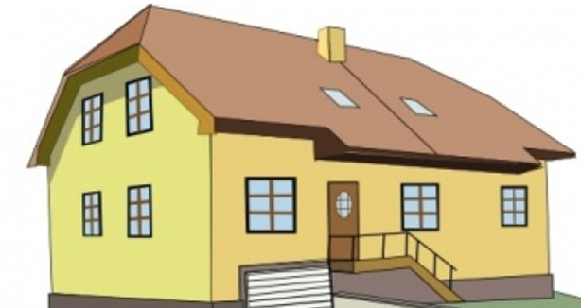

The flagpole is: _____ft _____in

73. The local fire academy is practicing evacuating a hotel. Two teams are going through two windows. Window one, 12 feet above the ground and the other "z” ft above the ground. They are using a 15ft ladder to get to the lower window and a 45ft ladder to get to the higher window. Find z, the distance between the short ladder and the building (x), the distance between the two ladders (y) and the distance between the two windows with the ladders. Keep answer in feet and round to the nearest tenth if needed.

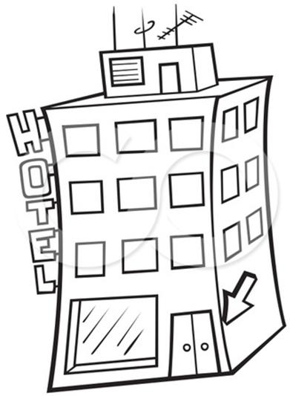

X= ______________

Y= _______________

**z**

45ft

15ft

z= _______________

y

**x**



74. How wide is the river?

Round to the nearest tenth of a foot.

**36 ft**

**A**



**E**

**C**

**D**

**48 ft**

**70 ft**

**River**

75. The perimeter of ABC = 54 inches, a = 6 inches and the perimeter of APQ = 18 inches.

ABCAPQ. Find b, x, y, and z.

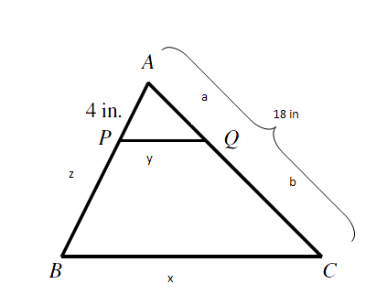

|  |  |
| --- | --- |
|  | b = ____________  x = ____________  y = ____________  z = ____________ |

7.



76.

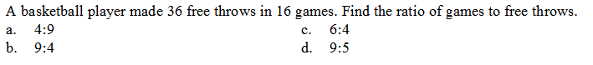77.

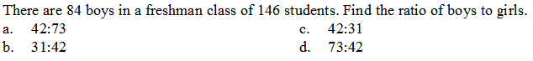78.

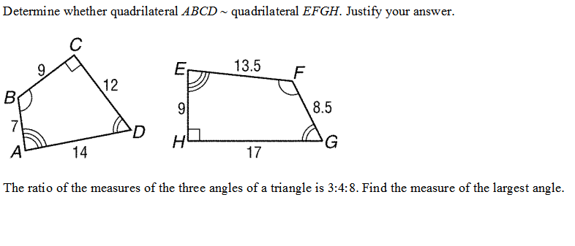79.



80.

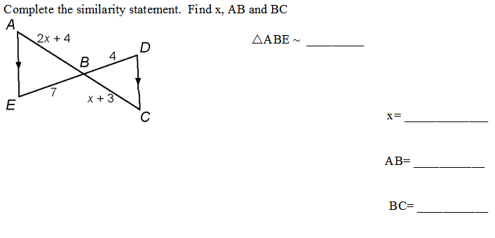81.



82.



83. State the similarity statement and find LM.

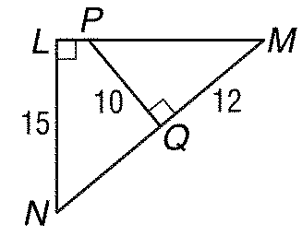

84. State the similarity statement and find x.

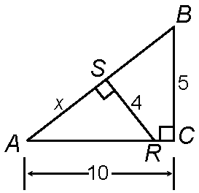

85. State the similarity statement and find x.

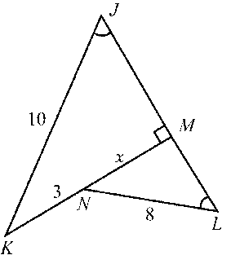

86. Find x.

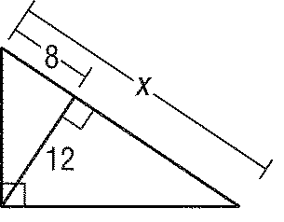

87. Find x.

