Name: ___________________________________________________ Date: _______________Hour:_______
ACC Geometry Basic Area Graded Assignment

1. Find the exact area. 2. Find the area, round to the nearest tenth.
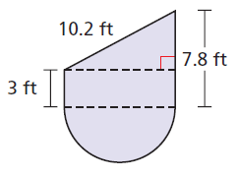

A= ________________ A = __________________

3. 4.

ML = ___________ FH= _____________
5. Find the area of ∆ABC. Show all work. Round each step to the nearest hundredth.
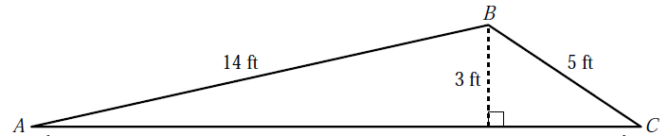

A = _________________
Area Applications – CCSS
6. Katie is using the given plan to convert part of her lawn to a xeriscape garden. A newly planted xeriscape uses 17 gallons of water per square foot per year. (a) Find the area of her garden (round to the nearest hundredth). (b) How much water will the garden require in one year? (c) The lawn that Katie is replacing requires 79 gallons of water per square foot per year. How much water will Katie save by planting the xeriscape garden per year?
(a) _______________

(b) _______________

(c) _______________

7. A plastic flying disc is circular and has a circular hole in the middle. If the diameter of the outer edge of the ring is 13 inches and the diameter of the inner edge of the ring is 10 inches, what is the exact area of the plastic ring?

Area of plastic ring = _________________
8. You have a part-time job at a school. You need to buy enough grass seed to cover the school’s soccer field. The field is 50 yards wide and 100 yards long. The instructions on the seed bags say that one bag will cover 5,000 square feet. How many bags do you need?

How many bags do you need? ___________________
9. You are making a triangular flag with a base of 24 inches and
an area of 360 square inches. How long should the flag be?

h = ______________

10. Dominick and Ramy are painting a stage backdrop for a play. The paint they are using covers 90 square feet per quart. How many quarts of paint should they buy to paint the figure below?

____________ Quarts

11. Mrs. Faehner will be tiling the area labeled tile, fireplace and hearth. She will be putting new carpet down in the family room and hardwood floors in the kitchen. She only has $5000 for her rennovation budget. (a) Find the area needed for each MATERIAL. (b) If the woodflooring costs $10 per square foot, the tile costs $3 per square foor and the carpet costs $3.30 per square foot, does your assistant principle have enough money (with tax) to complete this rennovation? Show all work.
(a) Area needed for:
Tile= ________________

Wood= ______________

Carpet= ______________

(b) How much will the total be for the renovation without tax? _____________
Tax = ___________
Total=_____________________
Will she be able to renovate? _____________________
