Name: _______________________________________________ DUE: ______________ HOUR: ______

**2018/2019 Accelerated Geometry Final Exam Review**

**Note to students:**

The semester exam will assess several content themes: right triangle trigonometry (24%), vectors (12%), circles (22%), area, surface area and volume (26%), and trigonometric functions/unit circle (16%).

**Right Triangle Trigonometry “Need to Know”**

* What is the Pythagorean Theorem? What is important to remember about the hypotenuse?
* What is a Pythagorean Triple?
* What are the side lengths for a 30-60-90 triangle with a hypotenuse of length 2?
* What are the side lengths for a 45-45-90 triangle with a leg of length 1?
* What are the Law of Sines and Law of Cosines? When do you use these laws?

20

48

52

20

48

1. Is the quadrilateral in the diagram a rectangle?   
   Explain how you know.
2. If the altitude is 6 $\sqrt{3}$, what is the perimeter of the equilateral triangle?

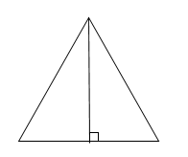

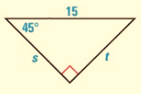

|  |  |
| --- | --- |
| 1. Find x and y. | 1. Find s and t. |

x

y

$$20\sqrt{3}$$

1. Find the lengths of the hypotenuses of these right triangles.

$$8x$$

x

$$9x$$

x

$$\sqrt{5}$$

x

1. In the figure, tan x = $\frac{9}{40}$. Find cos Y, cos X, sin Y, sin X.

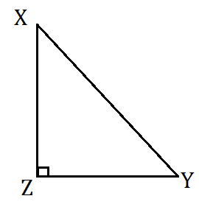

1. Find the measure of the missing angle. Round to the nearest degree.

|  |  |
| --- | --- |
|  |  |

1. Solve to find each missing side. Round to the nearest tenth.

|  |  |
| --- | --- |
|  |  |

1. A digital camera with a panoramic lens is described as having a view with an angle of elevation of 38 degrees. If the camera is on a 3 foot tripod aimed directly at a monument 158.7 feet away, how tall is the monument?
2. Sierra doesn’t know why she is not calculating the correct answer for her work. Find, describe, and correct her error.

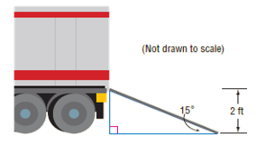

tan 15° $= \frac{2 ft }{?}$

The ramp is 7.5 ft long.

The

Find the length of the ramp to the nearest foot.

1. To approximate the length of a pond, a surveyor walks 400 meters from point L to point K, then turns and walks 220 meters from point K to point E. If m∠LKE  110°, find the length LE of the pond to the nearest tenth of a meter.

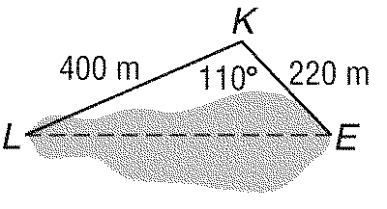

1. Solve PQR for r  22, p  51, and m∠Q  96°. Round angle measures to the nearest degree and side measures to the nearest tenth.
2. In $∆EFG$, $e=14, f=19, g=32,$ find the measure of the largest angle.
3. Three aircraft are flying in a triangular shape in the sky. In the figure below, $A$, $B$, and $C$ represent the position of the aircraft. Find the values of $x$ and $y$ to the nearest mile.

**Circles “Need to Know”**

* Know the vocabulary chord, tangent, secant, inscribed angle, and central angle.
* Know how to find circumference and area.
* What is the relationship between inscribed or central angle and arc measure?
* How do you calculate arc length, given arc measure?
* If a quadrilateral is inscribed in a circle, what do you know about the opposite angles of the quadrilateral?
* What can you tell about two tangent segments that meet at a point outside of a circle?
* What angle is formed by a line tangent to a circle and the radius of the circle?
* Translate between the geometric description and the equation of a circle.

1. 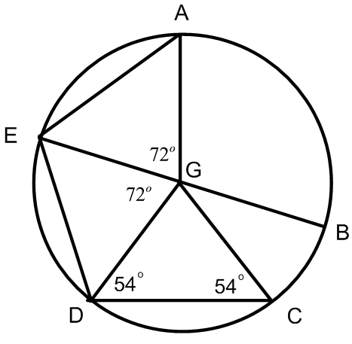Given: EB is a diameter of circle G. True or False?   
   If false, correct the statement to make it true.
   1. ∠BGC = 72⁰
   2. AE // CD
   3. ∠GED = ∠ GDC
   4. ∠DGC = 54⁰
$\overline{ED}≅\overline{AG}$

$\overline{AE}≅\overline{CD}$

2. Find the length of the segment indicated. Round your answer to the nearest tenth if necessary.

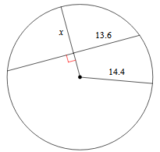

1. 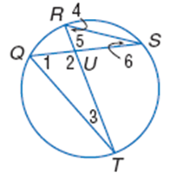Find the measure of each numbered angle. The measure of arc QR = 40° and the measure of arc TS = 110°.

∠1 =

∠2 =

∠3 =

∠4 =

∠5 =

∠6 =

1. The diameter $\overline{GE}$ of $⨀C$ is $32$ units long. Find the length of arc DHE if m∠ DCE = 90°.

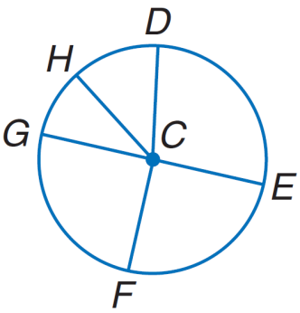

1. 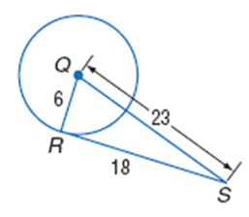Determine if segment $RS$ is tangent to circle *Q.*
2. Find the perimeter of the polygon. Assume lines which appear to be are tangent.

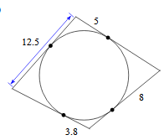

5x

12x + 5

38

8x

4x - 2

1. The points of a square are (0, 0), (–8, 0), (–8, 8) and (0, 8). Graph the square and write the equation of a circle that would be inscribed in the square.

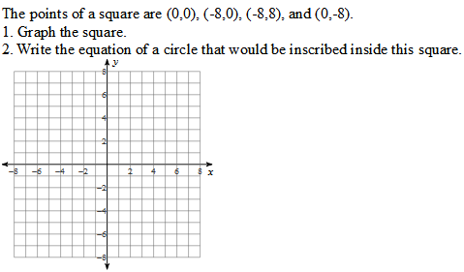

1. A circle is tangent to the triangle at (3, 4). The center of the circle is at (7, 7). Write the equation of the circle.

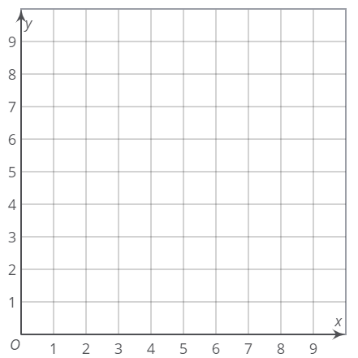

1. Find the exact area of the circle if arc length AB is 10π.

A

B

1. The length of arc AC is equal to one–third of the circumference of circle O and the arc length is 4π meters. Find the radius, m∠AOC, m∠ABC, and the area of the sector defined by ∠AOC and arc AC to the nearest tenth.

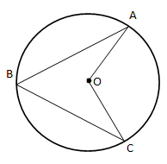radius = __________

m∠AOC = __________

m∠ABC = __________

sector area = __________

**Area, SA, and Volume “Need to Know”**

You will be provided with any formulas necessary to solve problems. You will have to understand how to apply the formulas to the assessment items.

1. Given the coordinates of the vertices, find the area of the figure.

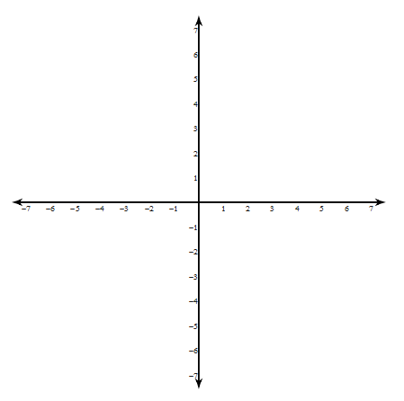(–2, 2) (2, 4) (2, –6) (–2, –2)

1. Find the area of the circle in terms of pi and the area of the shaded region.

A

C

B

6 cm

*r*

area of the circle: ___________

area of the shaded region:____________

1. a. What is the ratio of radii for the two spheres?

b. Compare the ratio of surface area for the two spheres to the ratio of radii.

c. Compare the ratio of volume for the two spheres to the ratio of radii.

4x

x

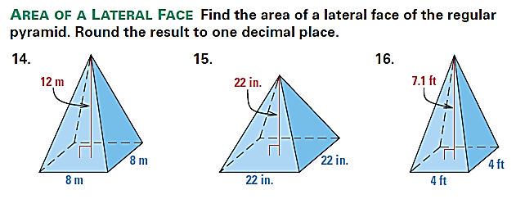

1. Find the SA of the square pyramid.
2. Jill wants to have her ottoman, shown below, reupholstered. Find the surface area that will be reupholstered. Do not count the area of the bottom.

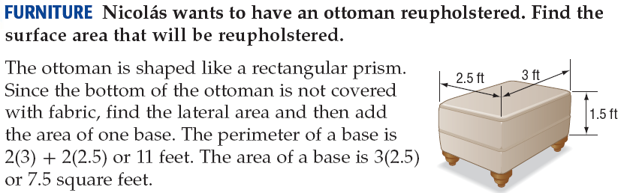

1. A fuel tanker is in the shape of a right cylinder. The full load of the fuel inside will be delivered to two locations; station A will receive one–third of the fuel and station B will receive two–thirds of the fuel. How many gallons of fuel will be delivered to station B? 1 ft3 = 7.5 gallons. Round to the nearest gallon.

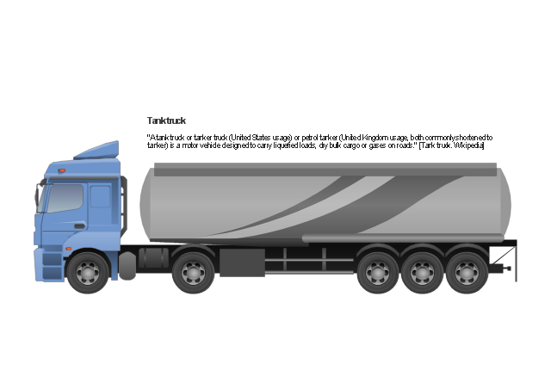

30 feet

10 feet

1. 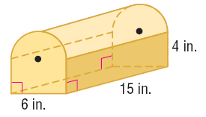Find the volume of the composite solid.   
   Round your answer to the nearest tenth.
2. The volume of a cone is 460π cm2. The cone has a diameter of 20 cm. Find the slant height of the cone.
3. If a right circular cylinder has a radius of 4 inches and a surface area of $112π$ square inches, what is the height of the cylinder in inches?
4. Compare the volume and tell which is greater: A rectangular prism that is 2 inches wide, 6 inches long and 1 inch deep or a square pyramid with a base that is 2 inches per side and is 6 inches high.
5. How many 1 x 1.5 x 2 inch ice “cubes” would be needed to melt into a cylindrical shaped ice bucket and fill it to the top without overflowing? The ice bucket has a diameter of 6 inches and a height of 10 inches. Cubes are whole ice cubes.

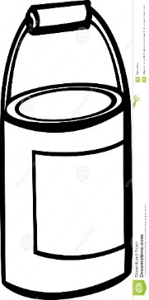

6 in

10 in

1. A cube has side length 10cm. What is the radius of a sphere with same volume? Round to the nearest tenth.

**Trigonometric Functions/Unit Circle “Need to Know”**

* Ratios for sin, cos, tan, csc, sec, and cot
* The length of the radius of the unit circle
* Coordinates in the (x,y) plane correspond to which trigonometric ratios?
* Definition of a radian
* How to convert between degrees and radians
* Which quadrants have positive and negative coordinates?
* What does each component of a trigonometric function (such as $y=a\sin{b\left(θ-h\right)}+k$) mean in terms of period, amplitude, phase shift, and the vertical shift?

1. Identify an angle in Quadrant IV with a reference angle of 30°. Tell the measure of the angle in both degrees and radians.
2. $\frac{3}{4}$ is an angle whose sine and cosine are opposites. Tell the measure of the other angle whose sine and cosine are opposites in both degrees and radians.
3. If θ is in Quadrant III and sin θ = – $\frac{1}{2}$, what other angle in a different quadrant will have the same sine?
4. Graph the point (1, –1) in standard position so its terminal side is θ. Then find the reference angle, θ’, and all exact trig ratio values.

θ’ = __________

sin θ’ = __________

cos θ’ = __________

tan θ’ = __________

1. Identify the point(s) on the unit circle where tangent is undefined.

Give the exact measurements for the following.

|  |  |  |
| --- | --- | --- |
| 1. cos –45° | 1. tan 210° | 1. cos 510° |
| $\sin\left(-\frac{5π}{4}\right)$ | $\cos{\frac{11π}{3}}$ | $\tan{\frac{3π}{6}}$ |

*State the vertical shift, amplitude, period, and phase shift for each function. Then graph the function.*

1. 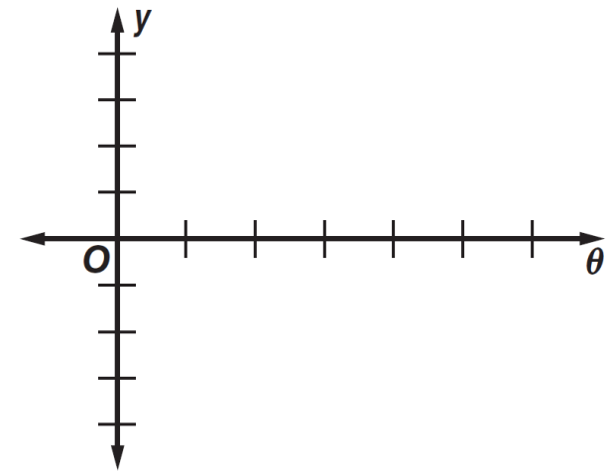 $y=\cos{θ}$

Vertical Shift: _____________

Amplitude: _______________

Period: __________________

 Phase Shift:

$y=2\sin{θ+1}$

 ______________

Vertical Shift: _____________

Amplitude: _______________

Period: __________________

 Phase Shift:

$y=\sin{4θ}$

 ______________

1. 

Vertical Shift: _____________

Amplitude: _______________

Period: __________________

Phase Shift:

$y=\cos\left(θ+\frac{π}{2}\right)$

 ______________

1. 

Vertical Shift: _____________

Amplitude: _______________

Period: __________________

Phase Shift: ______________

|  |  |
| --- | --- |
| 1. Write a sine function for the graph below. | 1. Write a cosine function for the graph below. |

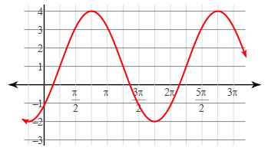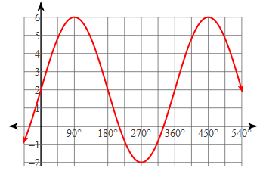

1. Graph the function y = 2sin3(θ + 30°) – 1.



Vertical Shift: _____________

Amplitude: _______________

Period: __________________

Phase Shift: ______________

**Vectors “Need to Know”**

* How do you find the magnitude or direction of a vector?
* If a vector is in standard position, the tail of the vector is at ____________________?
* How do you find the component form of a vector given two points? Given magnitude and direction?
* When are two vectors equal?
* What are the different methods for adding vectors?
* What is scalar multiplication of a vector?
* What happens when a vector is multiplied by a negative constant?

Let $\overset{⃑}{v}=<3, 7>$ and $\overset{⃑}{w}=<4, -2>.$ Compute the following, then find magnitude and direction.

|  |  |
| --- | --- |
| $3\overset{⃑}{v}+2\overset{⃑}{w}$ | $5\overset{⃑}{v}-\overset{⃑}{w}$ |

1. Consider vector $\overset{⃑}{v}〈-2,5〉$ and vector $\overset{⃑}{w}〈3, 7〉$. Draw a diagram that models $\overset{⃑}{v}+\overset{⃑}{w}$

Find the component form of vector $v$, with magnitude and direction given:

|  |  |
| --- | --- |
| $\overset{⃑}{v}=15, θ=208°$ | $\overset{⃑}{v}=73, θ=32°$ |

Draw each vector component to find the resultant. Find the direction and velocity.

1. A motorboat heads across a river due west t at 16 m/s. The river current flows north at 9.0 m/s.
2. An airplane is flying due north at $400$ miles per hour. The wind is blowing due east of north at $35$ miles per hour.
3. Write the component form of the vector and find the magnitude and direction of the vector.

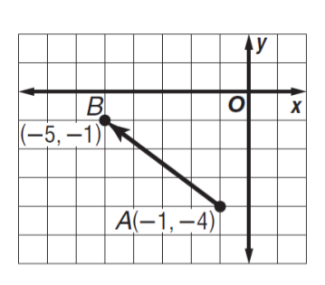

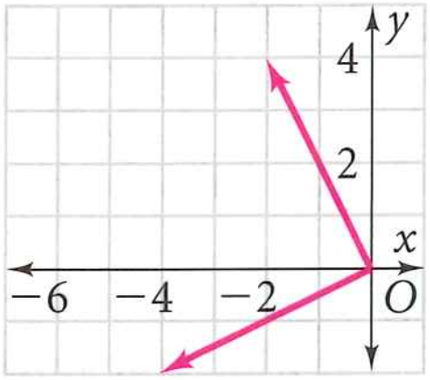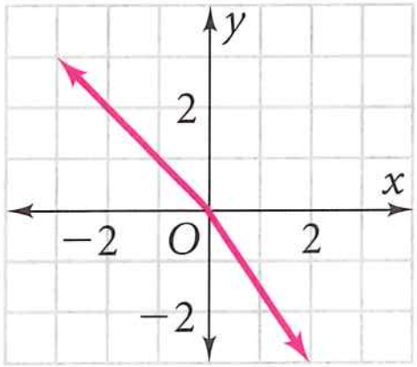Draw the resultant. Write the resultant in component form.

|  |  |
| --- | --- |
|  |  |

Solutions for 2018/2019 ACC Geometry Final Exam Review

|  |  |  |  |
| --- | --- | --- | --- |
| 1. Yes, converse of pyth thm | 1. 36 | 1. 10 |  |
| 1. , x | 1. , | 1. 40.8, 46.4 | 1. 16.2, 6.6 |
| 1. 127 | 1. 7.7 | 1. 518.3 | 1. q=57.6, p=61.7, <R=22.3 |
| 1. <G=151.4 | 1. 8.5 and 11.2 | 1. True: c f | 1. 9.7 |
| 1. 55, 105, 20, 55, 105, 20 | 1. 75.4 | 1. Not tangent | 1. 486 |
|  |  | 1. 100 | 1. 6, 120, 60, 37.7 |
| 1. 28 | 1. 12, 22.1 | 1. 4:1, 16:1, 64:1 | 1. 265.6 |
| 1. 24 | 1. 11781 | 1. 572.1 | 1. 17 |
| 1. 10 | 1. Rect prism | 1. 94 full cubes | 1. 6.2 |
| 1. 330 or | 1. 315 or | 1. 330 or | 1. 45, , ,-1 |
| 1. 90 and 270 |  |  |  |
|  | 1. 1/2 | 1. undef | 1. 0,1,360,0 |
| 1. 1,2,360,0 | 1. 0,1,90,0 | 1. 0,1,360,left 90 | 1. Y=4sinx+2 |
| 1. Y=3cos(x-135)+1 | 1. -1,2,120,left 30 | 1. <17,17>, | 1. <11,37>, 38.6, 73.4 |
| 1. draw | 1. <-13.2, -7> | 1. <61.9, 38> | 1. 18.4, 150.6 |
| 1. 425.5, 86.7 | 1. 5,143.1 | 1. <2,6> | 1. <-5,6> |