Accelerated Angle Relationships Homework #1

Find the value of the variable and find the m<PQR. Justify steps!

1. 2. 3.

$\vec{BA} and \vec{BC} are opposite rays.$ $\vec{BF}$ bisects <CBE and $\vec{BD}$bisects <ABE. Justify your steps.
4. If $m<EBF=8x^{2}-9x-5$and $m<CBF=4-3x$, find the possible value(s), if any, of the $m<EBC$. You must check your work for credit.

$\vec{BA} and \vec{BC} are opposite rays.$ $\vec{BF}$ bisects <CBE and $\vec{BD}$bisects <ABE. Justify your steps.
5. If $m<2={10x}^{2}+5x+7$and $m<1={3x}^{2}-17x+4$, find the possible value(s), if any, of $m<ABE$. You must check your work.

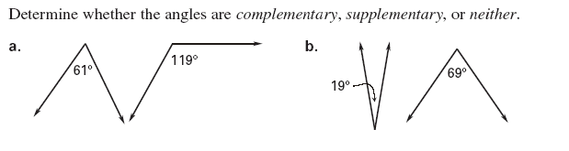
6.

7.

Decide whether the statement is true or false. If the statement if false, reword the statement so it is true.

8. Two angles are complementary if the sum of their measures is 180°

9. Two angles are supplementary if the sum of their measures is 180°

10. Two angles are adjacent angles if they share a common vertex.

Determine whether the angles are complementary, supplementary or neither.
11. 12. 13.

Find the measure of the complement of the given angle.
14. 15. 16.

Find the measure of the supplement of the given angle.
17. 18. 19.

Find the measure of EACH numbered angle. Justify steps!
20. 21. 22.

23. 24. 25.

