ACC Geometry
Advanced Angle and Segment Relationships: Class Work
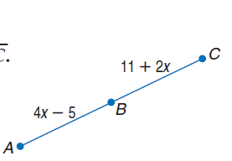
1. Find the measure of $\overline{BC}$ if B is the midpoint of $\overline{AC}$.

Find the value of the variable and ST if S is between R and T. Justify your steps.
2. $RS=7a, ST=12a, RT=76$ 3. $RS=12, ST=2x, RT=34$

4. $RS=4y-1, ST=2y-1, RT=5y$

$\vec{BA} and \vec{BC} are opposite rays, which means _____________________________.$ $\vec{BF}$ bisects <CBE and $\vec{BD}$bisects <ABE. Justify your steps.

5. What does it mean to bisect an angle? _____________________________________

6. If $m<EBF=6x+4$ and $m<CBF=7x-2$, find $m<EBC$.

7. If $m<1=4x+10$ and $m<2=5x$, find $m<2$.

8. If $m<2=6y+2$ and $m<1=8y-14$, find $m<ABE$.

9. Is $<DBF$ a right angle? Explain.

Justify your steps.
10. Find x.

11. Find x.

12. The measures of two complementary angles are $m<A= 16z-9$ and $m<B=4z+3$. Find the measures of both angles.

13. Find the measures of an angle and its complement if one angle measures 18 degrees more than the other.

14. The measure of the supplement of an angle is 36 less than the measure of the angle. Find the measures of the angles.

