Graded Assignment OR Practice Acc. Geo 2018 Name ___________________________________
Angle Relationships
1. Write an equation to model the given scenario and then find the two angles.
Find the measures of two complementary angles if the difference in their measures is 18.

____________ and ____________

2. Write an equation to model the given scenario and then find the two angles.
If a supplement of an angle has a measure of 78 less than the measure of the angle, what are the measures of the angles?

____________ and ____________

Show all work to receive full credit. Be sure to:
a.) draw a diagram if needed
b.) write a geometric equation
c.) justify your steps!

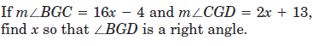
3.
This has 2 geometry and justifications for the set up.
SHOW BOTH!
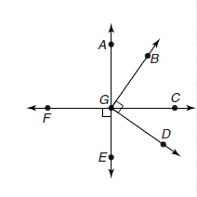

X = _____________________

In the figure, $\vec{YX} and \vec{YZ}$ are opposite rays. $\vec{YU}$ bisects $<ZYW$, and $\vec{YT}$ bisects $<XYW$. Show your work. Justify steps!
4. If $m<WYZ=74°$ and $m<ZYU=4r+30$, find r.

Geometry: Justification:

r = _________________

5. In the figure, $\vec{EA} and \vec{EB}$ are opposite rays.
$\vec{EF}$ bisects $<AEC$, $<AEF=4\left(x^{2}-x\right)$ and $<FEC=35°$.
Find the possible values for x. Make sure to check your work and justify your steps.

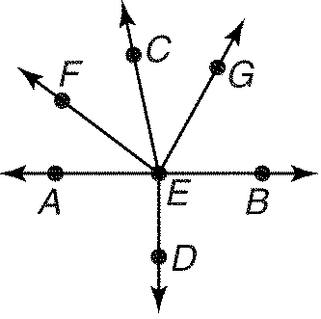

X = _________________________________________________

6. $m<11={2x}^{2}-7x+95, m<12={6x}^{2}-3x+88$. Find the possible value(s) for x. Make sure to justify your steps and check your work.
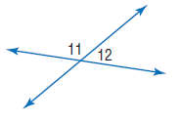

check your work

X = _________________________________________________

7. $m<17={10x}^{2}-25x, m<18={-4x}^{2}+6$. Find the possible value(s) for x. Make sure to justify your steps and check your work.

check your work

X = _________________________________________________

