Quadrilateral Practice
Directions: In #1-5 find all of the missing angles.
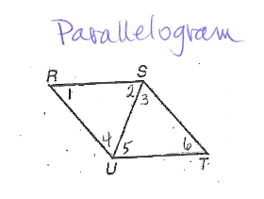
Parallelogram
1. Given that m<1 = 15° and m<3 = 85° for the parallelogram, find the following angles:
m<2 = _____________ m<4 = ________________
m<5 = _____________ m<6 = ________________

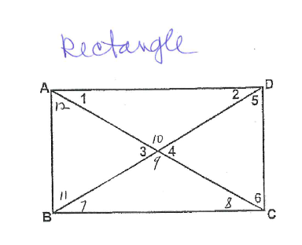
2. Given that m<1 = 20° and m<4 = 40° for the rectangle, find the following angles:
Rectangle
m<2 = _________ m<3 = ____________
m<5 = _________ m<6 = ____________
m<7 = _________ m<8 = ____________
m<9 = _________ m<10 = ___________
m<11 = _________

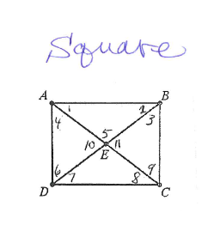
3. Given that the shape is a square, find the following angles:
Square
m<1 = ______________
m<2 = _______________ m<3 = __________________
m<4 = _______________ m<5 = __________________
m<6 = _______________ m<7 = __________________
m<8 = _______________ m<9 = __________________
m<10 = ______________ m<11 = _________________
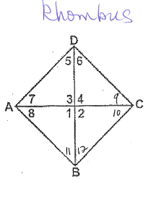
4. Given the m<9 = 30° for the rhombus, find the following angles:
Rhombus
m<1 = ____________ m<2 = ________________
m<3 = ____________ m<4 = ________________
m<5 = ____________ m<6 = ________________
m<7 = ____________ m<8 = ________________
m<10 = ___________ m<11 = _______________
m<12 = ___________

Isosceles Trapezoid
5. Given m<7 = 53° for the isosceles trapezoid, find the following angle measures:
m<1 = ____________
m<2 = ____________
m<3 = ____________
m<4 = ____________
m<9 = ____________

Identifying Properties: In problems 6-13 below, list the letters of the quarilaterals that the properties hold true for:
a) Parallelogram b) Rectangle c) Rhombus d) Square

6. Diagonals bisect each other. 7. All <’s are right <’s

8. All sides are congruent. 9. Opposite sides are congruent.

10. Opposite angles are congruent. 11. Diagonals are congruent.

12. Diagonals are perpendicular. 13. Opposite sides are parallel.

Directions: Find the missing angle measure or variable. Show all work! Justify your set ups!

14. ABCD is a rhombus. If m<8=35°, 15. ABCD is a rectangle. If m<1=20° find the
Find the measure of <1, <2, <3, <4, measures of <2, <3, <4, <5, <6.
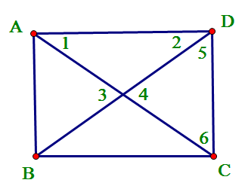
<5, <6, <7.
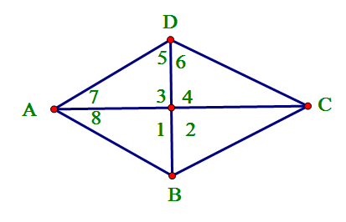

16. ABCD is a square. If AC=16in and 17. ABCD is a parallelogram. AR= 2x+ 3,
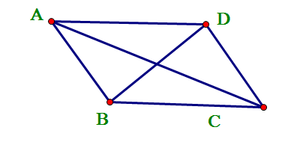
BD = 2x + 4, find x. RC= 35, BR= 4y – 10, DR= 90. Find x and y.
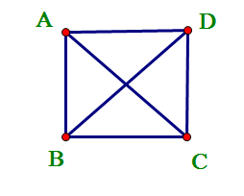
R

C

19.
18.
27.

20. Find x in the parallelogram. 21. Find x in the parallelogram.

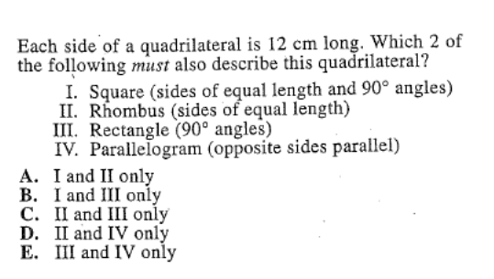
22. Find x in the parallelogram. 23.

22. ACT QUESTION!

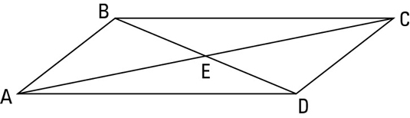
24. Write geometric statement along with the correct justification for parallelogram ABCD.

a.) AB __________ because :___________________________________________________
b.) <ABC __________ because :___________________________________________________
c.) EA __________ because :___________________________________________________
d.) BC // __________ because :___________________________________________________
e.) <BAD __________ because :___________________________________________________
f.) <BEA __________ because :___________________________________________________
g.) <BCA __________ because :___________________________________________________
h.) <BCD + < _____ = 180 because :___________________________________________________

25. Use rhombus PLAN to write the correct geometric statement (if needed) and justification.
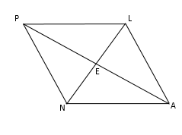
a.) AL PL because :___________________________________________________
b.) <NEA = 90 because :___________________________________________________
c.) EA __________ because :___________________________________________________
d.) NA // __________ because :___________________________________________________
e.) <NPE __________ because :___________________________________________________
f.) <PLA __________ because :___________________________________________________
g.) <LNA __________ because :___________________________________________________
h.) <LEA = 90 because :____________________________________________________________

