SA Questions ACC Geometry

1. The Great Pyramid of Egypt has a height of 148 m and a square base with a perimeter of 930 m. Find the side lengths of the base and surface area of the Great Pyramid.

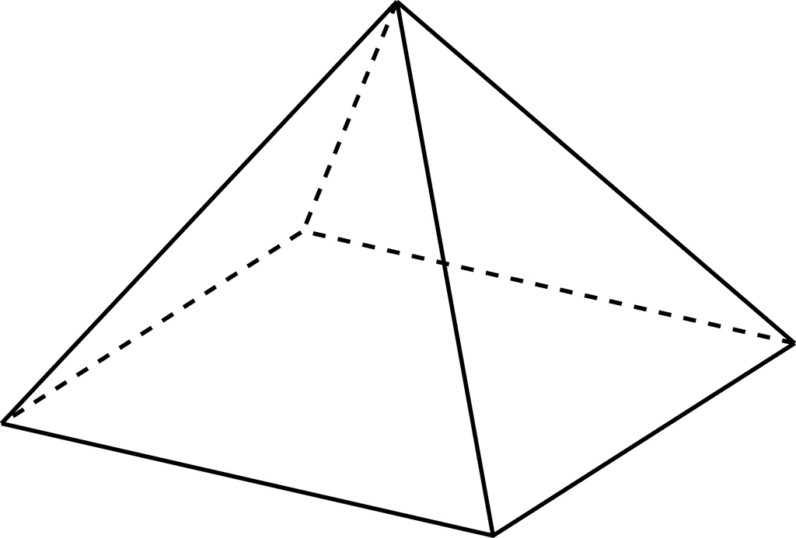

2. Walter has a new rectangular patio connected to his house that measures 2 m by 4 m. He wants to plant a garden that is 1.5 m wide around the patio (not against the house). How much paint does he need to paint the garden box if the garden is 0.5 m deep?

Patio

4 m

2 m

1.5 m

1.5 m

1.5 m

0.5 m

0.5 m

3. Jazz is painting the interior of my house. To the nearest square inch, how much wall space will

Jazz cover with one complete rotation of this paintbrush roller?

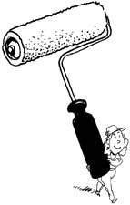

16 in

4 in

4. Suppose you are designing a tent in the design shown here. You want to use as little fabric as possible. Given the dimensions of the drawing, find the height of the triangular bases, the surface area of the tent including the floor, sides, windows and doors.

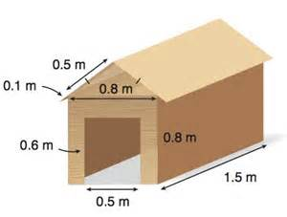5. Assuming this is a scale drawing of a bridge cover, find the surface area of the outside of the bridge cover.

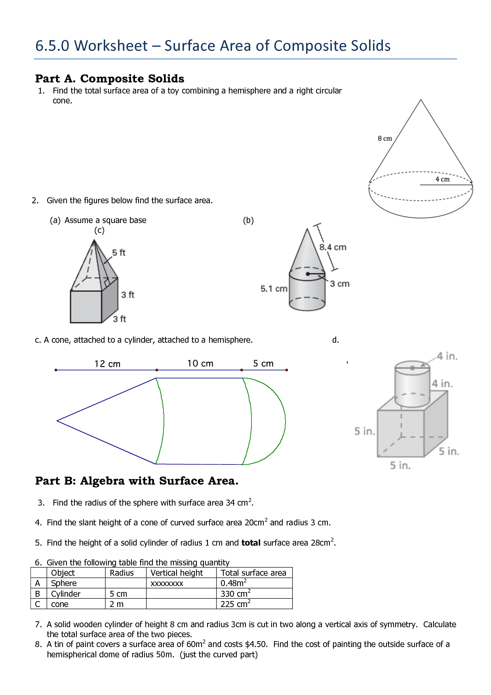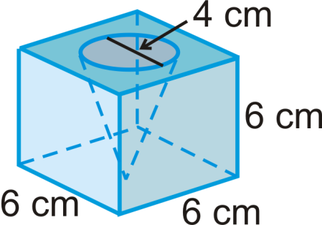6. Find the surface area of the composite figures if you were to paint on all surfaces.

a. b. c.

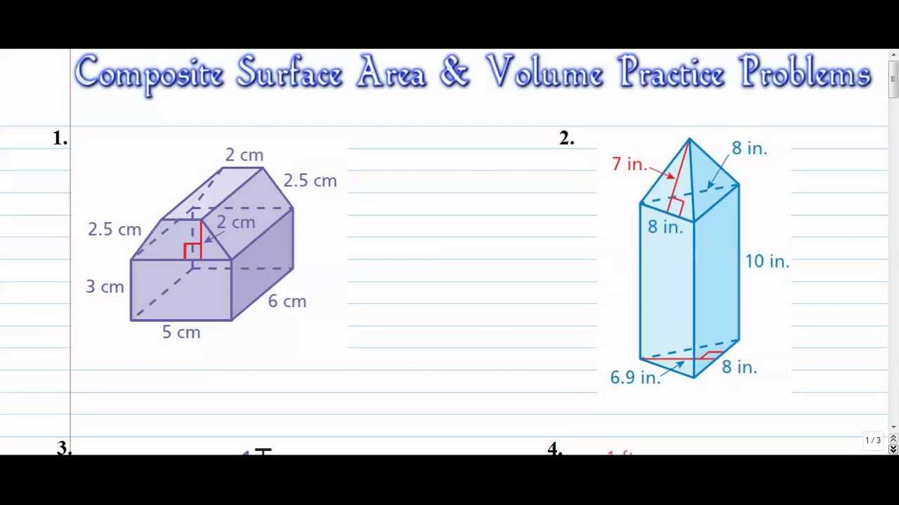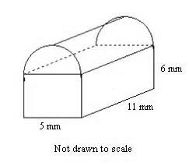



d. e. f.