**Advanced Triangle In-class Practice**

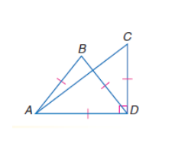

**Directions: #1-4 Identify the indicated type of triangles if m<ADC=90°,**

**AB≅BD≅AD≅CD.**

**1. Right 2. Equilateral**

**3. Scalene 4. Isosceles**

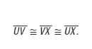

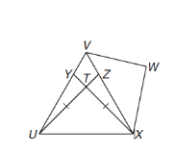

**#5-6**

**5. Name the scalene triangles:**

**6. Name the isosceles triangle:**

**7. Name the equilateral triangle:**

**Triangle Inequalities: Individual Practice**

****In #1-2, determine whether it is possible to draw a triangle with the sides given (yes or no).

****In #4-6, arrange the unknown measures in order from greatest to least.

