Name:___________________________________ Hour: ________
Advanced Congruent Triangle Practice

Use the given information to identify the congruent triangles.
Describe what congruence shortcut you used and what angles or sides you know are congruent.
(SHOW YOUR GEOMETRY!!!)
Use your three different colors to identify your three corresponding congruent parts.

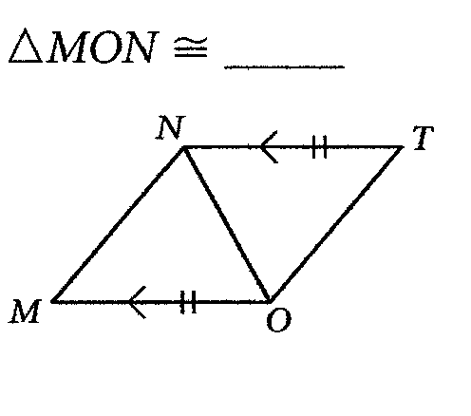
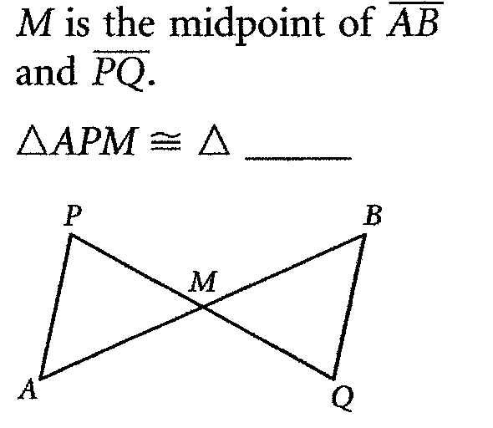
1. 2.

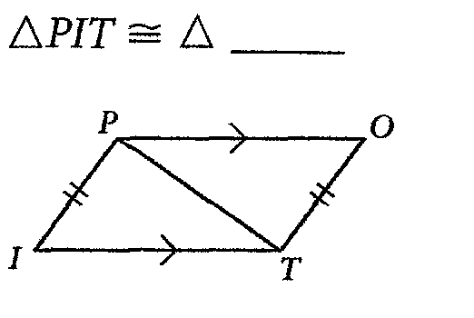
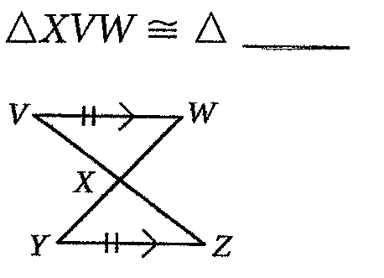
3. 4.

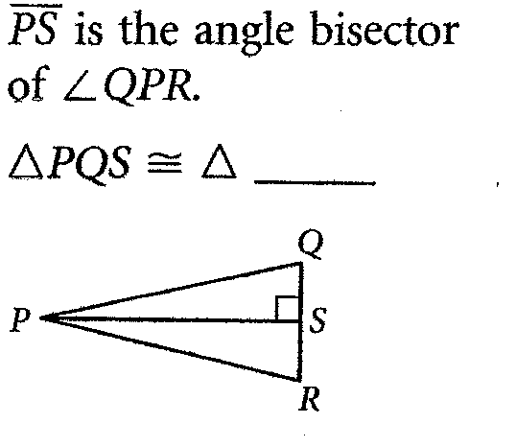
5.

