Angles and Arcs HW
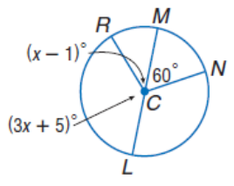
For 1 – 4, find the measure of the indicated angles.

- m<NCL 2. m<RCL

- m<RCM 4. m<RCN

For 5 – 8, find the measure of the indicated arc or arc length.
- m$\hat{BC}$ 6. m$\hat{CBE}$

7. Arc length of $\hat{ED}$ with d =13 cm 8. Arc length of $\hat{CD}$ with d = 13 cm

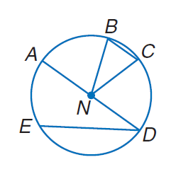
9.

10. If $m\hat{AE}=68°$ find m<ADE.

11. Find $m\hat{BC}$ if m<BNC=$23°$

12. Find $m\hat{AE}$ if $m\hat{EBA}=297°$

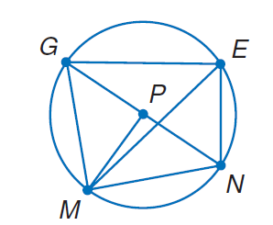
Directions: For 13, use Circle P and $m\hat{EN}=80°$ and m<GPM = 105$°$ to find each measure.
13. m<EGN 14. $m\hat{GE}$

15. $m\hat{MN}$ 16. m<EMN

17. m<MPN 18. $m\hat{NEG}$

19. $m\hat{MGN}$ 20. m<GEM

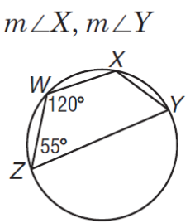
Directions: For 21-24, find the measure of each angle or segment in the figure.
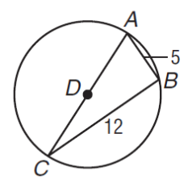
21. 22. m<ABC, and AD.

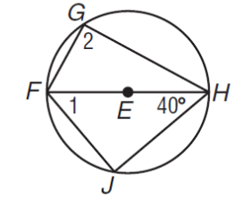
23. 24.

