Angles and Arcs Practice
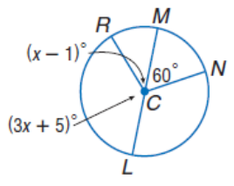
For 1 – 4, find the measure of the indicated angles.

- m<NCL 2. m<RCL

- m<RCM 4. m<RCN

For 5 – 8, find the measure of the indicated arc or arc length if r = 7in.
- m$\hat{BC}$ 6. m$\hat{CBE}$

7. Arc length of $\hat{ED}$ with d =13 cm 8. Arc length of $\hat{CD}$ with d = 13 cm

Angles and Arcs Homework
Directions: For 1 – 4, use Circle P and $m\hat{SV}=120$ and m<RPS = 76 to find each measure.
- m<PRS 2. $m\hat{RSV}$

- $m\hat{RT}$ 4. m<RVT

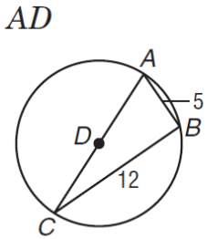
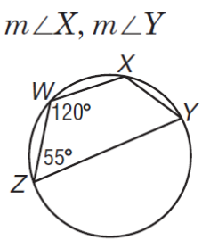
Directions: For 5-8, find the measure of each angle or segment in the figure.
- 6.

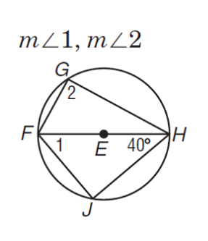
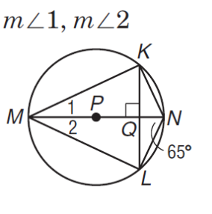
- 8.

