Name: \_\_\_\_\_\_\_\_\_\_\_\_\_\_\_\_\_\_\_\_\_\_\_\_\_\_\_\_\_\_\_\_\_\_\_\_\_\_\_\_\_\_\_\_\_\_\_\_\_\_\_\_\_\_\_ Date: \_\_\_\_\_\_ HR: \_\_\_\_

Angle of Elevation & Depression Worksheet Graded Assignment

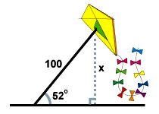**Draw a picture if one is not provided. Find all values to the nearest tenth. Show all work to receive full credit!*x* = 10 sec(20) latex_img1510.64 . The second boat must travel about 10.6 miles to get as far west as the first boat.**

**[Close](http://www.sparknotes.com/math/trigonometry/solvingrighttriangles/problems_1.html" \l "explanation1#explanation1)**

1. A man flies a kite with a 100 foot string. The angle of elevation of the

string is 52 o . How high off the ground is the kite?

*x* = 100 sin(52) latex_img1578.8 . The kite is about 79 feet above the ground.

[Close](http://www.sparknotes.com/math/trigonometry/solvingrighttriangles/problems_1.html#explanation2#explanation2)

2. From the top of a vertical cliff 40 m high, the angle of depression of an object that is level with the base of

the cliff is 34º.  How far is the object from the base of the cliff?

3. An airplane takes off 200 yards in front of a 60 foot building. At what angle of elevation must the

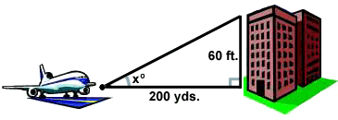 plane take off in order to avoid crashing into the building? Assume that the airplane flies in a

straight line and the angle of elevation remains constant until the airplane

flies over the building. (3 feet = 1 yard)

*x* = arctan(latex_img28) latex_img155.72 o . The plane must take off at an angle of elevation of about 5.72 o in order to avoid hitting the building.

[Close](http://www.sparknotes.com/math/trigonometry/solvingrighttriangles/problems_1.html#explanation3#explanation3)

4. A 14 foot ladder is used to scale a 13 foot wall. At what angle of elevation must the ladder be situated in

order to reach the top of the wall?

5. A person stands at the window of a building so that his eyes are 12.6 m above the level ground. An object is on the ground 58.5 m away from the building on a line directly beneath the person. Compute the angle of depression of the person’s line of sight to the object on the ground.

*x* = arcsin(latex_img31) latex_img1568.3 o . The ladder must be situated with about a 68.2 o angle of elevation in order to reach the top of the wall.

[Close](http://www.sparknotes.com/math/trigonometry/solvingrighttriangles/problems_1.html#explanation4#explanation4)

http://img.sparknotes.com/figures/C/c92e38c46d6be4610999d7936fd45ce2/prob235.gif6. A ramp is needed to allow vehicles to climb a 2 foot wall. The angle of elevation in order for the vehicles to

safely go up must be 30 o or less, and the longest ramp available is 5 feet

long. Can this ramp be used safely?

1. From an airplane at an altitude of 1200 m, the angle of depression to a rock on the ground measures 28°. Find the distance from the plane to the rock.
2. From a point on the ground 12 ft from the base of a flagpole, the angle of elevation of the top of the pole measures 53°. How tall is the flagpole?
3. From a plane flying due east at 265 m above sea level, the angles of depression of two ships sailing due east measure 35° and 25 °. How far apart are the ships?
4. Tom and Sam are on the opposite sides of a tower of 160 meters height. They measure the angle of elevation of the top of the tower as 40° and 55° respectively. Find the distance between Tom and Sam.

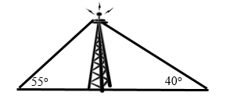

1. A man on the deck of a ship is 13 ft above water level. He observes that the angle of elevation of the top of a cliff is 40° and the angle of depression of the base is20°. Find the distance of the cliff from the ship and the height of the cliff if the base of the cliff is at sea level. (Find, x, y, and z)

