**C:\Users\Kelly\AppData\Local\Microsoft\Windows\Temporary Internet Files\Content.IE5\ORFY33ML\MC900434399[1].wmfAngle Relationships: Notes Day 1**

**Justifications**

***Justification:*** *Vertical angles are congruent!*

**1.** Name the vertical angles which are congruent. Find m<XAY and m<XAT.

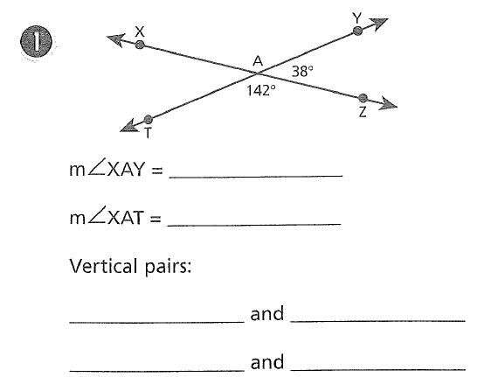

**2.** What is an angle bisector?

$\vec{CB}$ ___________________________________________________________

is an angle bisector. If m<BCD = 35° find m<ACB.

***Justification:*** *Definition of Angle Bisector*

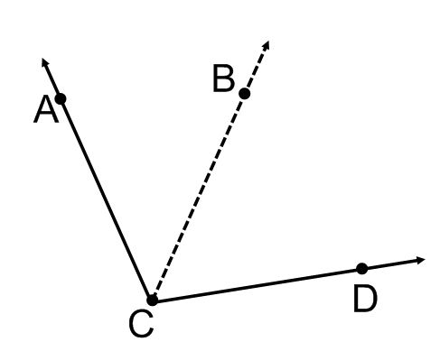

**3.** Use the same figure, but DO NOT assume Ray CB is an angle bisector: If *m<ACB=64ᵒ* and *m<BCD=33ᵒ* find the *m<ACD*.

***Justification:*** *Angle Addition*

**4.** Linear Pairs. Find m<AVB.

***Justification:*** *Linear Pairs are Supplementary*

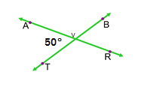

**5.** Draw $\overset{⃡}{FR}⊥\overset{⃡}{EB}$ which intersect at X. Find x. **6.** Draw $<HGT$ as a right angle. Find x.

***Justification:*** *Definition of Perpendicular* ***Justification:*** *Definition of Right Angle*

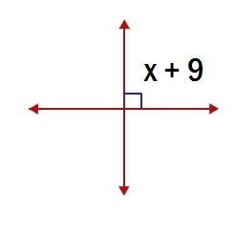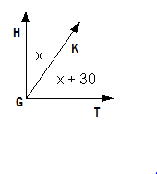

**7.** Draw $<1 \&<2$ as complementary angles. **8.**Draw $<1 \&<2$ as supplementary angles.

***Justification:*** *Definition of* ***Justification:*** *Definition of   
Complementary Angle Supplementary Angle*

If <1 and <2 are complimentary angles If <1 and <2 are supplementary angles and *m<1= 78ᵒ,* find the m<2. and *m<1= 78ᵒ*, find the m<2.

Name: ______________________________________________________________________

**Angle Relationships: Practice**

**Directions**: Find the measurement of the given angle.

**Use the figure to the right. Show Geometry and justify your SET UP!**

1. Find x. Geometry: Justify:

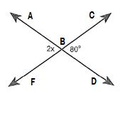

2. If <WXY and <YXZ are linear pairs, $<WXY= x+10 and <YXZ = 3x+10.$ Find x.

Geometry: Justify:

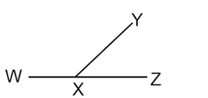

3. , Find

Geometry: Justify:

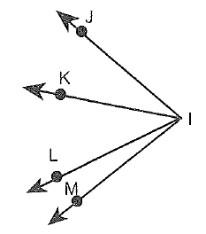

4. If <10 and <11 are complementary angles, m<10=32° then m<11 =_______.

Geometry: Justify:

5. If <14 and <15 are supplementary angles, m<14=68° then m<15 = _______

Geometry: Justify:

6. If <5 and <6 are complementary angles, <6 and <7 are supplementary angles, and m<5=34° then m<6 = _____ and m<7 = _______

Geometry: Justify:

**Rapid practice: No justifying needed.**

**Directions**: Find the measurement of the given angle.

**7.** m<VZT **8.** m<XZT

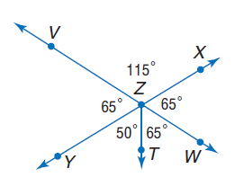

**9**. m<WZY **10.** m<VZW

**Directions**: Find the measurement of the given angle. If the m<1=65ᵒ

**Use the figure to the right.** 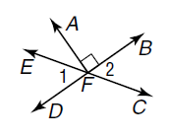

**11.** m<2 **12.** m<DFC

**13.** m<EFB **14.** m<EFA