Name: ________________________________________________________________________

Angle Relationships: Day 2 HW

Directions: Determine what concept you are using, WRITE THE GEOMETRIC SET UP and write the justification as part of your work.

1. 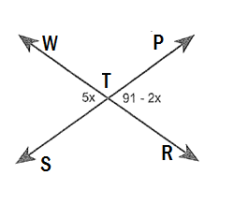Find x.

Geometry: Justify:



2.) Find x.

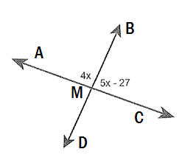



3.) Find x.

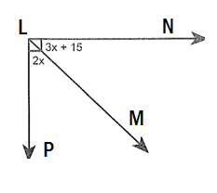

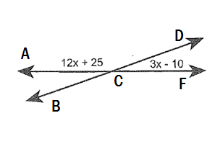4. Find x.

$\vec{BA} and \vec{BC} are opposite rays.$ $\vec{BF}$**bisects <CBE and $\vec{BD}$ bisects <ABE. Justify your steps.**

5. If and , find the possible value(s), if any, of the $m<EBC$. You must check your work for credit.

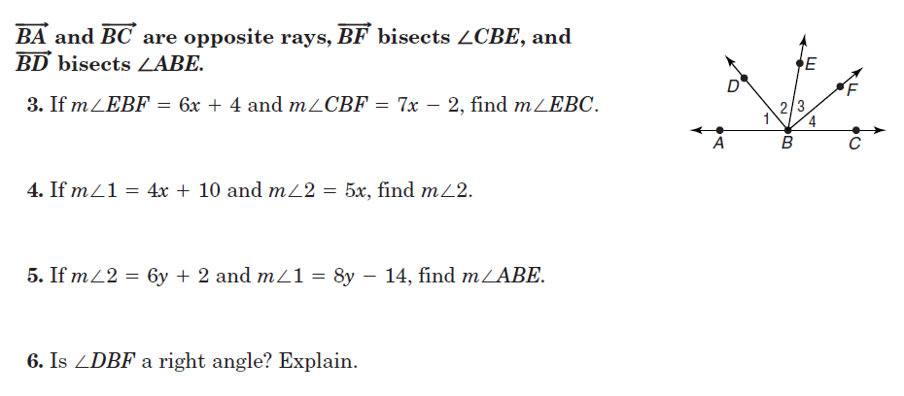

**Quick Angles Practice: Find the value of the variables. NO JUSTIFICATIONS NEEDED!**

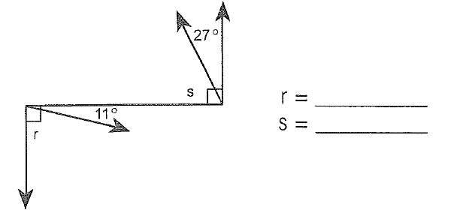

5.

35°

6. 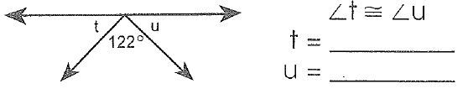

**110°**

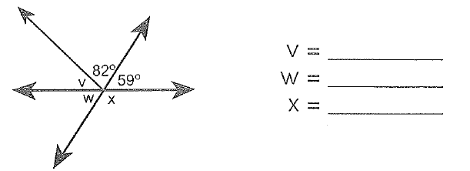

7.

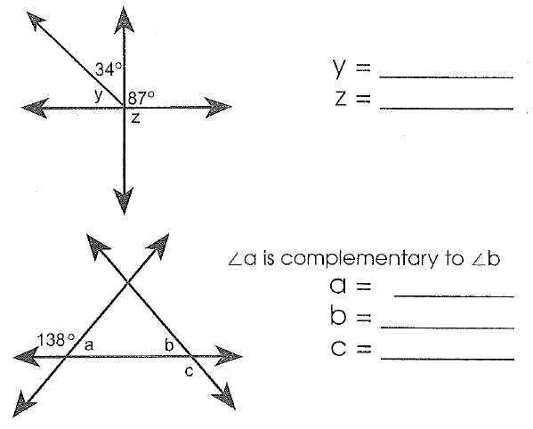8.

**84°**

9.

Angle Bisector Review

For questions 1-5, use the figure at the right to complete each statement.



55°

<BAD

AC

6. is an angle bisector of <ABC and $\vec{BD}$ is an angle bisector of <EBC

If <ABC= 168° Find the measures of

<ABE= _____________

<EBC= _____________

<EBD= _____________

<CBD=

$\vec{BA} and \vec{BC} are opposite rays.$ $\vec{BF}$_____________

**bisects <CBE and $\vec{BD}$ bisects <ABE. Justify your steps.**

7. If and , find the possible value(s), if any, of $m<ABE$. You must check your work.

