**Angle Relationships Review Focus: (Schmidt)**

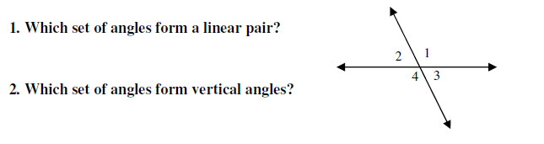Part 1:

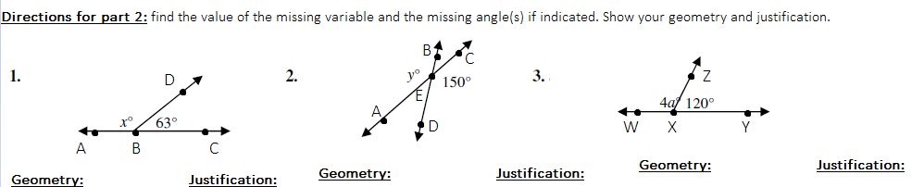

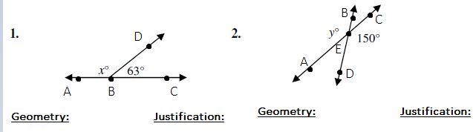



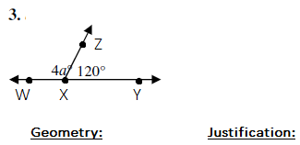

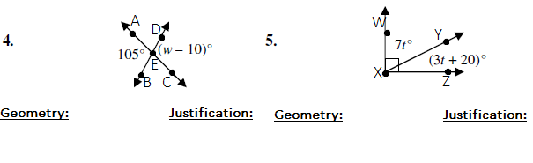



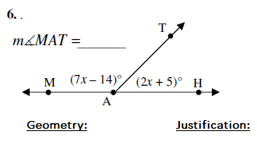

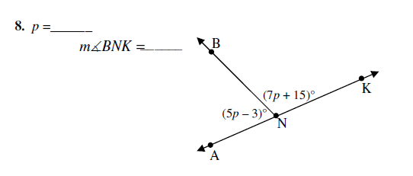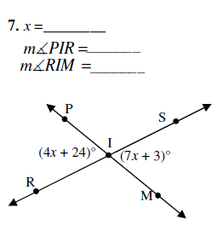







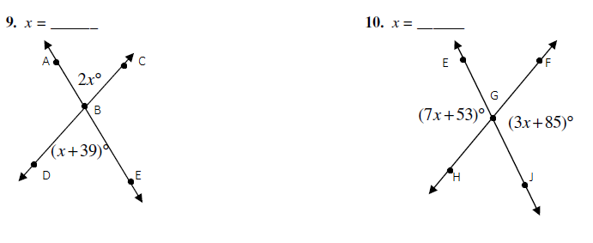



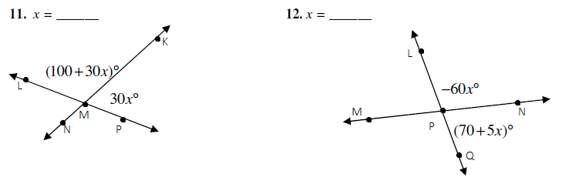





Part 3: Writing in Mathematics.

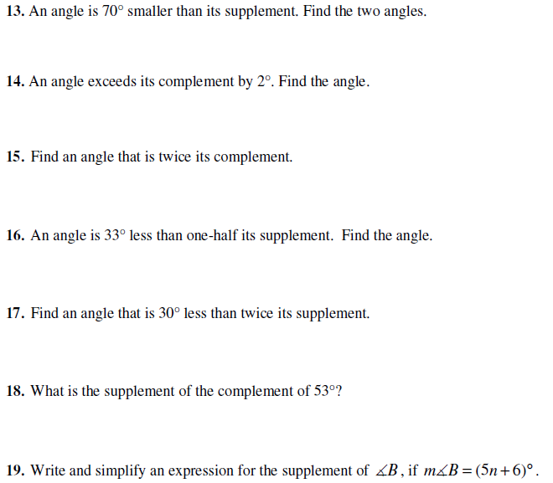

**Part 4: Angle Addition and Angle Bisectors.**

1. Find x and the if

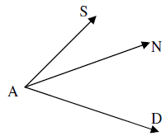

2. Find x and the if

6

3. Find x and the if



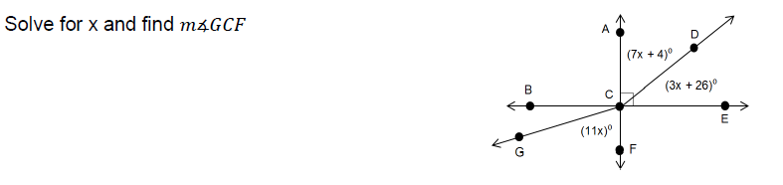4.



5. Find x and the if

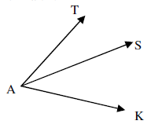

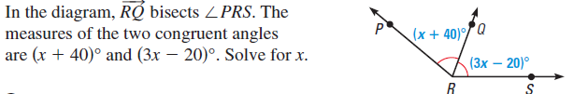6.





7.

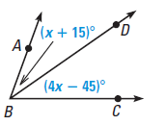

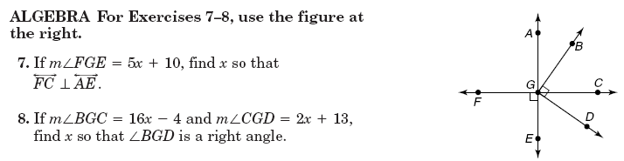

8. If  and , find x.



def of perpendicular or right angle

9. If , , and , find x.



Part 5: Parallels cut by transversals.

1. m∠1 = 3x - 17° and m∠2 = x + 1°. Find x.

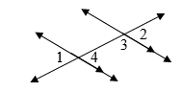



2. m∠3 = 20k + 11° and m∠4 = 8k + 1°. Find k.

1

2

3

4

3. m∠1 = 95° + 7h and m∠2 = 55° - h. Find h.

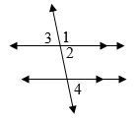

4. m∠3 = 5k + 12° and m∠4 = 7k - 16°. Find k.



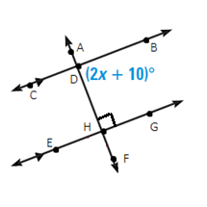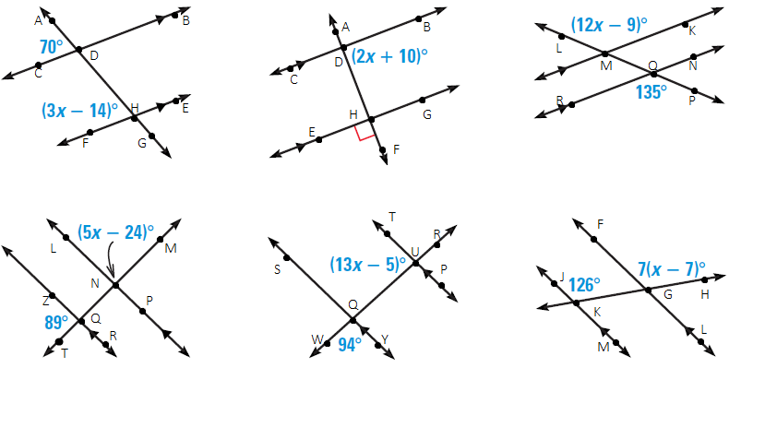Directions: Find x.

5. 6.



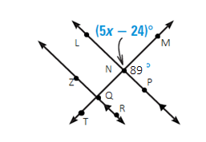



7. 8.



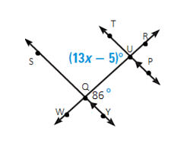



9. 10.