Angle Relationships TEST REVIEW

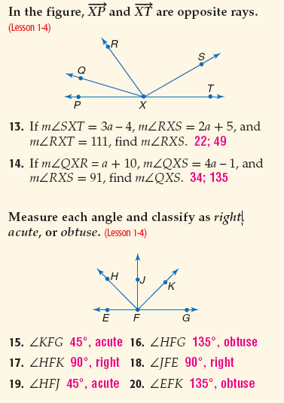1. Find the measure of each angle if the m<HFK=90° and m<HFG=135°.

a. m<KFG= ____________ b. m<JFK= ___________

c. m<HFE= ____________ d. m<EFK= ___________

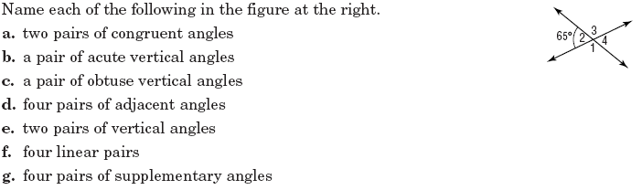2.

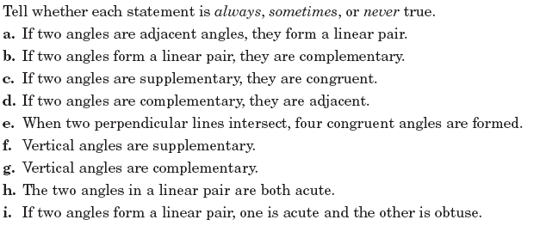

3.

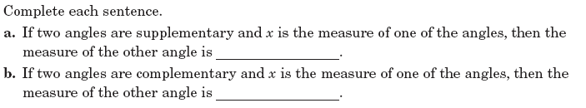4.

Directions: Classify all that apply, adjacent, vertical, linear pairs, ONE right angle, complementary, supplementary, and/or congruent.

5. a. <1 and <5 b. <GFH and <CFG

c. <2 and <5 d. <2 and <FCD

**Directions #6-14**: Show all geometry, justifications and work for every step.

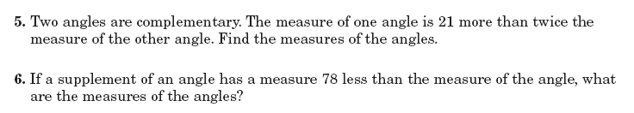6.



7.

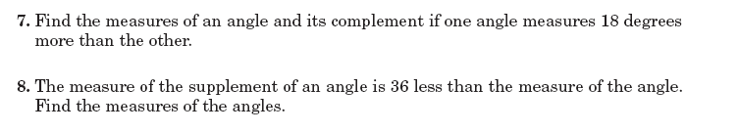

8.



9.

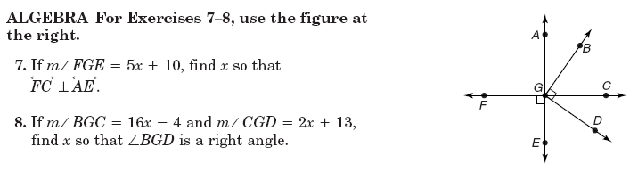

10 a. 10b.



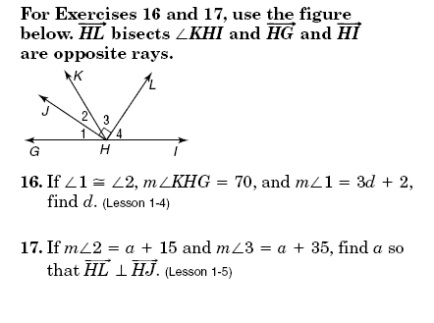11. $\vec{HL}$ bisects <KHI.

a. b.



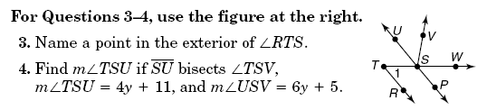12a. 12b. Using information from 12a., find x, if

m<VSW= 8x – 2.





13.

a. If *<SXT=3a – 4, <RXS=2a + 5, <RXT=111°.* Find *a* and the measure of <RXS.



b. If *<QXR= a + 10, <QXS = 4a – 1*, and *<RXS=91°,* Find *a* and <QXS.

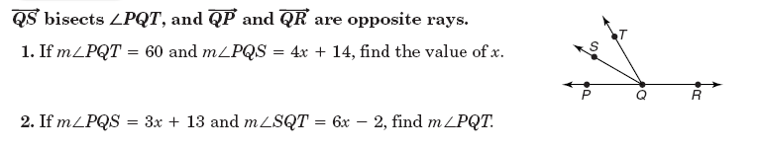

14.

a.



b.

**Parallels cut by transversals.**

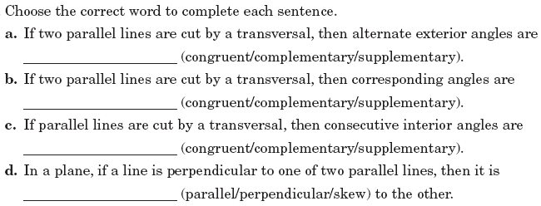

15.

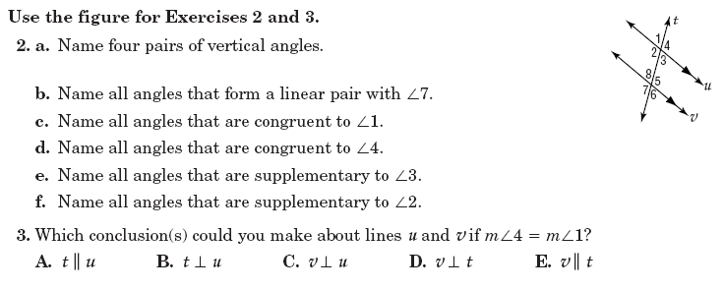



16.

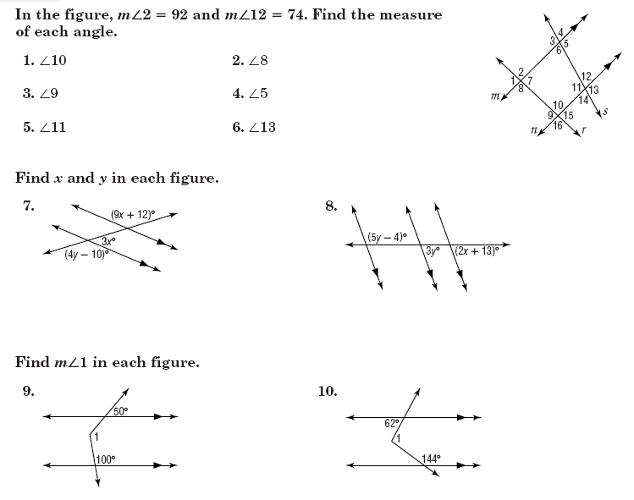

17.

**18. If *w //v*, give the justification for each statement**.

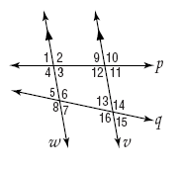a. <2<12 b. <8<14

c. <5<13 d. <10<2

e. <7 + <16 =180° f. <16<6

**19. If m<3=43°, find the measures of each angle. Fill them in on the picture and list them out in order.**

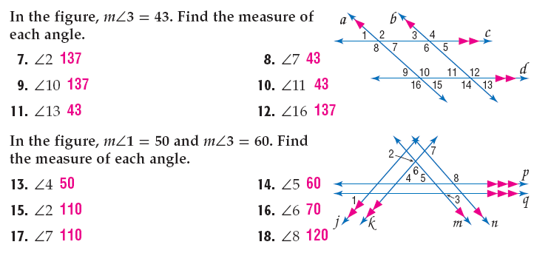

**20. If m<1= 50° and m<3=60°, find the measures of each angle. Fill them in on the picture and list them out in order.**



**Directions #21-26**: Show all geometry, justifications and work for every step and find x and y.

21. 22.

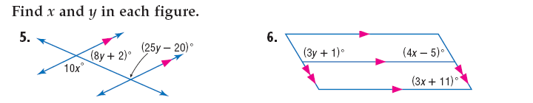23. 24.

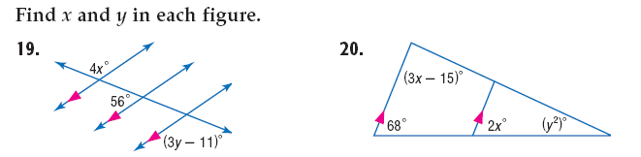25. 26.

27. If <3 is complementary to <2 and <1 is supplementary to <3.

Find x and y if <1= 13x+4, <2=5y+4 and <3= 6x - 14

**ADD IN Writing Equations Part 2 Review**