Name: ________________________________________ Date: ___________

Area of Composites Practice

Find the area of the shaded regions.

1. 2.

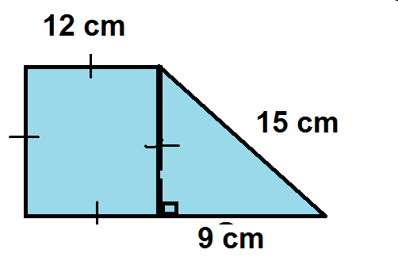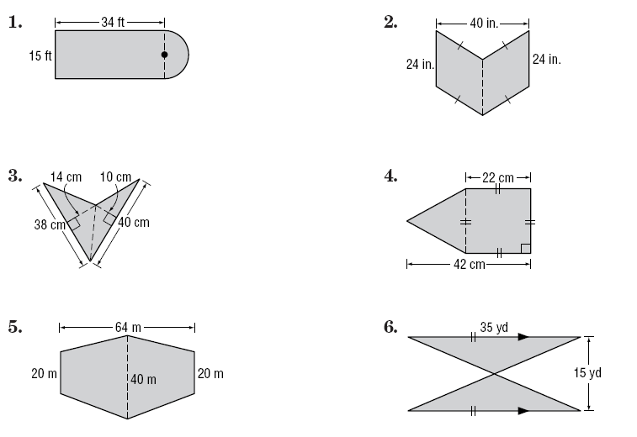

3. 4.

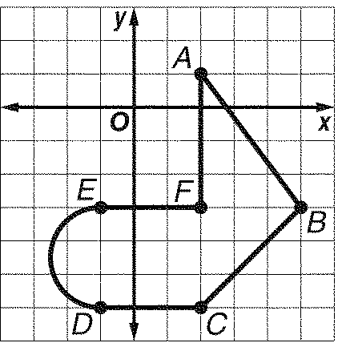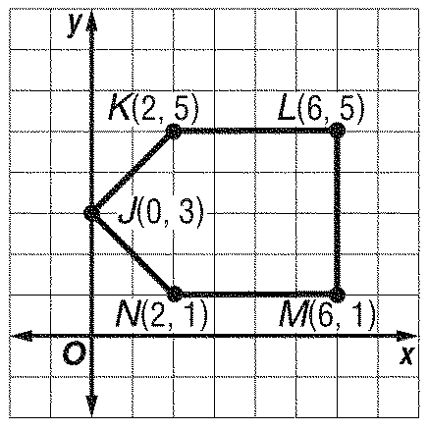5. 6.

7. Connor’s family is putting in a new patio pool deck. The radius of the pool is 15 feet and the width of the pool deck must be 8 feet making it 23 feet from the outer edge of the deck to the center of the pool. COLOR IN THE POOL DECK!!!!!! THEN.... Find the area of the pool deck.

