Name: ___________________________________________________ Hour: _____________

Area of Regular Polygons- Given a Radius HW
Find the area of each regular polygon given the information. Round your answers to the nearest tenth.

1. A regular heptagon with r = 10m 2. A regular dodecagon with r = 3in

10km
3. 4.

16m
12m
5. 6.

Find the area of each shaded region, rounding to the nearest tenth.
10km

7.

12m

8.

16m

9.

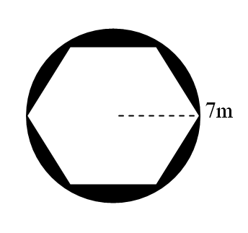

10.

