Area of Sectors and Segments Notes- ACC

Find the area of the shaded region.
Sectors: Example 1:
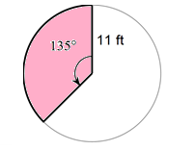

Example 2: Example 3:

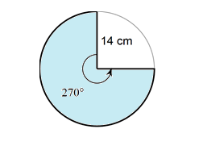

Segments: Example 1:

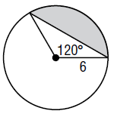

Example 2: Example 3:
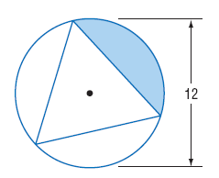

Example 4:
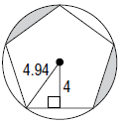

Area of Sectors and Segments HW- ACC

Find the area of the shaded region. Show in terms of pi and round to the nearest hundredth.

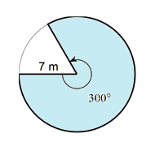
1. 2.
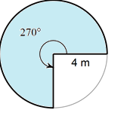

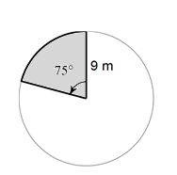
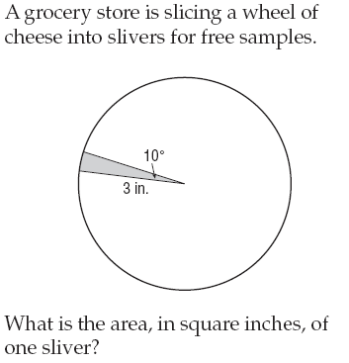
3. 4.

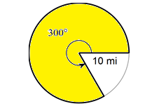
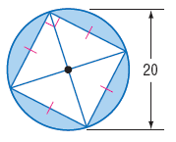
5. 6.

7. 8.

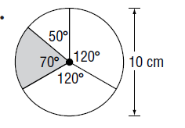
9. 10.

11. r=8cm 12. R = 12m, r = 9m

Find the missing variable.

13. The shaded area is 12cm². Find r. 14. The shaded area is 32cm². Find r.

15. The shaded area is 120cm² and the radius is 24cm. Find x. |  | 16. The shaded area is 10 cm². The radius of the large circle is 10 cm and the radius of the small circle is 8 cm. Find x.

