**Area of Sectors Notes**

Find the area of the shaded region.

Sectors: Example 1:

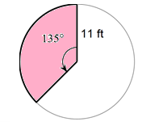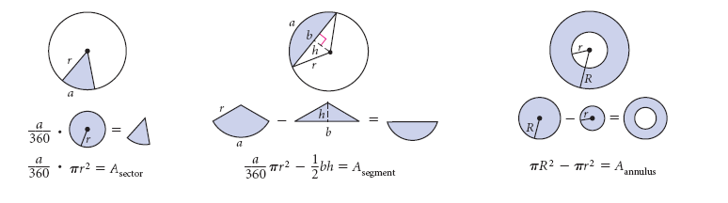

Example 2: Example 3:

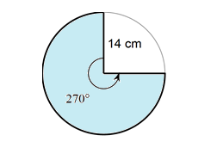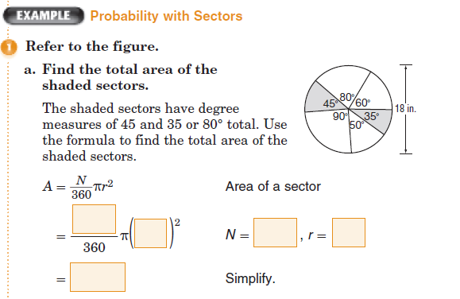

Example 4: The length of arc $XY$ of a circle is equal to $\frac{1}{6}$ of the circumference of the circle. The length of the arc is $7π$ inches. Find the central angle of the circle, in degrees. Find the radius, in inches, and then use that radius to find the area of the shaded sector, in square inches. If needed, round any answer to the nearest tenth.

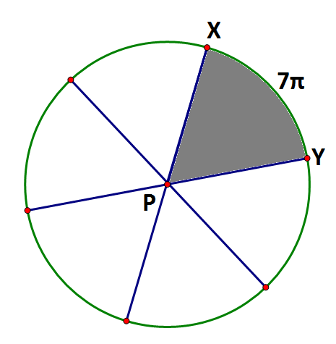

Central Angle ∠XPY= _________

Radius = _________

Sector Area =_________

Example 5.  
The area of the regular polygon ABC is 187.06 cm2. Round to the nearest tenth.

A. Find the radius of the circle, *r*.

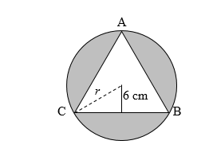

radius of circle: ___________________

B. Find the area of the shaded region.

A = ___________________________

Name: ______________________________________________________________________

**Area of Sectors HW**

Find the area of the shaded region. Show in terms of pi and round to the nearest hundredth.

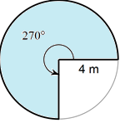

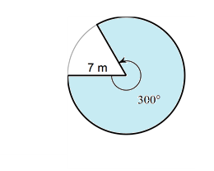

1. 2.

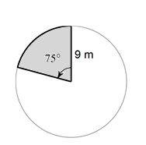

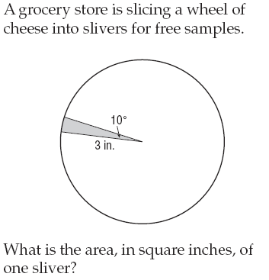

3. 4.

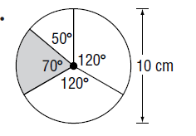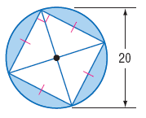

5. 6.

7. The area of the regular polygon is approximately 35735.6 m2. Round to the nearest tenth.

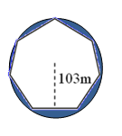A. Find the radius of the circle, *r*.

radius of circle: ___________________

B. Find the area of the shaded region.

A = ___________________________

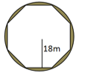8. The area of the regular polygon is 1075.5 m2. Round to the nearest tenth.

A. Find the radius of the circle, *r*.

radius of circle: ___________________

B. Find the area of the shaded region.

A = ___________________________

9. The length of arc of a circle is equal to of the circumference of the circle. The length of the arc is inches. Find the central angle of the circle, in degrees. Find the radius, in inches, and then use that radius to find the area of the shaded sector, in square inches. If needed, round any answer to the nearest tenth.

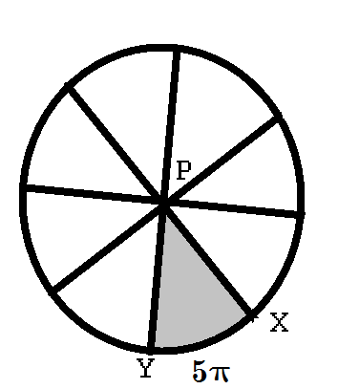

Central Angle ∠XPY= _________

Radius = _________

Sector Area =_________

10. The length of arc of a circle is equal to of the circumference of the circle. The length of the arc is inches. Find the central angle of the circle, in degrees. Find the radius, in inches, and then use that radius to find the area of the shaded sector, in square inches. If needed, round any answer to the nearest tenth.

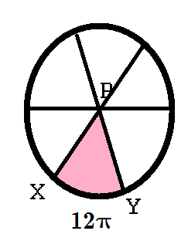

Central Angle ∠XPY= _________

Radius = _________

Sector Area =_________

11. The shaded area is 120cm2 and the radius is 24cm. Find x.

