Name: __________________________

**Area Test Review**

**Directions: Show all work and attempt all questions for credit! You will not earn credit if you do not show your set up(what you plugged in for the formulas) and all of your work.**

**Circle your final answers and include units.**

For # 1-6, find the **area** of each parallelogram. Keep answer in *exact* simplest form- simplify all radicals.

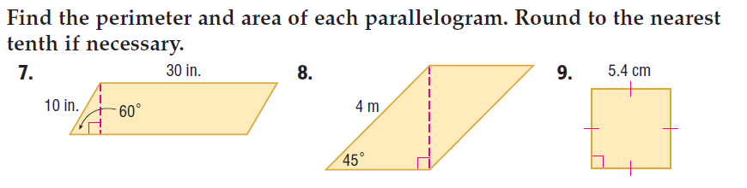

1.  2. 3.

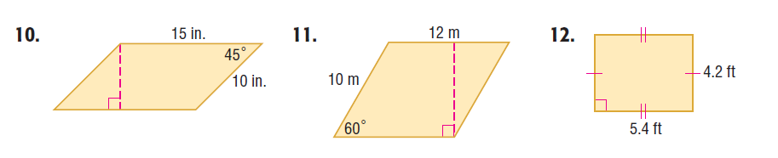



4. 5. 6.

For # 7 – 12, find the **area** of each figure. Round to the nearest tenth if necessary.

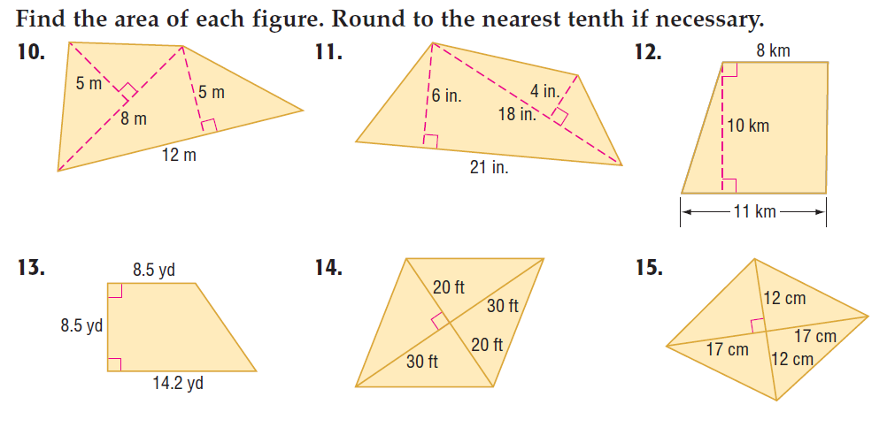

7. 8. 9.



10. 11. 12.

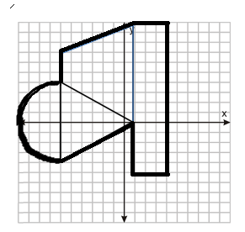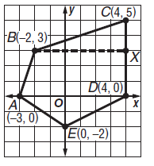

13. 14.

For # 17 – 22, find the **area** of each figure or shaded region. Round to the nearest tenth if necessary.

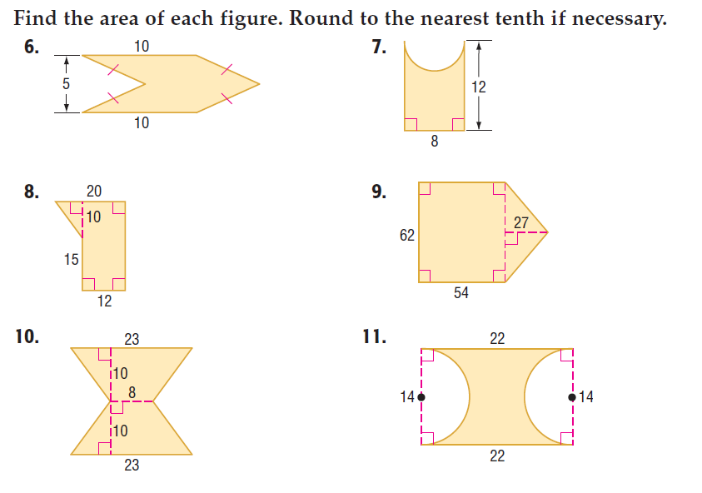

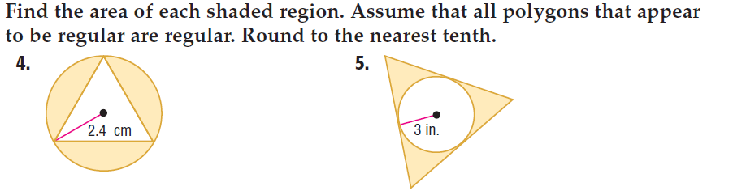15. 16. 17.

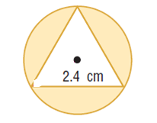



18. 19. 20. S = 2.4 cm

For # 23 – 26, find the **area** of each REGULAR polygon. Round to the nearest tenth.

21. Octagon with P = 72in. 22. Square with P =

[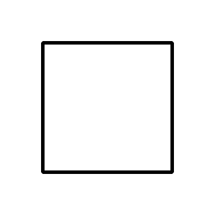](https://www.google.com/url?sa=i&rct=j&q=&esrc=s&source=images&cd=&cad=rja&uact=8&ved=0ahUKEwjCudPJ2ufTAhVB7YMKHReGCQ8QjRwIBw&url=https://commons.wikimedia.org/wiki/File:Square_-_black_simple.svg&psig=AFQjCNG8a_IhBRBz2f46a2Uluz6KLpB0ug&ust=1494587531551640)

[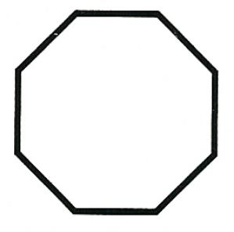](http://www.google.com/url?sa=i&rct=j&q=&esrc=s&source=images&cd=&cad=rja&uact=8&ved=0ahUKEwi6jsOX2ufTAhVE94MKHYZwCtoQjRwIBw&url=http://www.daviddarling.info/encyclopedia/O/octagon.html&psig=AFQjCNHm3MEm6CzhGi7N3-L6x_aGig6jfg&ust=1494587425129189)

23. Square with apothem = 12 in. 24. Hexagon with apothem = 24cm

[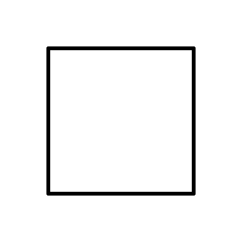](https://www.google.com/url?sa=i&rct=j&q=&esrc=s&source=images&cd=&cad=rja&uact=8&ved=0ahUKEwjCudPJ2ufTAhVB7YMKHReGCQ8QjRwIBw&url=https://commons.wikimedia.org/wiki/File:Square_-_black_simple.svg&psig=AFQjCNG8a_IhBRBz2f46a2Uluz6KLpB0ug&ust=1494587531551640)

[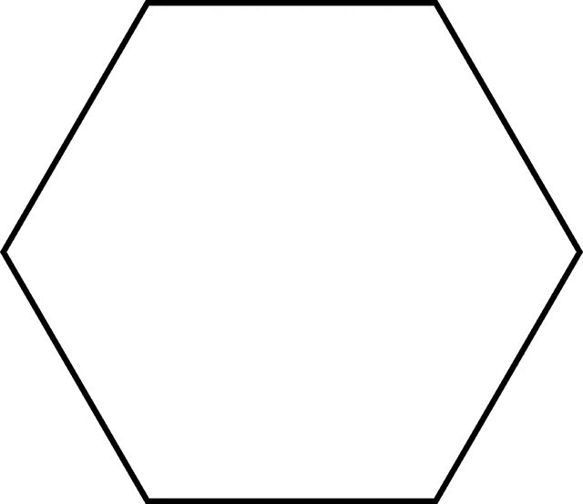](http://www.google.com/url?sa=i&rct=j&q=&esrc=s&source=images&cd=&cad=rja&uact=8&ved=0ahUKEwje_f6n2ufTAhUF2IMKHdFrBqIQjRwIBw&url=http://etc.usf.edu/clipart/40600/40681/pb_hex_40681.htm&psig=AFQjCNFOFXHzVCw27ikAPmUSp3OZyiNZHA&ust=1494587459052252)

[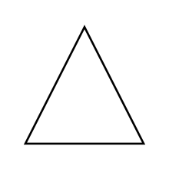](https://www.google.com/url?sa=i&rct=j&q=&esrc=s&source=images&cd=&cad=rja&uact=8&ved=0ahUKEwiL_Me92ufTAhWj64MKHdejD5wQjRwIBw&url=https://en.wiktionary.org/wiki/triangle&psig=AFQjCNHc2hJN5DZKdjI03bZOQprHcS5Blg&ust=1494587506741233)25. Triangle with side length=15.5 in. 26. Octagon with side length= 10km.

[](http://www.google.com/url?sa=i&rct=j&q=&esrc=s&source=images&cd=&cad=rja&uact=8&ved=0ahUKEwi6jsOX2ufTAhVE94MKHYZwCtoQjRwIBw&url=http://www.daviddarling.info/encyclopedia/O/octagon.html&psig=AFQjCNHm3MEm6CzhGi7N3-L6x_aGig6jfg&ust=1494587425129189)

27. Find the area. 28. Find the area.

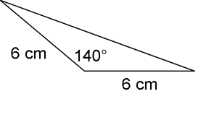

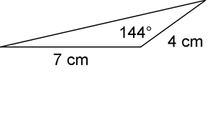

Find the exact value of the area of the sector.

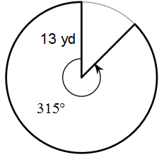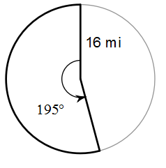29. 30.

31. 32.

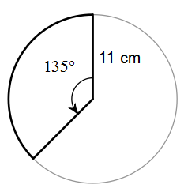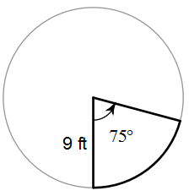

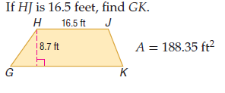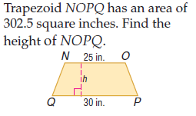For #33-36, Find a missing length.

33. 34.

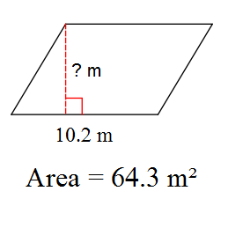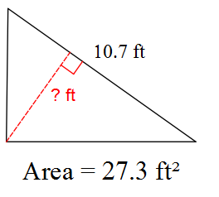

35. 36.

37. The length of arc $XY$ of a circle is equal to $\frac{1}{6}$ of the circumference of the circle. The length of the arc is $7π$ inches. Find the central angle of the circle, in degrees. Find the radius, in inches, and then use that radius to find the area of the shaded sector, in square inches. If needed, round any answer to the nearest tenth.

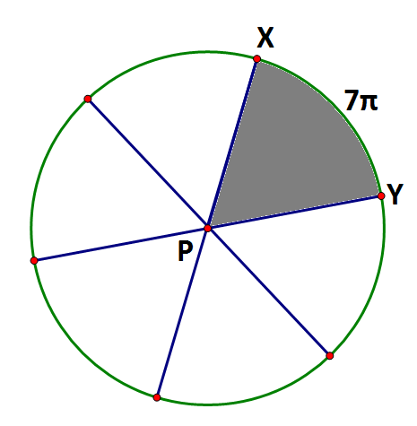

Central Angle ∠XPY= _________

Radius = _________

Sector Area =_________

38. The area of the regular polygon ABC is 187.06 cm2. Round to the nearest tenth.

A. Find the radius of the circle, *r*.

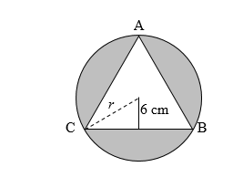

radius of circle: ___________________

B. Find the area of the shaded region.

A = ___________________________

39. A rectangular pane of glass measuring 10 inches by 12 inches is surrounded by a wooden frame that is 1 inch wide. What is the area of the window, including the frame? Draw a picture with labels 1st! (If you don’t do this you will not earn credit for attempting the question).

40. What is the shaded area?



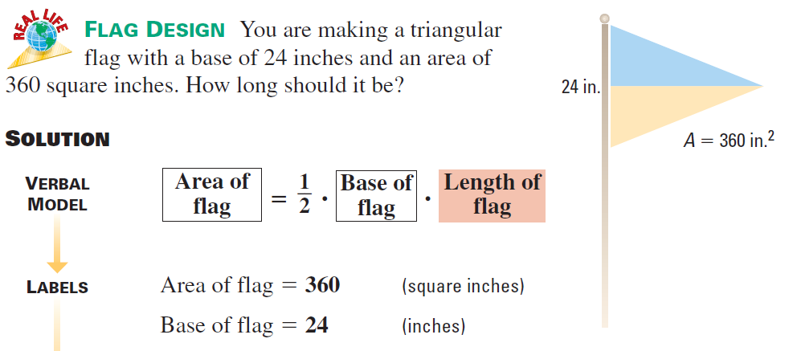41. You are making a triangular flag with a base of 24 inches and

an area of 360 square inches. How long should the flag be?

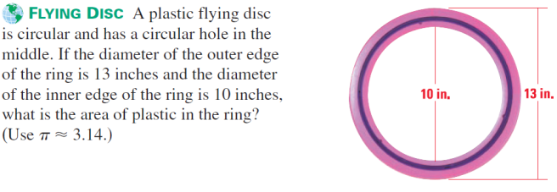**42.** A plastic flying disc is circular and has a circular hole in the middle. If the diameter of the outer edge of the ring is 13 inches and the diameter of the inner edge of the ring is 10 inches, what is the exact area of the plastic ring?

43. Leah would like to tile the 3 bathrooms and the kitchen. She would also like to carpet the 3 bedrooms (Bedrooms and Master Bedroom) and the hallway. A) Find the area for each type of flooring. B) If tile costs $0.02 per square inch and carpet costs $15.00 per square yard, how much would this renovation cost Leah including tax?

