Basic Transformation Constructions Notes: Rotations
Rotate the given pre-image the desired rotation around the point of rotation R.
1. Rotate 60° counterclockwise

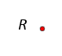
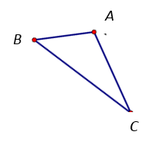

2. Rotate 115° clockwise.
