Cast List:

-The following will serve as cast members and Festival Players-

Friar Tuck’s Girls-Makenzie Coil & Hayley Jones
Serf- MaKayla Trivett
Towncriers-Ciara Wichtner
Somebody’s, the pickpocketing thief (Merrymen)- Lakon Korchmar
Poor Yeoman- Rachel Schmitt
Fortune Teller- Ylenia Bonni
Merrymen- Malachi Lane, Hunter Reed & Jaleena Suarez
Sheriff’s Men- Jasmine Aoun, Samantha Fisher & Jessica Marszalec
Footman- Samantha Fisher
Jester- Geralynn Maston
Peasents- Brandi LaJoie, Rebecca McNicol, Vanessa Montano, Olivia Neumann,
Katherine Schnieder, Kayla Shoaff & Alyssa Stehlin
Nobel Women- Ashley Andris, Amanda Gelaj, Angela Popovich, LaQuera Ramsey, Hanna Sciullo
& Caroline Wolber
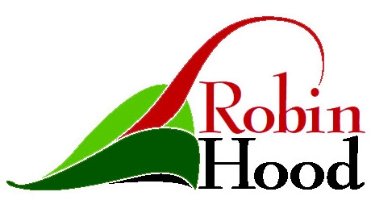
Cast (non-festival)
Robin Hood- Rudolph Obarto
Little John- James Koos
Lord Dunstan- Matheus Reinas
Rugged Woodsman and Merryman- Spencer Gura
Will Scarlet- Adam Towers
Maid Marian- Cassady Temple
Handmaidens- Christina Hami & Lindsay Bruce
Friar Tuck/Bishop/Alan Adele- Dean Michel
Sheriff of Nottingham-Norris Thompson

