Acc Geometry **Transformations:**

Transformations Follow Up CCSS - Reflections over intersecting lines.

1. Composite: (ry=x ◦ ry=0 )( ABC)

Equation of the first line of reflection: y = 0

Equation of the second line of reflection: y = x

|  |  |  |  |  |  |
| --- | --- | --- | --- | --- | --- |
| A | (3,-2) | B | (1,-6) | C | (6,-10) |
| A' |  | B' |  | C' |  |
| A" |  | B" |  | C" |  |

What transformation occurred from this composite? In other words, what transformation would transform ABC to A"B"C" without using any reflections?

Give an image formula for this transformation.



2 Composite: ry=0(ry=x(ABC))

Equation of the first line of reflection: y = x

Equation of the second line of reflection: y = 0

|  |  |  |  |  |  |
| --- | --- | --- | --- | --- | --- |
| A | (3,-2) | B | (1,-6) | C | (6,-10) |
| A' |  | B' |  | C' |  |
| A" |  | B" |  | C" |  |

What transformation occurred from this composite? In other words, what transformation would transform ABC to A"B"C" without using any reflections?

Give an image formula for this transformation.

Acc Geometry **Transformations:**

**Use a composition of reflections to find the rotation image with respect to lines k and m. Then find the angle of rotation for each image.**

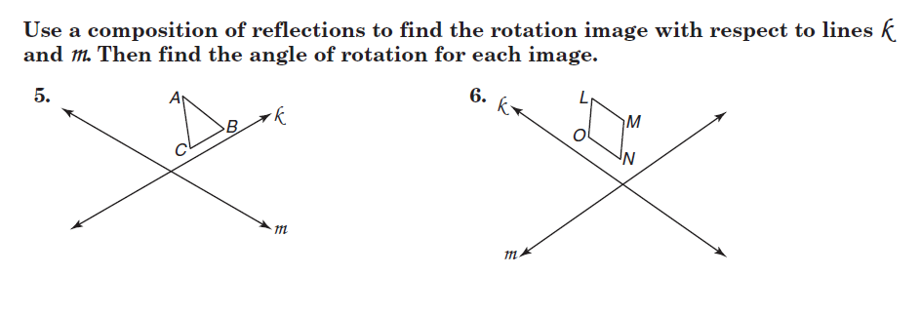

1. 2.

Transformations Follow Up CCSS - Reflections over parallel lines.

1. Using a colored pencil, reflect ABC over the x = -3 line and label the points A', B', and C' respectively. Draw A'B'C'.
2. Using a black pencil, reflect A'B'C' over the x = 2 line and label the points A", B", and C" respectively. Draw A"B"C".
3. Draw arrows from A to A", from B to B", from C to C" using a different color.
4. What transformation occurred that would map ABC onto A"B"C"?___________
5. How far did ABC move to become  A"B"C"?___________in what direction?_______

**In each figure, *a//b*. Determine whether Figure 3 is a translation image of Figure 1. Write yes or no and then explain your answer.**

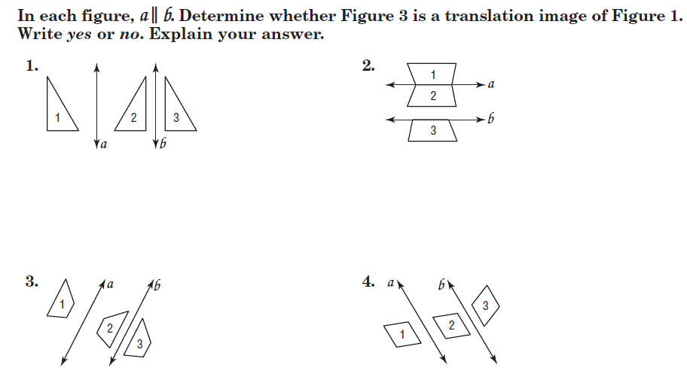

8. 9.



10. 11.