Determine whether $\overset{⃡}{AB}$ and $\overset{⃡}{DF}$ are parallel, perpendicular, or intersecting. Explain.

14. A(-2, -11) B(6,5) D(-7,-10) F(2,8) _____________________________________________

15. A(-1,6) B(2,-9) D(-10,-1) F(5,2) _____________________________________________

16. Write the equation of the line in slope intercept form that passes through point (-2,1) and is perpendicular to $y=\frac{1}{3}x+5.$

______________________

17. Write an equation of a line in slope-intercept form through (2,4) and parallel to $x-3y=6.$

______________________

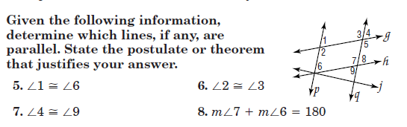
19.
21.
20.
18.

18._________________________________________________________________________

19.________________________________________________________________________

20.________________________________________________________________________

21.________________________________________________________________________

