**Circumference and Arc Lengths Notes**

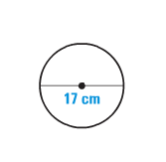

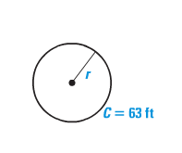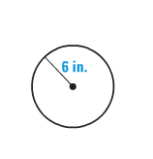**Use the diagram to find the indicated measure.**

**1.** Find the circumference  **2.**  Find the circumference **3.** Find the radius

**Find the indicated measure.**

**4.** The circumference of a circle with diameter 5 inches.

**5.** The radius of a circle with circumference of  meters.

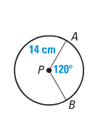

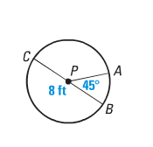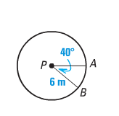

**Find the length of .**

**6. 7. 8.**

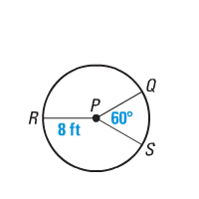

**In shown at right, . Find the indicated measure.**

**9.** m<RPQ **10.** m<RPS

**11.** length of ** 13.** length of ** 14.** length of 

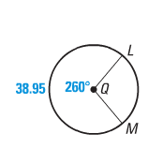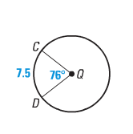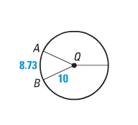**Find the indicated measure.**

**15. m<AQB 16.** Circumference of  **17.** Radius of 