Notes – Congruent Polygons | Name:
Standard: | Hour:

Objective: I can determine if two polygons are congruent by identifying all of their congruent parts. I can use the congruent parts of congruent polygons to solve for a variable and find measures.

Definition
For two or more polygons to be considered congruent, ________ of their corresponding _______________ must be ________________________.
When writing congruence statements, _______________________ ______________________!

Examples
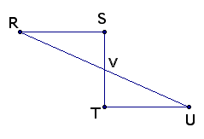
Write all of the segment and angle congruence statements for each pair of polygons. Then write the congruence statement for each polygon.
1a.  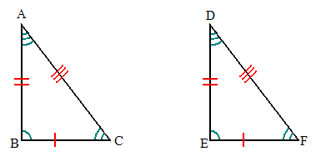  Segments Angles  Congruence Statement:  2. List all reasons for this proof.  Given:  RS//UT, V is the midpoint of ST and RU, and RSUT  Prove: RSTUTV | 1b.  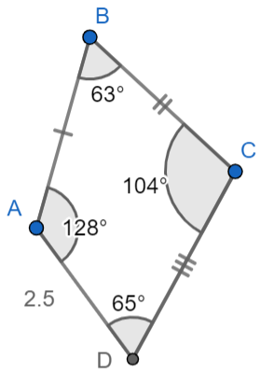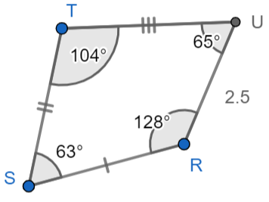  Segments Angles  Congruence Statement:

Use the congruence statement given to mark the polygons congruent.
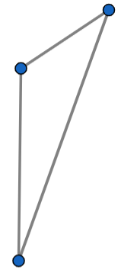  - $∆GHK≅∆TRW$ | 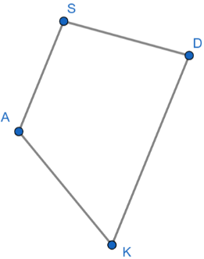  - $NBRP≅ASDK$  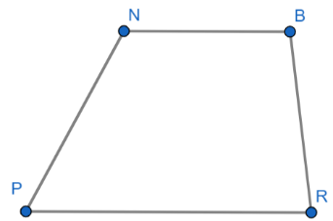
Use the given congruence statement to complete each blank.
- $HJKLP≅QWRTY$  $∠W≅$ ______ $∠H≅$ ______  $\overline{TY}≅$ ______ $\overline{PH}≅$ ______  $KLPHJ≅$ ________________ | - $∆GHE≅∆KLP$  $∠E≅$ ______ $∠K≅$ ______  $\overline{GH}≅$ ______ $\overline{PK}≅$ ______  $∆LKP≅$ ____________
Recall – Definition
Congruence means to be equal in measure.

Practice
Find the indicated value using the information given.
- $∆GIH≅∆BCM$  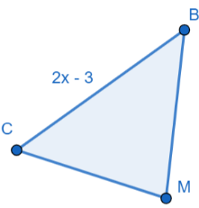  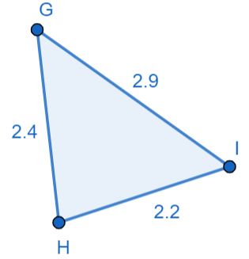  BC = _________ x = ________ | - $QRS≅BCA$  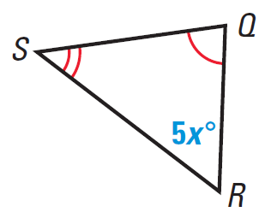  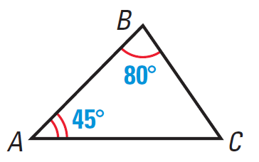  x = ________
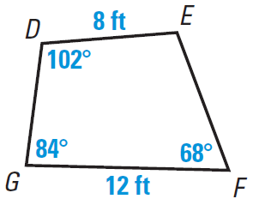
- $DEFG≅SPQR$
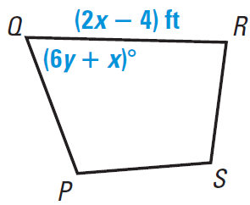

x = _______ y = _______ $∠S=$ _______ $SP=$_______

Homework (Th) – Congruent Polygons Name: _________________________________

Identify all pairs of congruent corresponding parts. Then write a different congruence statement than what is already given for the figures.
- $∆ABC≅∆DEF$  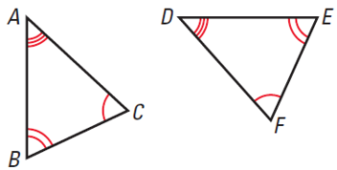  Segments Angles  Congruence Statement: | - $GHJK≅QRST$  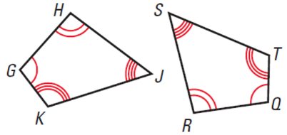  Segments Angles  Congruence Statement:
Complete each statement using the diagram provided.
$∆TJM≅∆PHS$
- $∠P≅$ ______ | - $\overline{JM}≅$ _______
- $m∠M=$ ______ | - $m∠P=$ _______ | 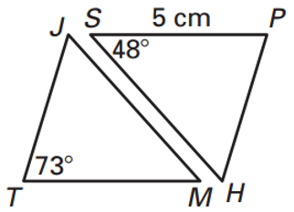
- $MT=$ _______ | - $∆HPS≅$ __________

$∆XYZ≅∆MNL$
- $m∠Y=$ _______ | - $m∠M=$ ________
- $YX=$ _______ | - $\overline{YZ}≅$ _______ | 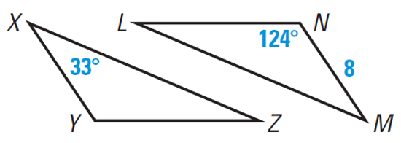
- $∆LNM≅$ ________ | - $∆YXZ≅$ _________

- $EFCD≅GHAB$  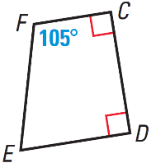  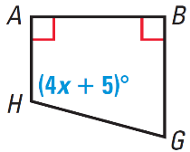  x = ________ | 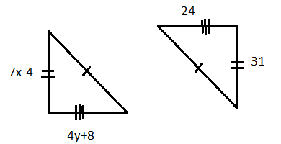  x = _______  y = _______
- $∆HJK≅∆TRS$  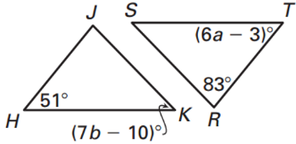  a = _______  b = _______ | - $MNPQ≅LHJK$  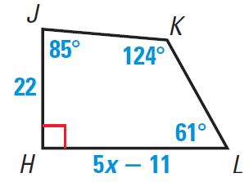  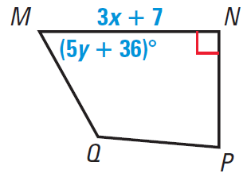  x = _______  y = _______
- Suppose $∆ABC≅∆EFD$, $∆EFD≅∆GIH$, $m∠A=90°$, and $m∠F=20°$. What is $m∠H$?

Algebra Challenge
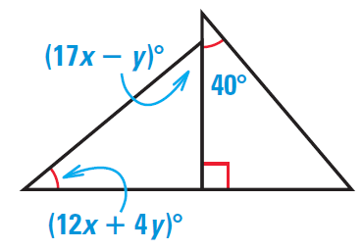  What is the measure of the missing angle?  40 is the same as which expression?  40 = _________________  ______ = 17x – y  Solve the system of equations you just wrote by substitution, elimination, or graphing.  Eq 1: ___________________________  Eq 2: ___________________________  x = ____________ y = ____________  Check your answers! Plug in x and y | 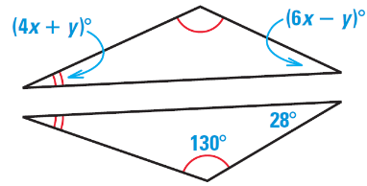  What is the measure of the missing angle?  Use the triangle sum theorem to write an equation for the top triangle.  _______________ + ________________ + _______ = 180  Solve  x = ________  28 is the same as which expression?  28 = ________________  Plug in the value of x to solve for y  y = ________

