Name: ________________________________________________________ Date: ________ HR: _____

Congruent Triangles: HW

1) Identify the congruent triangles in the given figure
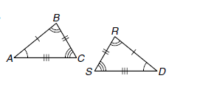

∆ABC≅____________ ∆ABC≅____________ ∆XYZ≅________ ∆MLP≅____________

2) Verify that the following transformation preserves congruence.
a.
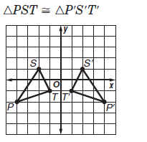

b. c.

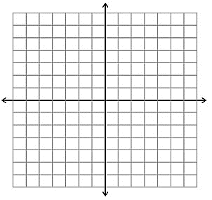

Use the given information to identify the congruent triangles. Describe what congruence shortcut you used and what angles or sides you know are congruent.

3.
a. Short cut congruence used __________

b. Name the 3 congruent corresponding parts:
$$∆ SRP≅__________$$

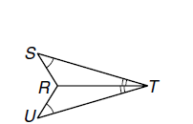

4.

a. Short cut congruence used __________

b. Name the 3 congruent corresponding parts:

$$∆ STR≅__________$$

5.
a. Short cut congruence used __________

b. Name the 3 congruent corresponding parts:

$$∆ ABC≅__________$$

6.
a. Short cut congruence used __________

b. Name the 3 congruent corresponding parts:

$$∆ ABD≅__________$$
$$∆ ABD≅__________$$

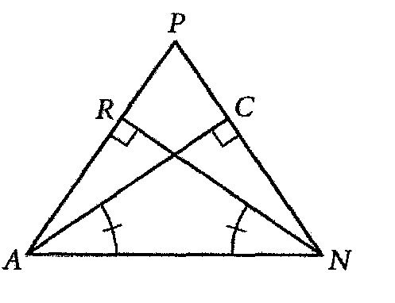
7.

a. Short cut congruence used __________

b. Name the 3 congruent corresponding parts:

$$∆ RNA≅__________$$

