**Construction Practice of Rotations and Reflections**

Reflect the given figure over the given line.

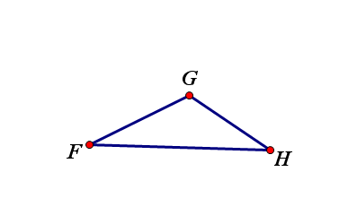

1.

**Rotate the given figures around the point of rotation, point R.**

2. Rotate 125° counterclockwise

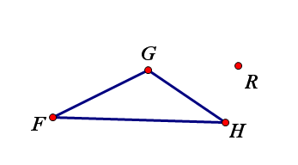

**Rotate the given figures around the point of rotation, point R.**

3. Rotate 100° clockwise



Reflect the given figure over the given line.

4.

