Name: ____________________________________________________________ Date: ___________ Hour: _____

Coordinate Classification Practice
Determine whether the figure is a trapezoid, a parallelogram, a square, a rhombus or a general quadrilateral given the vertices
1.
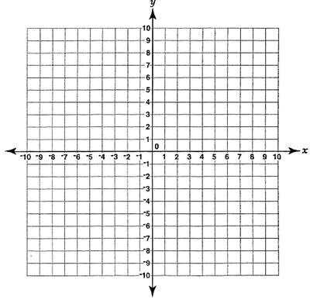

2.

3.

4.

5.

6.

KEY:
1. Trapezoid
2. Rectangle
3. Isosceles Trapezoid
4. Rhombus
5. Square
6. Rhombus

