Name: ____________________________________________________________ Date: ___________ Hour: _____

Coordinate Classification Practice
Determine whether the figure is a trapezoid, a parallelogram, a square, a rhombus or a general quadrilateral given the vertices. Show your work! Graph the figure to help you. If the graph is not large enough, extend it for you
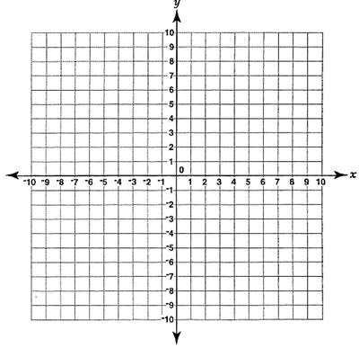
1.
Slopes: Distances:

Conclusion:
ABCD __________ a parallelogram because _______________________________________________
ABCD __________ a rhombus because ___________________________________________________
ABCD __________ a rectangle because ___________________________________________________
ABCD __________ a square because _____________________________________________________
(is or is not)

Review: Find the perimeter.

2.
Slopes: Distances:

Conclusion:
BEFG __________ a parallelogram because _______________________________________________
BEFG __________ a rhombus because ___________________________________________________
BEFG __________ a rectangle because ___________________________________________________
BEFG __________ a square because _____________________________________________________
(is or is not)

Review: Find the perimeter.

3.
Slopes: Distances:

Conclusion:
BEFG __________ a parallelogram because _______________________________________________
BEFG __________ a rhombus because ___________________________________________________
BEFG __________ a rectangle because ___________________________________________________
BEFG __________ a square because _____________________________________________________
(is or is not)

Review: Find the perimeter.

Find the missing coordinate in the quadrilateral. Practice for MIDTERM!
4. $ABCD$ is a rectangle with $B\left(-10, 7\right), C\left(-10, 4\right),$and $D(8, 4)$. Find the coordinates of $A.$
- $A(7, 10)$
- $A(8, 10)$
- $A(4, 7)$
- $A(8, 7)$
- $A(-10, 4)$
5. $ABCD$ is a rectangle with $B\left(-4, 0\right), C\left(-4, 2\right),$and $D(12, 0)$. Find the coordinates of $A.$
- $A(0, -4)$
- $A(0, 4)$
- $A(12, 2)$
- $A(2, 12)$
- $A(-2, 4)$
6.$ABCD$ is a rectangle with $B\left(2, 4\right), C\left(-3, 3\right),$and $D(2, 3)$. Find the coordinates of $A.$
- $A(3, 4)$
- $A(-3, 4)$
- $A(3, -3)$
- $A(2, 2)$
- $A(4, 3)$

KEY:

1. Rectangle,
2. Rhombus,
3. Square,
4. D
5. C
6. B

