Coordinate Geometry Day 1 HW

Determine whether the figure is a parallelogram, rectangle, rhombus, square or just a general quadrilateral. Explain your reasoning. (Classify all that apply)
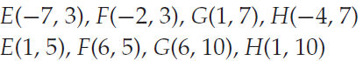
1.
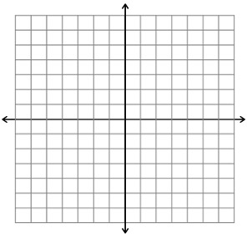
Distances:
Slopes:

Conclusion:

Perimeter:
Area:

2.

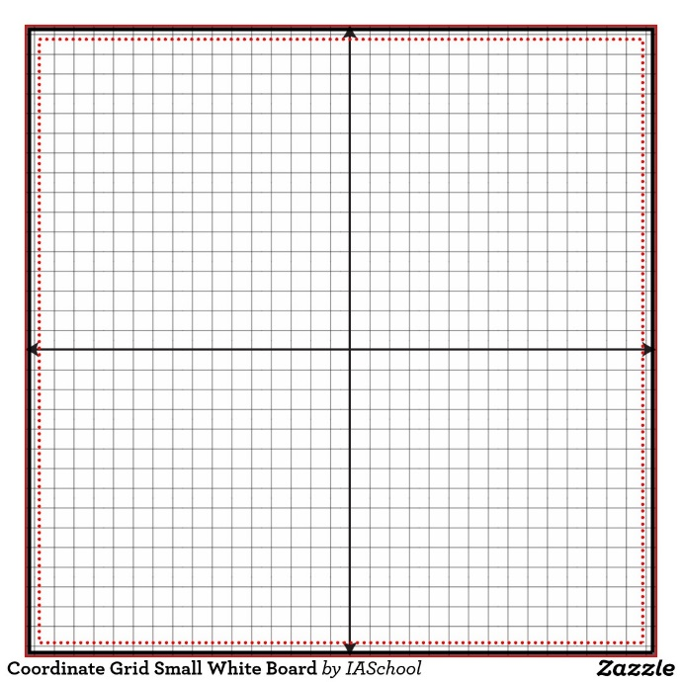

Area:
Perimeter:
Distances:
Slopes:
Conclusion:

3.
Conclusion:
Perimeter:

Slopes:
Distances:
Area:

4.

Conclusion:
Slopes:
Distances:
Perimeter:
Area:

Solutions:
1. rhombus para
2. square, rectangle, para, rhombus
3. square, rectangle, para, rhombus
4. none

