Triangles – Day ____
Name__________________________________

Triangle Coordinate Geometry Examples Day 1

1. Classify the triangle as scalene, equilateral, or isosceles. The determine if the triangle is a right triangle.
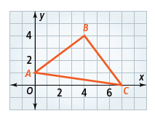
Work:

Conclude:

2. a.) Plot F(1,4) and G(-3,4). What is the length of FG? b.) Plot F(a,b) and G(a,-4b). What is the length of FG?

3.) ABCD is a rectangle plotted with the vertices below.
a.) Find the lengths of ALL FOUR SIDES and BOTH Diagonals.
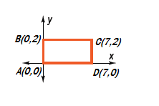

ABCD is a rectangle plotted with the vertices below.
b.) Find the lengths of ALL FOUR SIDES and BOTH Diagonals.
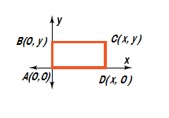

4. M and N are midpoints of QP and QR respectively for ∆PQR. P(-4,0), Q(0,10), and R(8,0).
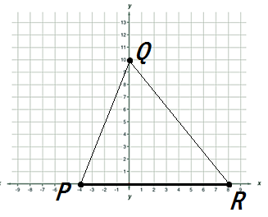
a.) Find the coordinates of midpoints M and N. To check midpoints, use the midpoint formula.

M: ______________ N: _________________

b.) M and N are midpoints of QP and QR respectively.
Find the coordinates of midpoints M and N. To check midpoints, use the midpoint formula.
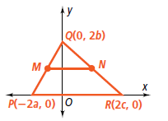

M: ______________ N: _________________

5. M and N are midpoints of QP and QR respectively for ∆PQR. P(-4,0), Q(0,10), and R(8,0). Record your midpoints from the previous question.
a.)Is MN || PR? Why or why not. SHOW MATH! To check parallel, we need to look at ______________.

b.) Record your midpoints from the previous question. Is MN || PR? Why or why not. SHOW MATH! To check parallel, we need to look at ______________.

Name______________________________________________ Hour: _______

Practice Triangle Coordinate Geometry Day 1

Work: Work: Work:

Conclude: Conclude: Conclude:

2. Find the SLOPES of ALL three sides of the triangle.

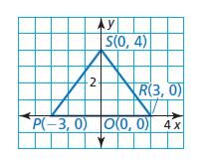

3. Find the SLOPES of ALL three sides of the triangle.
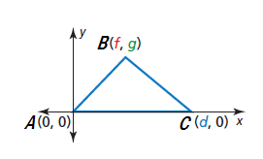

4. Given the two triangles below, show your math to determine what 3 PAIRS of sides are congruent.
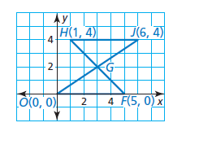

5. Determine if G is the midpoint of JO AND HF. Explain your mathematics.

6. J and K are midpoints of AB and AC respectively.
a.) Find the coordinates of midpoints J and K.

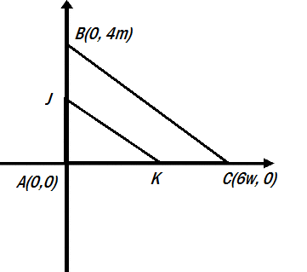

J: ______________ K: _________________

b.) Is JK||BC? Why or why not. SHOW MATH!

7. M and N are midpoints of QP and QR respectively.
a.) Find the coordinates of midpoints M and N.
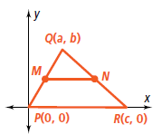

M: ______________ N: _________________

b.) Is MN || PR? Why or why not. SHOW MATH!

